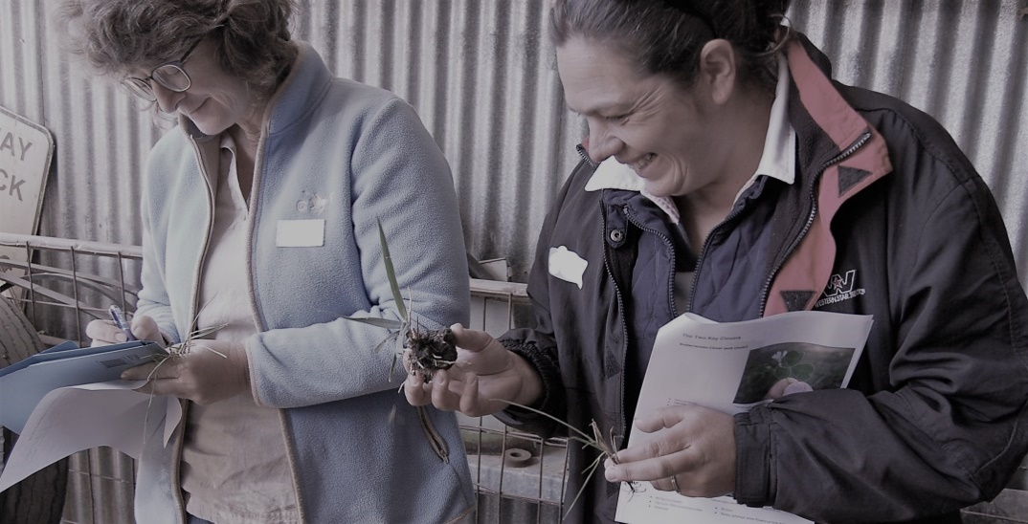



**DATE & LOCATION**

***Wednesday 8 June 2022***

Jigsaw Farms

1895 Hensley Park Rd, Hensley Park VIC 3301



**TIME: 9.45am-2.00pm**



**REGISTRATION ESSENTIAL**

**Click on the link to register**

**<https://forms.office.com/r/HRJKRD4X6C>**

**CONTACT**

**Lisa Miller SFS**

[**lmiller@sfs.org.au**](mailto:lmiller@sfs.org.au) **0488 600 226**

**supporting**

**women on farms**

**Best Practice Whole Farm Planning & Farm Tour**

***As a woman involved in a crop and livestock business, you and your neighbours are invited to come along to find out more about pasture management.***

Topics covered in the day will include:

* How animals grow
* Understanding production cycles and critical times of year
* Feed budgeting
* Common animal health issues

The day will include presentations, group discussion and time out in the paddock. Make sure you bring your questions!

Places are limited, so make sure you secure your place by sending an

**RSVP to Zoe Creelman on 0488 600 509 or zcreelman@sfs.org.au**

 

supporting

women on farms

LIVESTOCK

WORKSHOP

**DATE & LOCATION**

**20th June – Inverleigh**

**21th June – Werneth**

**TIME**

**9.30 am start**

**3 pm finish**

**Lunch and morning tea provided**

supporting women on farms

supporting women on farms

supporting women on farms

CROP PRODUCTION WORKSHOP



***As a woman involved in an agricultural business, you are invited to participate in a Whole Farm Planning Workshop & Farm Tour***

***On the day:***

* *Hear from Mark Wootton on his insights into creating a profitable, highly productive stock and agroforestry operation whilst adhering to environmental guidelines.*
* *Farm tour to see some of the successes - please remember to wear warm clothes and waterproof boots.*
* *Lunch provided*
* *Learn about land classing.*
* *Workshop what to get right in planning farm layout (planting trees/vegetation, farm subdivision & stock movement, water supply).*

***New Participants are WELCOME!***

*Jigsaw Farms is a 3500 ha family property run by Mark Wootton and Eve Kantor. One of the farms was initially a Potter Farm, set up in the 1980’s to demonstrate best practice farm planning. The bits of the puzzle have incorporated productive livestock, pastures, agroforestry, water storage and more recently carbon farming.*

This project is supported by Glenelg Hopkins CMA through funding from the Australian Government’s National Landcare Program