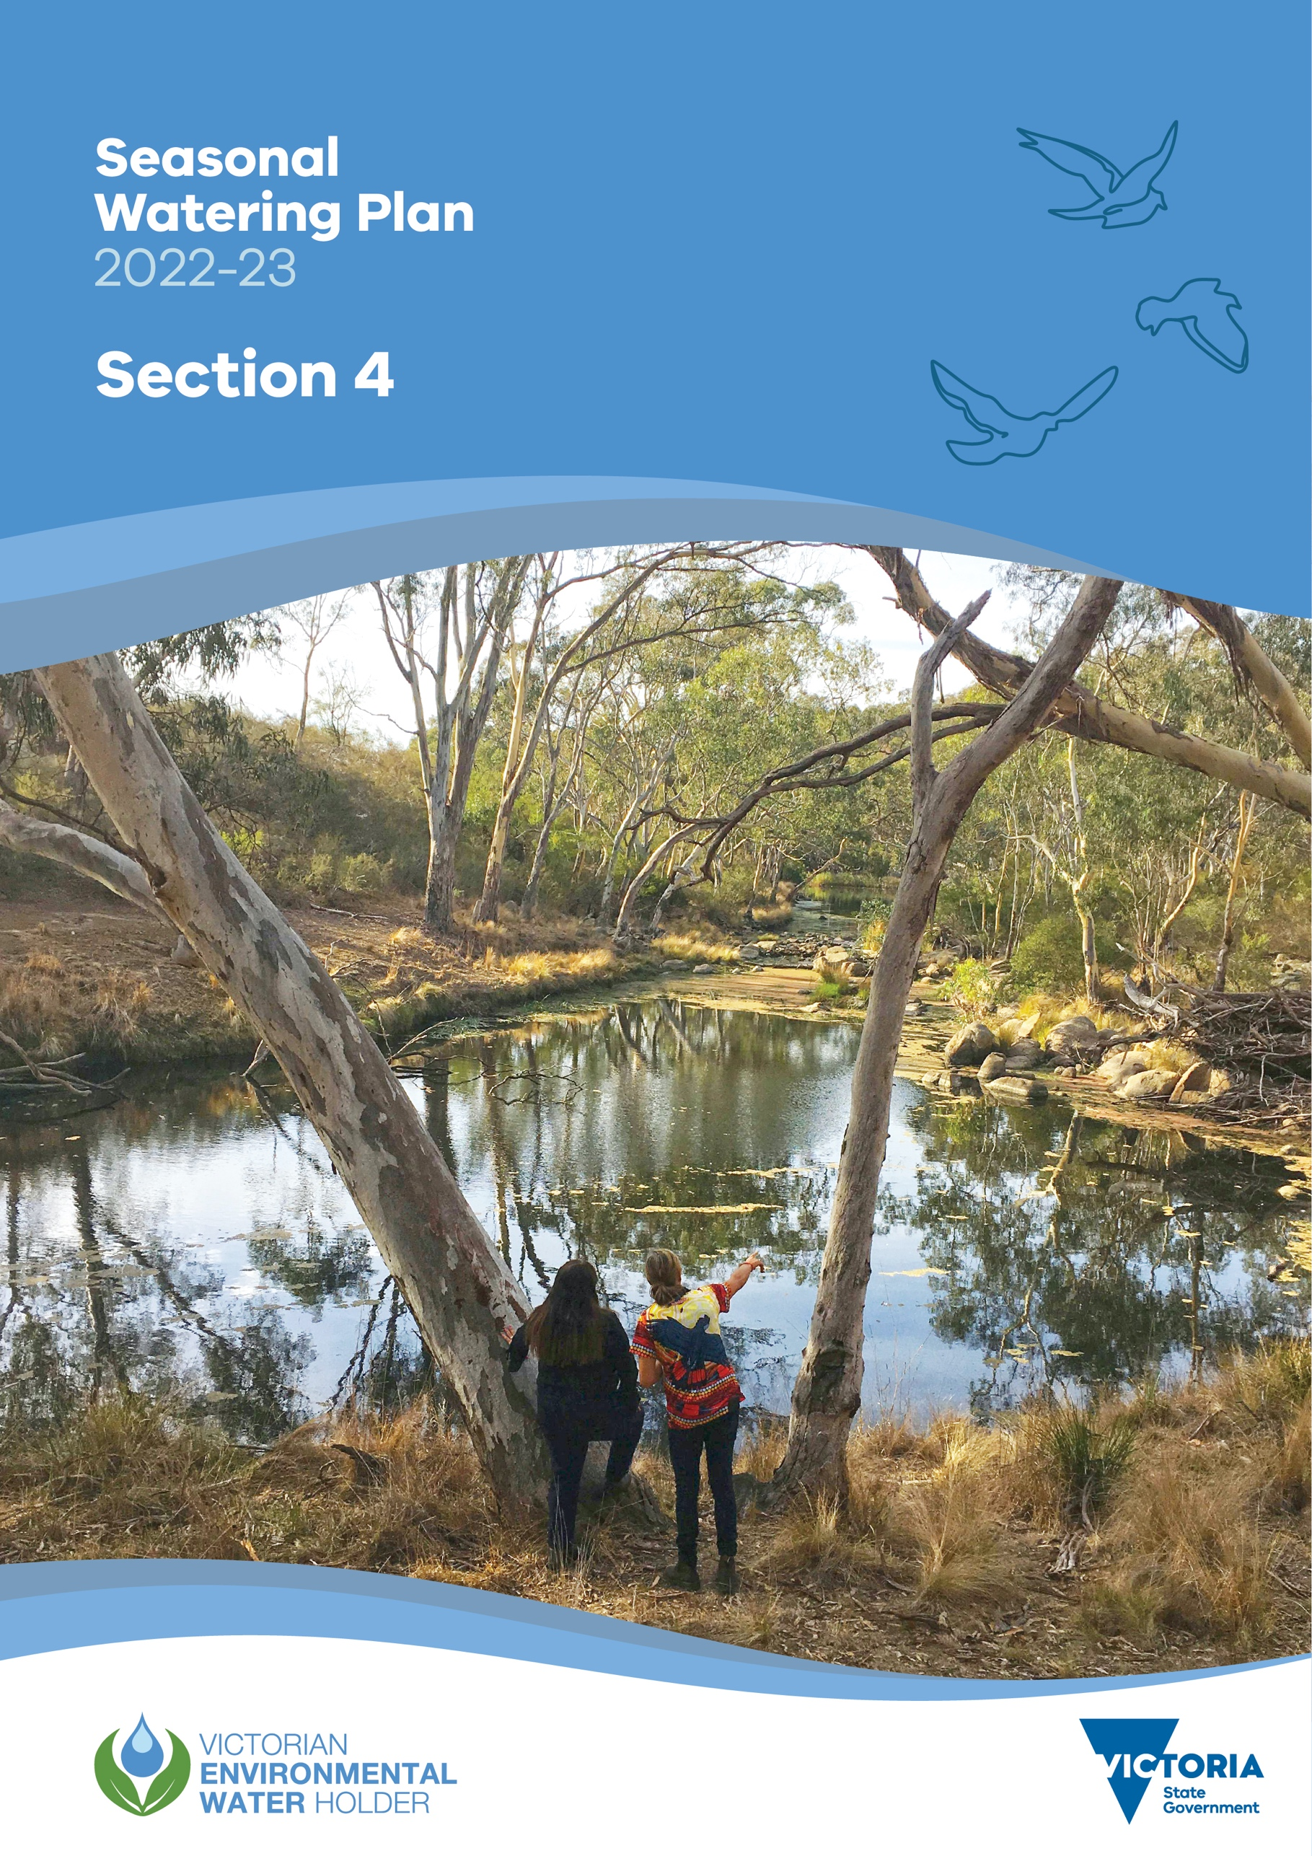

Section 4

Western region

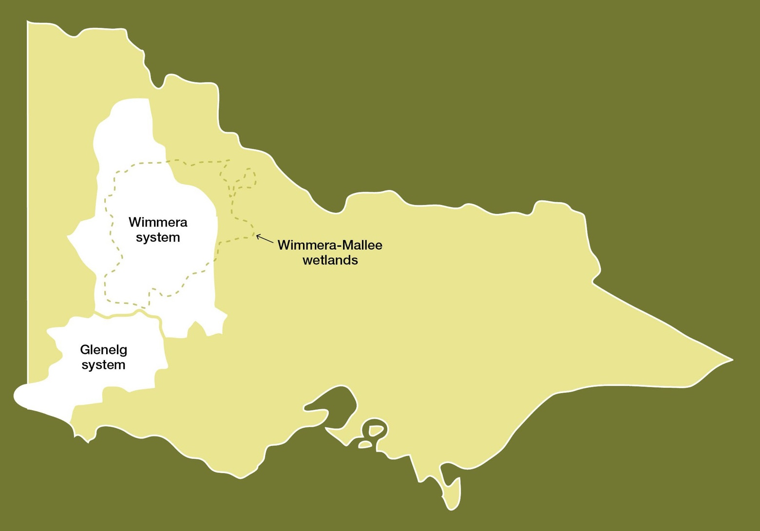

  - Western region overview 132
  - Glenelg system 139
  - Wimmera system 150
  - Wimmera-Mallee wetlands 164

Western region overview

The systems in the western region that can receive water from the VEWH’s environmental entitlements are Bochara-Bogara-Pawur (Glenelg River), the Wimmera River system and the Wimmera-Mallee wetlands. The Wimmera River system and Wimmera-Mallee wetlands are part of the Murray-Darling Basin, although Barringgi Gadyin (Wimmera River) ends in terminal lakes without directly flowing into the Murray River.
Water for the environment in the western region is supplied from the Wimmera-Mallee System Headworks, which is a series of on-stream reservoirs, off-stream storages and connecting channels that harvest water (mainly near the Grampians) and distribute it to entitlement holders throughout the Wimmera catchment and parts of the Avoca, Loddon, Glenelg and Mallee catchments.
The Wimmera and Glenelg systems share water available under the environmental entitlement, and the VEWH works with the Wimmera and Glenelg Hopkins CMAs to determine how available allocation will be used in each river in a given year. There is an additional volume of water available to the Glenelg River as a compensation flow account. The Commonwealth Environmental Water Holder (CEWH) also holds entitlement in the Wimmera system that can be used to supply the Wimmera River and lower Mount William Creek systems. Water for the environment available to the Wimmera-Mallee wetlands is provided under the same entitlement but not shared with the Glenelg system. Instead, the water is available for use in small wetlands supplied by the Wimmera-Mallee pipeline across the Wimmera, Mallee and North Central CMA areas.
Environmental values, recent conditions, objectives and planned actions for each system in the western region are presented in the system sections that follow.

Traditional Owners in the western region
Traditional Owners and their Nations in the western region have intrinsic connections to Country that have endured for tens of thousands of years. These include inherent rights and cultural obligations to Country and community.
The Barengi Gadjin Land Council Aboriginal Corporation, Dja Dja Wurrung Clans Aboriginal Corporation and Gunditj Mirring Traditional Owners Aboriginal Corporation are the Registered Aboriginal Parties for the areas incorporating waterways covered by this section of the seasonal watering plan.
The Burrandies Aboriginal Corporation (based in South Australia) currently works in partnership with the South East Aboriginal Focus Group (SEAFG) who as First Nations from the South East of South Australia have ancestral connections across Bunganditj/Boandik Country from the Limestone Coast region in South Australia to the western parts of the Glenelg River catchment in Victoria. The SEAFG ancestral connections include Tanganekald (Southern Clans), Tatiara/Ngarkat, Meintangk/ Moandik/Mootatunga/Thangal, Potaruwutij/Pinejunga, Wichantunga/Wattunga and Bunganditj/Boandik.
The SEAFG has had some engagement around Victorian water initiatives, including the 2009 Western Region Sustainable Water Strategy, the 2013 Wimmera Waterway Strategy and increased engagement through Burrandies in the Glenelg Cultural Flows discussions starting around 2017.
The Burrandies Corporation seeks to:
- Build relationships between First Nation groups through current and future engagement opportunities
- Investigate and implement reconnection of traditional/historic inland flow paths from Piccannine Ponds to the Glenelg River inlet.
Some parts of the Wimmera-Mallee wetlands area are on Barapa Barapa Country.

In 2005, the Wotjobaluk, Jaadwa, Jadawadjali, Wergaia and Jupagalk peoples, who are often referred to collectively as the Wotjobaluk Peoples and who are represented by the Barengi Gadjin Land Council, were recognised in a Native Title Consent Determination. The Barengi Gadjin Land Council also entered into an Indigenous Land Use Agreement with the Victorian and Australian governments in 2005.
In 2007, the Gunditjmara people were granted nonexclusive native title rights and interests over almost 140,000 ha of Crown land, national parks, reserves, rivers, creeks and sea in Victoria’s western district, and the State of Victoria reached an Indigenous Land Use Agreement with the Gunditjmara People that establishes how they will exercise their rights and interests in the determination area, including the Glenelg River.
In 2013, the Dja Dja Wurrung Clans Aboriginal Corporation entered into a recognition and settlement agreement under the Traditional Owner Settlement Act 2010 in Victoria. Under the agreement, Dja Dja Wurrung people have rights to access and use water for traditional purposes, providing the take of water does not affect other parties.
Return to start of section

The Eastern Maar Aboriginal Corporation is also a Registered Aboriginal Party within the geographic area, but its boundaries do not incorporate waterways managed with water for the environment in this section of the seasonal watering plan.
In the context of Treaty negotiations in Victoria and the Victorian Government’s commitment to self-determination for First Nations, program partners in the environmental watering program are aware that structural changes (such as legislative, policy and governance changes) to how water is managed may be made in the future in recognition of Aboriginal water rights. Program partners have heard for many years that Traditional Owners want empowerment and agency in water management, and in many cases, they want to manage water on Country on their own terms.

Engagement
Seasonal watering proposals are informed by community and program partner engagement, including Traditional Owner engagement. Program partners and communities help to identify priorities and opportunities for the delivery of water for the environment in the coming year.
Longer-term regional catchment strategies, regional waterway strategies, relevant technical studies (such as environmental flows studies), environmental water management plans and Traditional Owner Country plans (and associated documents) also inform seasonal watering proposals. These strategies, plans and technical reports collectively describe a range of environmental, economic, social and Traditional Owner perspectives and longer-term integrated catchment and waterway management objectives that influence environmental flows and priorities.
The VEWH and its program partners consider cultural, social, economic and recreational values and uses of waterways when planning for the delivery of water for the environment. Where possible, opportunities to support these values and uses are incorporated into watering decisions, provided they do not compromise environmental outcomes. Cultural, social, economic and recreational values considered for each system in the western region are presented in the system sections that follow.
The International Association for Public Participation’s Public Participation Spectrum (IAP2 Spectrum) has been used to categorise the levels of participation of stakeholders involved in the planning process for water for the environment. Table 4.1.1 shows the IAP2 Spectrum categories and participation goals.

Table 4.1.1 International Association for Public Participation’s Public Participation Spectrum categories and participation goals1

IAP2 level | Engagement goal
Inform | Provide balanced and objective information to assist understanding, alternatives, opportunities and/or solutions
Consult | Obtain feedback on analysis, alternatives and/or decisions
Involve | Work directly throughout a process to ensure that concerns and aspirations are consistently understood and considered
Collaborate | Partner in each aspect of the decision, including the development of alternatives and the identification of the preferred solution
Empower | Place final decision-making in the hands of the stakeholder
1 The VEWH has the permission of the International Association for Public Participation to reproduce the IAP2 Spectrum.

Tables 4.1.2, 4.1.3 and 4.1.4 show the partners, stakeholder organisations and individuals with which Glenelg Hopkins CMA, Mallee CMA, North Central CMA and Wimmera CMA engaged when preparing the Glenelg, Wimmera and Wimmera-Mallee wetlands systems’ seasonal watering proposals. This includes engagement conducted as part of developing the seasonal watering proposals as well as engagement during the preparation of key foundational documents that directly informed the proposals. VEWH staff were also consulted for operational information as part of the development of all seasonal watering proposals by CMAs.
The tables also show the level of engagement between Glenelg Hopkins CMA, Mallee CMA, North Central CMA and Wimmera CMA and stakeholders of the environmental watering program in the western region based on the CMAs’ interpretation of the IAP2 Spectrum.
The level of engagement differs between organisations and between systems, depending on the availability, capacity or interest of stakeholders to participate, roles and responsibilities of organisations in managing a site or system, and potential interaction of proposed watering with other activities on the waterway. For example, in the Wimmera region, councils have a strong involvement in environmental flows planning and delivery because they manage town weir pools in Horsham, Dimboola and Jeparit through which environmental flows must pass. Councils in the Wimmera region have also expressed a strong interest in water for the environment because of the benefits watering provides to the region’s economy, tourism and environment. Wimmera CMA works with these councils in the planning process and during the year to incorporate any aspirations or concerns. In other parts of the western region, local governments are less involved in management and may only need to be informed of the seasonal watering proposals.
External factors also influence engagement opportunities. COVID-19 restrictions reduced opportunities across the western region for face-to-face meetings with the community and Traditional Owners.
Return to start of section

Table 4.1.2 Partners and stakeholders engaged by Glenelg Hopkins Catchment Management Authority in developing seasonal watering proposals for the Glenelg system and other key foundation documents that have directly informed the proposal (grouped in alphabetical order)

Partner/stakeholder | Glenelg system
Community groups and environment groups | IAP2 level: Inform  - Friends of the Glenelg River Inc.  - Glenelg River User Group
Government agencies | IAP2 level: Collaborate  - Department of Environment, Land, Water and Planning  - GWMWater  - Natural Resources South East (South Australia)  - Parks Victoria  - Victorian Fisheries Authority  - Wimmera CMA
IAP2 level: Inform
- Limestone Coast Landscape Board
Landholders/farmers | IAP2 level: Collaborate  - Individual landholders
Local businesses | IAP2 level: Inform  - Balmoral Bush Nursing Centre  - Balmoral Local Post Office  - Glenelg River Boat Cruises  - Harrow Discovery Centre  - Nelson Boat and Canoe Hire  - Nelson River Cruises  - Paestan Canoe Hire  - Vickery Bros (sand extraction)
Recreational users | IAP2 level: Consult  - Balmoral District Angling Club  - Casterton Angling Society Inc.  - Dartmoor Angling Club  - Individual anglers  - Kayakers  - Southwest Victoria fishing reports  - Vic Bream Classics (organisers and participants)  - VRFish
IAP2 level: Inform
- Individual anglers
Traditional Owners | IAP2 level: Collaborate  - Barengi Gadjin Land Council  - Burrandies Aboriginal Corporation  - Gunditj Mirring Traditional Owners Aboriginal Corporation
Return to start of section

Table 4.1.3 Partners and stakeholders engaged by Wimmera Catchment Management Authority in developing the seasonal watering proposal for the Wimmera system and other key foundation documents that have directly informed the proposal (grouped in alphabetical order)

Partner/stakeholder | Wimmera system
Community groups and environment groups | IAP2 level: Consult  - Friends of Bungalally and Burnt Creek Group  - Lake Lonsdale Action Group  - Yarriambiack Creek Advisory Committee
Government agencies | IAP2 level: Collaborate  - Commonwealth Environmental Water Office  - Department of Environment, Land, Water and Planning  - Glenelg Hopkins CMA  - GWMWater
IAP2 level: Involve
- Hindmarsh Shire Council
- Horsham Rural City Council
IAP2 level: Consult
- Murray-Darling Basin Authority
- Northern Grampians Shire Council
- Parks Victoria
- Victorian Fisheries Authority
- Yarriambiack Shire Council
Landholders/farmers | IAP2 level: Inform  - Wimmera community members, especially landholders and stock and domestic water users
Recreational users | IAP2 level: Consult  - Dimboola Boat and Water Ski Club  - Dimboola Fishing Classic  - Dimboola Rowing Club  - Field and Game  - Hindmarsh Ski Club  - Horsham Fishing Competition Inc.  - Horsham Triathlon Committee  - Jeparit Anglers Club  - Murtoa Angling Club  - Natimuk Lake water ski club  - Paddle Victoria  - Stawell and District Angling Club  - Warracknabeal Angling Club  - Wimmera Anglers Association  - VRFish
Traditional Owners | IAP2 level: Collaborate  - Barengi Gadjin Land Council
Return to start of section

Table 4.1.4 Partners and stakeholders engaged by Mallee Catchment Management Authority, North Central Catchment Management Authority and Wimmera Catchment Management Authority seasonal watering proposals for the Wimmera-Mallee wetlands and other key foundation documents that have directly informed the proposals (grouped in alphabetical order)

Partner/stakeholder | Wimmera-Mallee wetlands
Community groups and environment groups | IAP2 level: Inform  - Berriwillock Landcare  - Birchip Landcare Group  - Birchip Cropping Group  - Cokum community group  - Community members on the Mallee CMA Land and Water Advisory Committee  - Culgoa Landcare  - Curyo-Watchupga Landcare  - Donald and District Landcare Group  - Green Lake Regional Park  - Hopetoun Landcare  - Lake Tuhum Committee  - Lalbert Landcare  - Millewa-Carwarp Landcare  - Nullawil Landcare  - Ouyen Lake Project  - OzFish Unlimited  - Sea Lake Landcare  - Ultima Landcare  - Waitche Landcare  - Wimmera Bushwalking Club  - Woomelang-Lascelles Landcare
Government agencies | IAP2 level: Collaborate  - Commonwealth Environmental Water Office  - GWMWater  - Mallee CMA  - North Central CMA  - Parks Victoria  - Wimmera CMA
IAP2 level: Inform
- Buloke Shire Council
- Department of Environment, Land, Water and Planning
- Mildura Rural City Council
- Yarriambiack Shire Council
Landholders/farmers | IAP2 level: Collaborate  - Private landholders
IAP2 level: Consult
- Wimmera-Mallee Pipeline Environmental Water Advisory Group (North Central CMA)
Local businesses | IAP2 level: Inform  - Ouyen Lake Project  - Wimmera Mallee Tourism

Partner/stakeholder | Wimmera-Mallee wetlands
Recreational users | IAP2 level: Consult  - Natimuk & District Field & Game Inc.
IAP2 level: Inform
- Recreational users in the local community
Traditional Owners | IAP2 level: Collaborate  - Barapa Barapa Nation Aboriginal Corporation  - Barengi Gadjin Land Council  - Dja Dja Wurrung Clans Aboriginal Corporation

Integrated catchment management
Altered water regimes are one of many threats to the health of Victoria’s waterways. To be effective, environmental flows need to be part of an integrated approach to catchment management. Many of the environmental objectives of water for the environment in the western region will not be fully met without simultaneously addressing issues such as barriers to fish movement, high nutrient loads, loss of streambank vegetation and invasive species.
Victorian and Australian government agencies, Traditional Owner groups, community groups and private landholders collectively implement a wide range of programs that aim to protect and improve the environmental condition and function of land, soils and waterways throughout Victoria’s catchments.
Examples of CMA on-ground works programs likely to support environmental flows outcomes in the western region include:
- fish passage works at Sandford Weir, Dergholm Gauge and Warrock are used in combination with the delivery of water for the environment to facilitate the movement of migratory fish from the estuary to the upstream reaches of the Glenelg and Wannon rivers
- installation of artificial wetland pontoons in the Dimboola weir pool and a regulating structure to reconnect Langlands Anabranch in the Horsham weir pool, as well as walking tracks to manage recreational access along the Wimmera River to reduce bank erosion
- weed and rabbit control to prevent bank erosion in the upper Wimmera catchment to improve water quality, stream form and increase native biodiversity
- stock-exclusion fencing along priority waterways throughout the Wimmera and Glenelg catchments to support the re- establishment of streamside and in-stream vegetation
- sand management, removal of excess bedload sand to improve the availability and quality of habitat for native fish, platypus and crayfish
- carp management activities in the Wimmera and Glenelg systems to reduce the number of carp and to better understand their behaviour in both rivers to help improve environmental flows outcomes
- restoration of complex habitat for native fish by installing large wood in reach 2 of the Glenelg River using red gum trunks and root balls
- control of invasive species and stock-exclusion fencing in the Wimmera-Mallee wetlands.

For more information about integrated catchment management programs in the western region, refer to the Glenelg Hopkins, Mallee, North Central and Wimmera CMA’s regional catchment strategies and regional waterway strategies.

Risk management
During the development of the seasonal watering proposals for the Glenelg, Wimmera and Wimmera-Mallee wetland systems, environmental watering program partners assessed risks associated with potential environmental flows for 2022-23 and identified appropriate mitigating strategies. Risks and mitigating actions are continually assessed by program partners throughout the year (see subsection 1.3.6).
Return to start of section

Seasonal outlook 2022-23
Rainfall in 2021-22 was close to the long-term average across much of the western region, although inflows to system storages were below the long-term average for the fifth consecutive year. In the Glenelg River, tributary inflows downstream of Rocklands Reservoir, natural baseflow and regulated passing flow maintained river connectivity throughout most of the year.Water for the environment was used to supplement summer low flow where needed and to deliver two summer freshes in reaches 1 and 2. In the Wimmera system, natural inflows delivered unregulated flow through the length of the Wimmera River from June to late December, which was the longest period of unregulated flow since 2016. A large rainfall event in early
November caused flow at Glenorchy to increase to 300-400 ML per day and triggered golden perch and silver perch spawning. Water for the environment was used to maintain drought refuges in the MacKenzie River, Burnt Creek and lower Mount William Creek throughout summer and autumn.
Water storages across the Wimmera-Mallee System Headworks were collectively at 31 percent capacity at the start of 2021-22. They rose to 44 percent in November 2021 and dropped back to 32 percent capacity at the end of April 2022. The Wimmera and Glenelg Rivers Environmental Entitlement 2010 received 59 percent allocation in May 2022. This allocation, combined with carryover, meant 49,210 ML of water for the environment was available in 2021-22. The CEWH did not receive any allocation in the Wimmera system for the fifth year in a row, and its carryover from previous years was exhausted in 2019-20.
Long-range rainfall forecasts from the Bureau of Meteorology for May to July 2022 indicate a 35 percent to 55 percent chance of falls exceeding the median rainfall across the catchment. Falls in the Grampians are expected to be below the median, which would result in low inflows to storage during this period. The storage manager has indicated that entitlement holders will receive low allocations in 2022-23 under all but wet climate scenarios and are unlikely to receive full allocations under
a wet scenario. VEWH is expecting to hold approximately 23,000 ML carryover against the Wimmera and Glenelg rivers environmental entitlement on 1 July 2022. This will be a combination of water held back when seasonal watering statements were issued to CMAs, planned actions that were met by natural flows and savings CMAs have made through the efficient use of water throughout the year. The Wimmera-Mallee wetlands received only one percent allocation by 4 May 2022 for the
2021-22 water year. Watering actions in the Wimmera-Mallee wetlands were met by carryover from previous years, and about 300 ML will be carried over to support wetland watering in 2022-23.
Annual allocations against the Wimmera and Glenelg rivers environmental entitlement alone have been less than the minimum volume needed to deliver planned watering actions in both rivers for the last four years, and carryover has been essential in helping to maintain environmental values across the western region. Unless inflows to catchment storages are significantly above average, allocations in 2022-23 are likely to be less than the total environmental demand for the year; therefore, carryover will again be prioritised to help support watering actions in 2023-24. The VEWH, in consultation with the Glenelg Hopkins and Wimmera CMAs, have agreed to prioritise between 14,000 ML and 28,000 ML for carryover at the end of 2022-23 under drought to average climate scenarios. If it is wet, then the target carryover volume may increase with water availability, boosting available supply and securing watering actions for future dry years. The VEWH will consult with the Wimmera and Glenelg Hopkins CMAs during the season and set a final target when there is sufficient information to do
so. Protecting these carryover volumes is a priority, and it will influence allocation volumes and authorised watering actions in each system during 2022-23.
The Wimmera-Mallee Pipeline wetland environmental entitlement is not expected to receive any allocation in 2022-23 under any of the drought to average climate scenarios. Therefore, all wetland watering in 2022-23 is expected to rely on carryover from 2021-22. The planned watering actions for the wetlands in 2022-23 are expected to use up to 119 ML, which will leave about 117 ML to support watering actions in future years if dry conditions continue. The current supply for the Wimmera-Mallee wetlands will only allow essential watering actions to the end of 2023-24 without new allocations.
Return to start of section

Glenelg system
Waterway manager – Glenelg Hopkins Catchment Management Authority
Storage manager – GWMWater
Environmental water holders – Victorian Environmental Water Holder and Commonwealth Environmental Water Holder

Proportions of water entitlements in the Wimmera-Mallee System Headworks held by private users, water corporations and environmental water holders on 30 June 2020
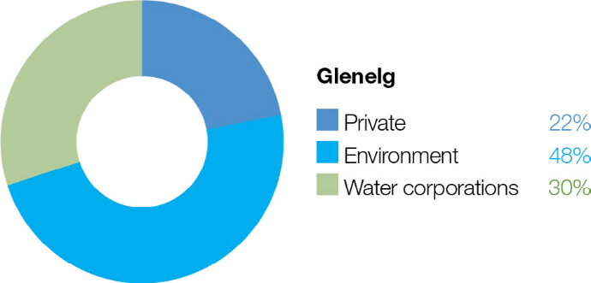

The Wimmera-Mallee System Headworks captures run-off from both the Wimmera and Glenelg catchments. Entitlements to water held in this system cannot be accounted for separately in the two river basins, so this figure shows the proportion of entitlements across both systems.

System overview

Bochara-Bogara-Pawur (Glenelg River) rises in the Gariwerd (the Grampians) and flows west through Harrow and then south to Casterton and Dartmoor (Figure 4.2.1). The Glenelg River estuary flows west from Dartmoor and passes through South Australia for a short distance before returning to Victoria and flowing into the sea at Nelson. At over 500 km, the Glenelg River is one of the longest rivers in Victoria.
Moora Moora Reservoir and Rocklands Reservoir are Wimmera-Mallee System Headworks water storages in the Glenelg River system that contribute to the supply of water to towns and properties across the Wimmera, Mallee, Glenelg, Loddon and Avoca catchments. Water for the environment is actively managed in the Glenelg River below Rocklands Reservoir. Passing- flow rules are in place for the Glenelg River and upper Wannon River.
The priority reaches of the Glenelg River that can be targeted by environmental flow releases are Rocklands Reservoir to
5-Mile Outlet (reach 1a), 5-Mile Outlet to the confluence with the Chetwynd River (reach 1b), Chetwynd River to the Wannon River (reach 2) and Wannon River to the tidal extent just below the confluence with Crawford River (reach 3). Water for the environment in the Glenelg system is released from Rocklands Reservoir for reach 1a via the reservoir wall outlet and for reaches 1b, 2 and 3 via the 5-Mile and 12-Mile outlets.
The Glenelg River estuary benefits from releases of water for the environment to upstream reaches, but releases do not currently target the estuary. Glenelg Hopkins CMA is investigating the influence of water for the environment on the Glenelg River estuary, which is listed as a heritage river reach and a site of international significance under the Ramsar Convention.
Return to start of section

Figure 4.2.1 The Glenelg system
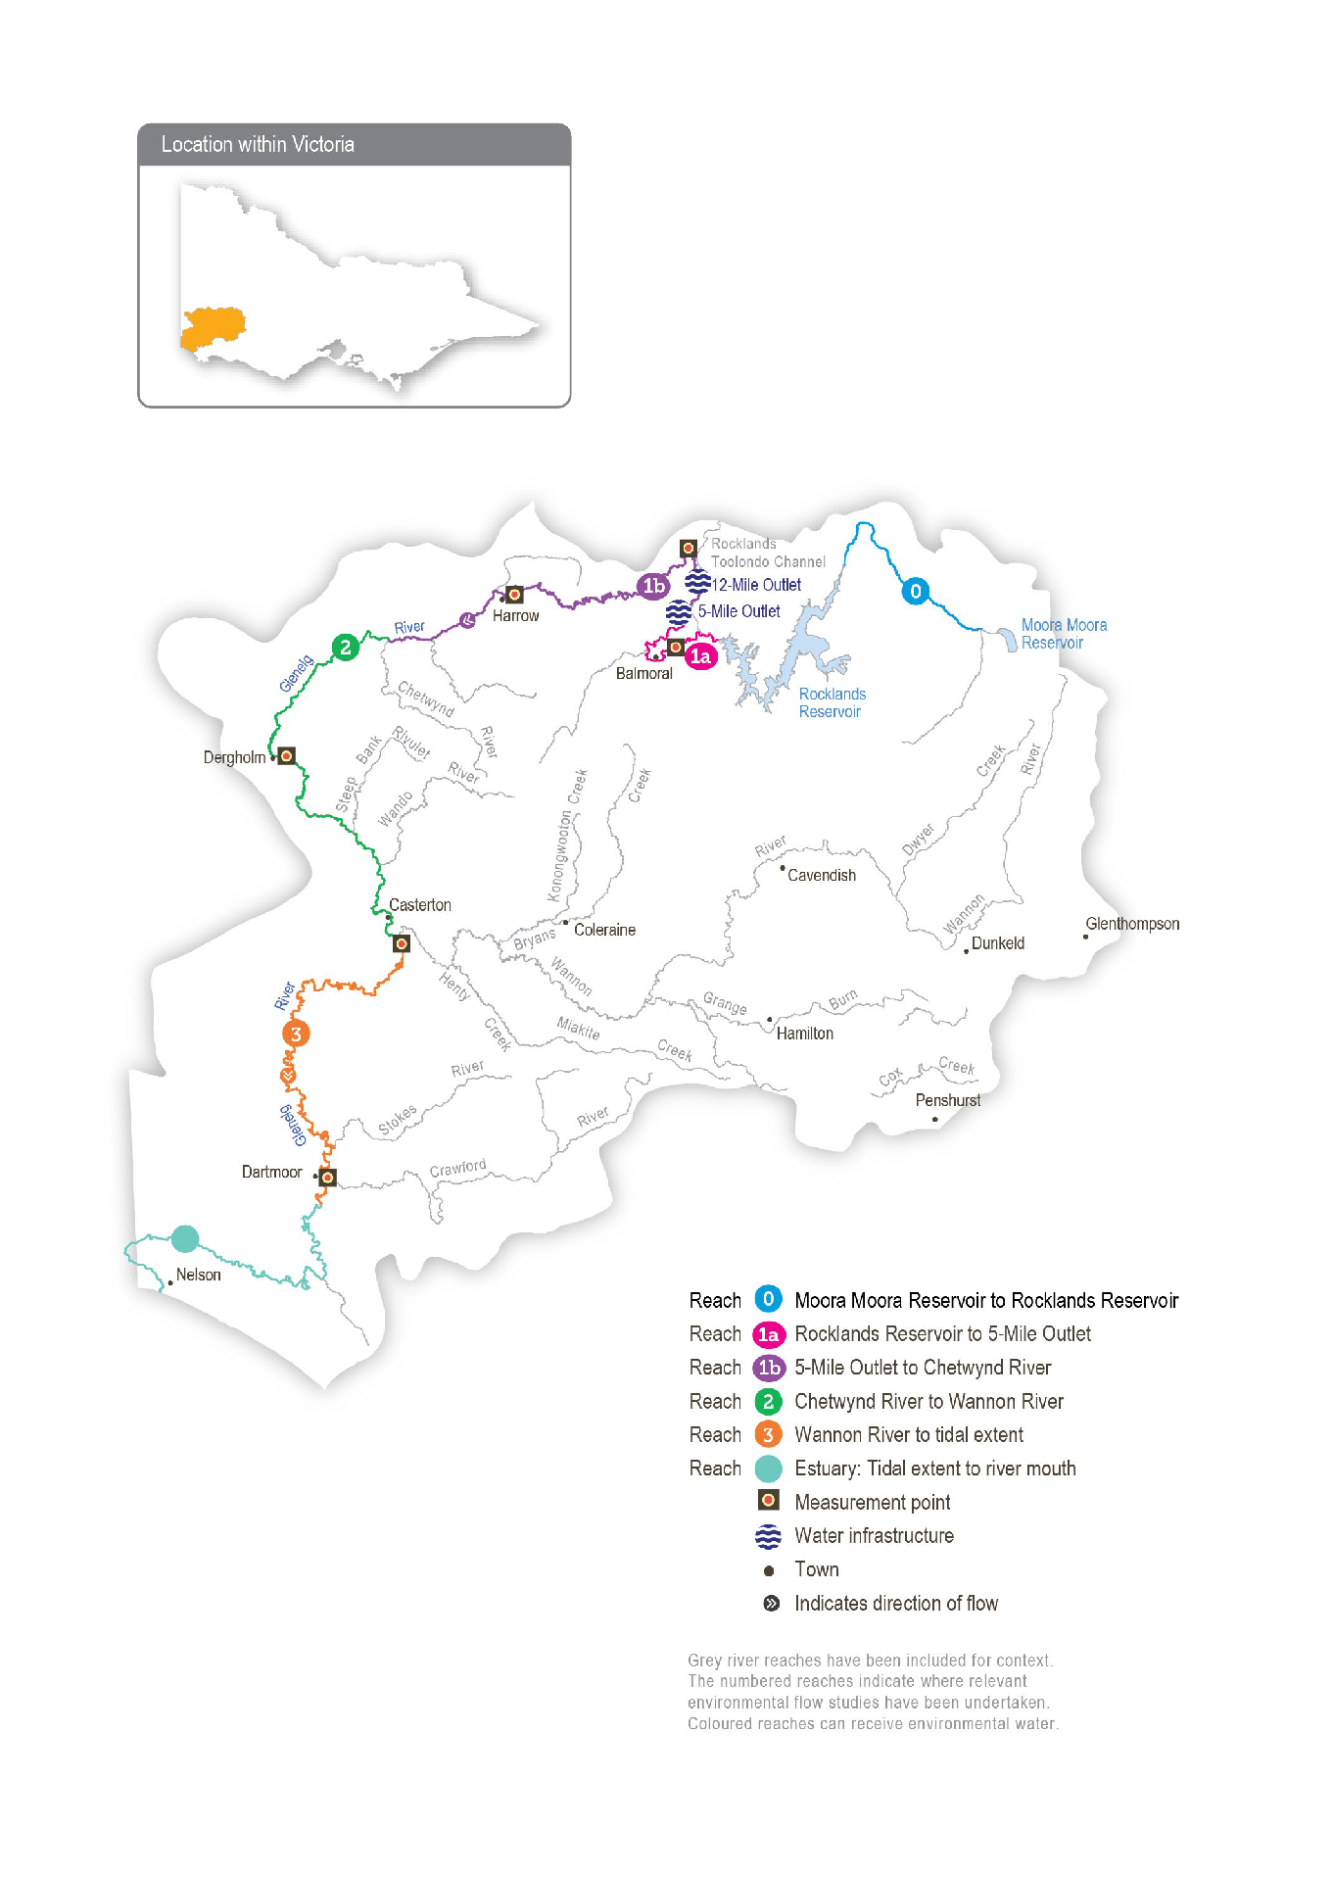
Return to start of section

Environmental values
The Glenelg River starts in the Grampians (Gariwerd) National Park and flows to the sea through the Lower Glenelg National Park. The lower reaches of the Glenelg River are part of a landscape recognised as one of Australia’s 15 national biodiversity hotspots, and the Glenelg Estuary and Discovery Bay site is Australia’s most recent listing under the Ramsar Convention.
The Glenelg River supports a range of rare and unique aquatic life, including the endangered Glenelg freshwater mussel, Glenelg spiny crayfish and a newly described species of river blackfish. It is also home to platypus and populations of native fish, including estuary perch, kooyang (short-finned eel), tupong and three species of pygmy perch, including the threatened variegated pygmy perch and Yarra pygmy perch. Some of these fish species migrate long distances to and from the Glenelg River estuary to complete their life cycles.
Frasers Swamp is another important feature of the upper Glenelg system and is home to a healthy growling grass frog population.
The Glenelg River supports a variety of streamside vegetation communities and species, including the endangered Wimmera bottlebrush. Streamside and floodplain vegetation is comprised of river red gum woodlands with paperbark, bottlebrush and tea tree understorey.

Environmental watering objectives in the Glenelg system

Icon | Environmental objectives in the Glenelg system
 | Protect, maintain and where possible enhance populations of endemic fish, including threatened and diadromous species
 | Maintain deep pool habitats and connectivity along the river
 | Maintain the platypus population
 | Maintain healthy and diverse mosaics of water-dependent vegetation (such as river red gums and Wimmera River bottlebrush)
 | Maintain a wide range and large number of waterbugs to break down organic matter and support the river’s food chain
 | Maintain water quality for native fish, waterbugs, aquatic vegetation and other water-dependent animals

Traditional Owner cultural values and uses
The Glenelg River, known as Bochara in Dhauwurd Wurrung, Pawur in Bunganditj and Bogara in Wergaia-Jadawadjali languages, is a significant feature in the cultural landscape of south-western Victoria. The river features in the region’s creation stories. Bochara-Bogara-Pawur continues to be an important place for Traditional Owners, who have inhabited the area for thousands of years, using the rich resources available along the river and the associated habitats.
In planning for environmental flows in the Glenelg River, the Gunditj Mirring Traditional Owners Aboriginal Corporation, Barengi Gadjin Land Council, Burrandies Aboriginal Corporation and Glenelg Hopkins CMA have considered:
- supporting the health of cultural heritage sites (such as scar trees, ring trees, stone structures, middens and rock paintings) and the health of native plants, which are sources of traditional foods and medicines
- that improving the health and abundance of totem species and their habitat by delivering water for the environment also benefits Traditional Owners’ spiritual wellbeing
- supporting contemporary cultural events (such as the Johnny Mullagh Cup).

Aboriginal Peoples across the Glenelg catchment have retained a strong identity and connection to the traditional lands for which they have custodial rights and responsibilities. Traditional Owners’ values in the Bochara-Bogara-Pawur system align strongly with environmental values. Traditional Owners’ values are holistic and interrelated: they are bound up with the health of the river system overall and the Country of which the river is part. Traditional Owners’ wellbeing is connected to the health of the river and of Country.
Gunditjmara Traditional Owners have identified that it is a priority to spend time on the river and increase cultural practices and connection to Country. They have highlighted the importance of increasing ceremonial and on-Country gatherings along the river, including at Casterton and Nelson.
Return to start of section

The Glenelg River Yarns website (glenelgriveryarns.com.au) was launched in late 2021 as part of the Glenelg River Cultural Flows project. The website shares cultural values and stories on a virtual tour and welcomes all visitors to Country.

Figure 4.2.2 Glenelg River Environmental Flow Seasonal Calendar

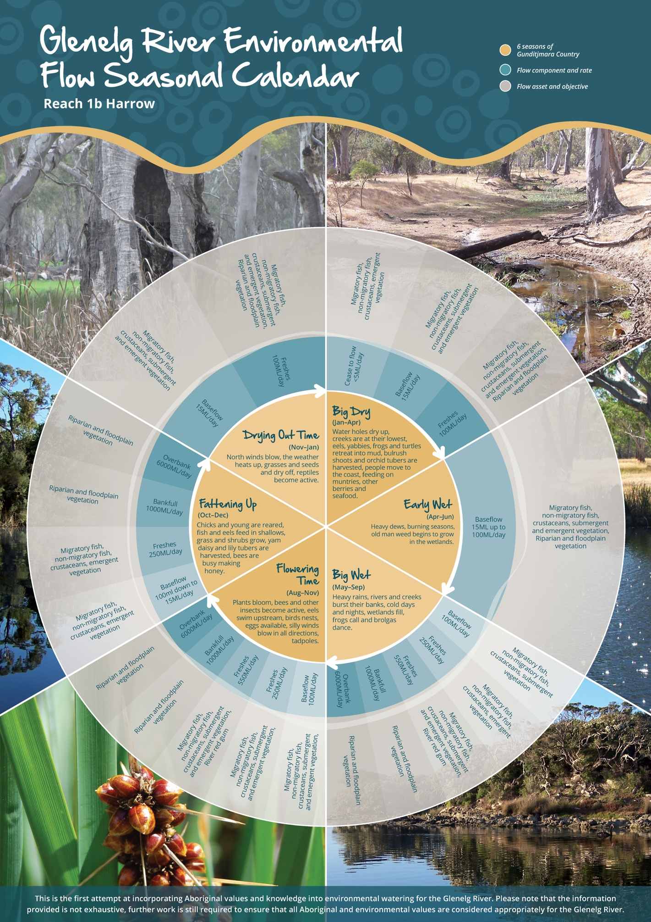
Return to start of section

Figure 4.2.2 describes the six seasons of Gunditjmara Country, and it was produced by the Gunditj Mirring Traditional Owners Aboriginal Corporation. The northern part of the river upstream of the Harrow area is in Jadawadjali Country, and the south- western part of the system is in Boandik Country. The calendar describes the six seasons alongside flow components for reach 1b of the Glenelg River — from 5-Mile Outlet to Chetwynd River — and aligns them with corresponding watering effects and objectives. The calendar reflects the seasonal flow conditions that all Traditional Owner groups recognise.
The value of the calendar is in its clear visual depiction of Traditional Owners’ knowledge, developed over many generations, of how varying flows correspond to seasonal conditions and broader environmental patterns. In recognition of this knowledge, the Gunditjmara seasons have been incorporated into Table 4.2.1 as a complementary description of the timing of potential watering actions. The six seasons will eventually be embedded in environmental flow recommendations and scenario planning in future years.
Increasing the involvement of Traditional Owners in the planning and management of environmental flows and ultimately providing opportunities to progress towards self-determination within the environmental watering program is a core commitment of the VEWH and its agency partners. This is reinforced by a range of legislative and policy commitments, including the Water Act 1989, the Victorian Aboriginal Affairs Framework, the 2016 Water for Victoria and in some cases, agreements under the Traditional Owner Settlement Act 2010.
Where Traditional Owners are more deeply involved in the planning and/or delivery of environmental flows for a particular site, their contribution is acknowledged in Table 4.2.1 with an icon. The use of this icon is not intended to indicate that these activities are meeting all the needs of Traditional Owners but is incorporated in the spirit of valuing their contribution and indicating progress towards deeper involvement.

Watering planned and/or delivered in partnership with Traditional Owners to support cultural values and uses
The timing of the summer/autumn fresh is planned to support the annual Johnny Mullagh Cup cricket match between the Gunditj Mirring and Barengi Gadjin Traditional Owners. The fresh will improve water quality in swimming holes and improve amenity for Traditional Owners attending the cricket match, which is an important cultural event on the river.

Social, recreational and economic values and uses
In planning the potential watering actions in Table 4.2.1, Glenelg Hopkins CMA considered how environmental flows could support values and uses, including:
- water-based recreation (such as canoeing and fishing)
- community events and tourism (such as the Johnny Mullagh Cup and visitation)
- socioeconomic benefits (such as for diverters for stock needs and domestic use: water levels and water quality can rely on the delivery of water for the environment, particularly in summer).
If the timing or management of planned environmental flows may be modified to align with a community benefit, this is acknowledged in Table 4.2.1 with the following icons.

Watering planned to support angling activities
Watering planned to support water sports activities (e.g. canoeing)
Watering planned to support peaks in visitation (e.g. camping or other public activities on long weekends or school holidays)
Environmental flow releases support the spawning and recruitment of popular angling species like estuary perch and bream. Local anglers continue to report increased fish activity associated with the delivery of freshes, improving fishing opportunities in the river. Releases support numerous fishing competitions, including those of the Balmoral, Casterton and Dartmoor angling clubs.
The planning of the summer fresh improves accessibility, water quality and amenity for canoeists planning trips on the Glenelg River over the summer holiday period.
Summer and spring freshes improve conditions at popular riverside campgrounds in the upper reaches of the Glenelg River, including Fulham Reserve near Balmoral and the Johnny Mullagh Reserve at Harrow.
Return to start of section

Recent conditions
Rainfall in the Glenelg catchment in 2021-22 was close to the long-term average, and consistent rain events over spring and summer contributed to significant tributary inflows below Rocklands Reservoir. However, rainfall in the catchments of the Wimmera-Mallee System Headworks storages was below the long-term average. Low storage levels at the beginning of the season coupled with limited inflows to storages meant allocations to the Wimmera and Glenelg Rivers Environmental Entitlement 2010 only reached 59 percent by early May 2022. Summer rain events provided natural freshes in the system, contributing to the maintenance of river connectivity throughout the season. Large natural flows during August peaked at
1,598 ML per day in reach 1b and 1,859 ML per day in reach 2, providing natural connections between the river and some low- lying floodplain areas.
The Glenelg system was managed under a dry climate scenario through 2021-22, with an emphasis on conserving water for carryover. Most planned watering actions were at least partially achieved through a combination of natural flows, managed passing flows and water for the environment, although results varied between reaches. Water for the environment was used to supplement summer/autumn low flows and summer/autumn freshes, particularly in reach 1b and reach 2. Flow targets were largely met in reach 1b and reach 3, which had significant inflows from local tributaries and received the most water for the environment. Most flow targets were also met in reach 2, although the natural freshes in summer and autumn were relatively small.
Small releases from Rocklands Reservoir wall outlet have little effect on downstream reaches. To conserve water in dry conditions, most water for the environment is released from Five Mile Outlet to optimise outcomes in reach 1b and reach 2. In 2020-21, water for the environment was used to supplement the natural baseflow in reach 1a to help maintain a continuous flow between Rocklands Reservoir and the estuary throughout the year. The preferred flow targets for reach 1a were generally not met due to Rocklands Reservoir affecting the natural inflow through this reach. The flow through reach 1a likely prevented significant environmental harm, but larger flows will be needed in coming years to improve environmental outcomes in that part of the river. Good flow during 2021-22 has allowed the maintenance of connection from Rocklands Reservoir to the estuary at Nelson. This flow has supported a diverse range of healthy habitats and provided beneficial dispersal opportunities required by native plants and animals throughout the Glenelg system.

Scope of environmental watering
Table 4.2.1 describes the potential environmental watering actions in 2022-23, their expected watering effects (that is, the intended physical or biological effects of the watering action) and the longer-term environmental objective(s) they support. Each environmental objective relies on one or more potential environmental watering actions and their associated physical or biological effects.

Table 4.2.1 Potential environmental watering actions, expected watering effects and associated environmental objectives for the Glenelg system

Potential environmental watering action | Expected watering effects | Environmental objectives
Winter/spring low flow in reach 1a (60 ML/day or natural during June to November) | - Maintain water quality for fish and waterbugs  - Wet aquatic vegetation to maintain its condition and prevent encroachment by terrestrial species  - Maintain shallow-water habitat for fish, waterbugs and platypus
Winter/spring low flow in reach 1b (100 ML/day or natural during June to November/Big Wet to Fattening Up1)
Winter/spring low flow in reach 2 (160 ML/day or natural during June to November)
Winter/spring low flow in reach 3 (400 ML/day or natural during June to November) | - Wet benches to increase habitat and allow widespread fish passage

Potential environmental watering action | Expected watering effects | Environmental objectives
Winter/spring fresh(es) in reach 1b (one to five freshes of 250 ML/ day for one to five days during June to November/Big Wet to Fattening Up1) | - Wet benches to improve the condition of emergent vegetation and vegetation on the riverbanks to support recruitment and growth and maintain habitat diversity  - Provide adequate depth for fish passage and cue fish movement  - Encourage female platypus to select a nesting burrow higher up the bank to reduce the risk of greater flow later in the year flooding the burrow when juveniles are present  - Scour sand from pools to improve the quality of fish habitat
Winter/spring fresh(es) in reach 2 (one to five freshes of 300 ML/ day for one to five days during June to November)
Summer/autumn low flow in reach 1a (10 ML/day or natural during December to May) | - Protect against rapid water-quality decline over the low-flow period  - Maintain edge habitats, pools and shallow-water habitat for fish, waterbugs and platypus  - Maintain a near-permanent wetted stream channel to promote the growth of in-stream vegetation and prevent encroachment by terrestrial plants
Summer/autumn low flow in reach 1b (15 ML/day or natural during December to May/Big Dry to Early Wet1)
Summer/autumn low flow in reach 2 (25 ML/day or natural during December to May)
Summer/autumn low flow in reach 3 (80 ML/day or natural during December to May)

Potential environmental watering action | Expected watering effects | Environmental objectives
Summer/autumn freshes in reach 1a (one to two freshes of 60 ML/day for two to three days during December to May) | - Flush fine silt from the stream bed and hard substrate to improve the quality of the fish and waterbug habitat  - Wet emergent vegetation on the lower banks to improve its condition and prevent the encroachment of terrestrial species  - Flush pools to improve water quality and lower temperatures  - Provide sufficient flow to allow native fish and platypus to access habitat
Summer/autumn fresh(es) in reach 1b (one to two freshes of 100 ML/day for two to three days during
December to May/Big Dry to Early Wet1)

Summer/autumn fresh(es) in reach 2 (one to two freshes of 150 ML/ day for two to three days during December to May)

Summer/autumn fresh(es) in reach 3 (one to two freshes of 150 ML/ day for three days
each or natural during December to May)

1 See Figure 4.2.2: Glenelg River Environmental Flow Seasonal Calendar.

Scenario planning
Table 4.2.2 outlines potential environmental watering and expected water use under a range of planning scenarios.

The strategy for delivering environmental flows in the Glenelg River has been developed to protect the most significant environmental values within the system and to make the best use of available water. As a result, there are some notable differences in watering priorities between reaches under each climate scenario.
Under a drought or very dry climate scenario, there will be limited water for the environment, and because the catchment will be relatively dry, deliveries will only influence conditions in the reaches close to the release point. Under these scenarios, most of the available water for the environment will be used to deliver summer/autumn low flows from Five Mile Outlet at the top of reach 1b to maintain a continuous flow between that point and Casterton, where the flow can be sustained by tributary inflows. Under a drought scenario, a low flow in reach 2 will likely be delivered at less than the recommended magnitude to conserve the available resource, but it should be possible to deliver the recommended low flow under a very dry scenario.
Return to start of section
These continuous flows will be essential to maintaining native fish and platypus populations that have recovered since the Millennium Drought.
Small volumes of water for the environment will also be used under drought or very dry conditions to deliver summer/autumn freshes to reach 1a. These flows will aim to top up key refuge pools to help small-bodied fish, macroinvertebrates and some aquatic vegetation persist in reach 1a, but they will not maintain a continuous flow through that reach. Natural inflows and cooler temperatures are likely to maintain a connecting flow through most of the system during winter and spring, even under a drought or very dry scenario, so no environmental flows are planned for those seasons.
If more water is available under dry, average and wet climate scenarios, it will be used to deliver summer/autumn freshes to as many reaches as possible and to provide a continuous flow through reach 1a to grow populations of native plants and animals. These freshes would wet streamside vegetation and provide more opportunities for fish and platypus to move through the system and increase their access to food and alternative habitats. Natural inflows under average and wet climate scenarios would deliver larger baseflows, and water for the environment may be delivered on top of these to achieve recommended low- flow magnitudes in some seasons to boost ecosystem productivity.
If more water becomes available, the next priorities under all scenarios will be to deliver winter/spring low flow and winter/ spring freshes in all reaches. These flows facilitate the migration and spawning of native fish from the upper reaches down to the estuary. Providing periods of additional or increased flow during winter/spring is likely to also support the re-establishment of small-bodied native fish populations in the upper Glenelg River and Frasers Swamp, located in reach 1.
Reserving water for carryover into the 2023-24 water year is a priority under all scenarios for the Wimmera and Glenelg Rivers Environmental Entitlement 2010. Carryover is vital to ensure there is sufficient water to deliver the highest-priority flows during summer and autumn 2023-24 if there are low allocations during the year. A range of scenarios has been discussed
for carryover targets under the entitlement. The VEWH will consult with the Wimmera and Glenelg Hopkins CMAs during the season and set a final target when there is sufficient information to do so. The target carryover volume for 30 June 2023 will be based on use during 2022-23, environmental conditions and seasonal outlooks for 2023-24.

Table 4.2.2 Potential environmental watering for the Glenelg system under a range of planning scenarios

Planning scenario | Drought | Very dry | Dry | Average | Wet
Expected river conditions | - No passing flow and low volumes of compensation and natural flow | - Low volumes of passing, compensation and natural flow | - Some passing, compensation and natural flow | - Some passing, compensation and significant natural flow, particularly in winter/spring | - Passing, compensation and natural flow meet some watering requirements in winter/spring
Predicted supply of water for the environment1 | - 25,400 ML | - 32,300 ML | - 43,500 ML | - 54,600 ML | - 64,800 ML
Glenelg River (targeting reach 1a)
Potential environmental watering – tier 1 (high priorities) | Tier 1a (can be achieved with predicted supply)
 | - Summer/ autumn freshes (two freshes) | - Summer/ autumn fresh (one fresh) | - Summer/ autumn low flow  - Summer/ autumn freshes (two freshes) | - Winter/spring low flow  - Summer/ autumn low flow  - Summer/ autumn freshes (two freshes) | - Winter/spring low flow  - Summer/ autumn low flow  - Summer/ autumn freshes (two freshes)
 | Tier 1b (supply deficit)
 | - Winter/spring low flow  - Summer/ autumn low flow | - Winter/spring low flow  - Summer/ autumn low flow  - Summer/ autumn fresh (one additional fresh) | - Winter/spring low flow | - N/A

Planning scenario | Drought | Very dry | Dry | Average | Wet
Glenelg River (targeting reach 1b)
Potential environmental watering – tier 1 (high priorities) | Tier 1a (can be achieved with predicted supply)
 | - Summer/ autumn low flow | - Summer/ autumn low flow | - Summer/ autumn low flow  - Summer/ autumn freshes (two freshes) | - Summer/ autumn low flow  - Summer/ autumn freshes (two freshes) | - Summer/ autumn low flow  - Summer/ autumn freshes (two freshes)
 | Tier 1b (supply deficit)
 | - Winter/spring low flow  - Winter/spring fresh (one fresh)  - Summer/ autumn freshes (two freshes) | - Winter/spring low flow  - Winter/spring fresh (one fresh)  - Summer/ autumn fresh (one fresh) | - Winter/spring low flow  - Winter/spring freshes (two freshes) | - Winter/spring low flow  - Winter/spring freshes (three freshes) | - Winter/spring low flow  - Winter/spring freshes (five freshes)
Glenelg River (targeting reach 2)
Potential environmental watering – tier 1 (high priorities) | Tier 1a (can be achieved with predicted supply)
 | - Summer/ autumn low flow (partial delivery) | - Summer/ autumn low flow | - Summer/ autumn low flow  - Summer/ autumn freshes (two freshes) | - Summer/ autumn low flow  - Summer/ autumn freshes (two freshes) | - Summer/ autumn low flow  - Summer/ autumn freshes (two freshes)
 | Tier 1b (supply deficit)
 | - Winter/spring low flow  - Winter/spring fresh (one fresh)  - Summer/ autumn low flow (full delivery)  - Summer/ autumn freshes (two freshes) | - Winter/spring low flow  - Winter/spring fresh (one fresh)  - Summer/ autumn freshes (two freshes) | - Winter/spring low flow  - Winter/spring freshes (two freshes) | - Winter/spring low flow  - Winter/spring freshes (three freshes) | - Winter/spring low flow  - Winter/spring freshes (five freshes)

Planning scenario | Drought | Very dry | Dry | Average | Wet
Glenelg River (targeting reach 3)
Potential environmental watering – tier 1 (high priorities) | Tier 1a (can be achieved with predicted supply)
 | - N/A |  |  | - Summer/ autumn freshes (two freshes) | - Summer/ autumn low flow  - Summer/ autumn freshes (two freshes)
 | Tier 1b (supply deficit)
 | - Winter/spring low flow  - Summer/ autumn low flow  - Summer/ autumn freshes (two freshes) | - Winter/spring low flow  - Summer/ autumn low flow  - Summer/ autumn fresh (one fresh) | - Winter/spring low flow  - Summer/ autumn low flow  - Summer/ autumn freshes (two freshes) | - Winter/spring low flow  - Summer/ autumn low flow | - Winter/spring low flow
Possible volume of water for the environment required  to achieve objectives | - 6,962 ML (tier 1a)  - 47,430 ML (tier 1b) | - 7,962 ML (tier 1a)  - 44,528 ML (tier 1b) | - 11,440 ML (tier 1a)  - 38,979 ML (tier 1b) | - 16,460 ML (tier 1a)  - 38,183 ML (tier 1b) | - 21,327 ML (tier 1a)  - 25,778 ML (tier 1b)
Priority carryover requirements1 | - 14,000 ML | - 19,000 ML | - 23,000 ML | - 28,000 ML | - 32,000 ML

1 Volume applies to the shared Wimmera and Glenelg Rivers Environmental Entitlement 2010.

Return to start of section

Wimmera system
Waterway manager – Wimmera Catchment Management Authority
Storage manager – GWMWater
Environmental water holders – Victorian Environmental Water Holder and Commonwealth Environmental Water Holder

Proportions of water entitlements in the Wimmera-Mallee System Headworks held by private users, water corporations and environmental water holders on 30 June 2020
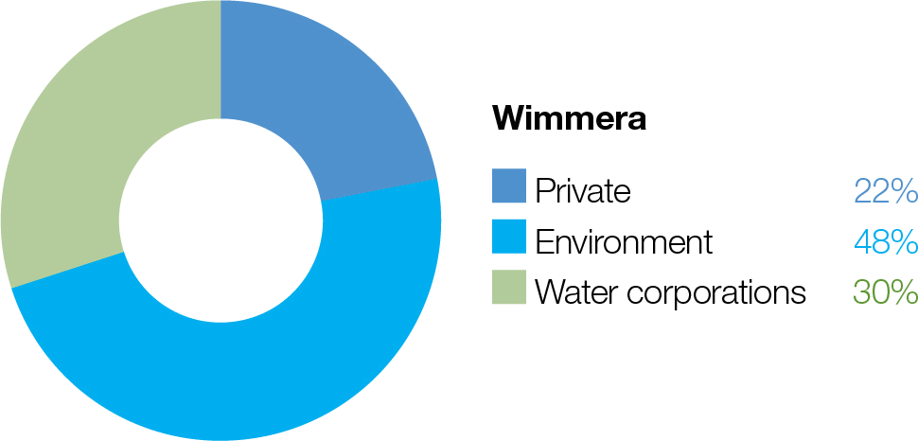

The Wimmera-Mallee System Headworks captures run-off from the Wimmera and Glenelg catchments. Entitlements to water held in this system cannot be accounted for separately in the two river basins, so this figure shows the proportion of entitlements across both systems.

System overview

Barringgi Gadyin (Wimmera River) rises in the Pyrenees Ranges near Elmhurst and flows through Horsham, Dimboola and Jeparit before terminating at Lake Hindmarsh, which is Victoria’s largest freshwater lake and the first of a series of terminal lakes. The Wimmera River receives flows from several regulated tributaries, including the MacKenzie River, Mount William Creek and Burnt Creek (Figure 4.3.1). These tributaries — Bungalally Creek and the Wimmera River below Mount William Creek — can receive water for the environment. In exceptionally wet periods, Lake Hindmarsh will overflow into Outlet Creek and on to Lake Albacutya, an internationally recognised Ramsar- listed wetland. There are numerous wetlands beyond Lake Albacutya which have not filled with water for decades.
Water in the Wimmera system is stored in three on-stream reservoirs (Lake Wartook on the MacKenzie River, Lake Lonsdale on Mount William Creek and Lake Bellfield on Fyans Creek) and in several off-stream storages (Taylors Lake, Lake Fyans and Toolondo Reservoir). A channel system enables water to be moved between several storages. Water can also be transferred from Rocklands Reservoir in the Glenelg system to the Wimmera system via the Rocklands-Toolondo Channel and from Moora Moora Reservoir via the Moora Channel. The connected storages and channels are collectively called the Wimmera- Mallee System Headworks. Water that is harvested in the system headworks is used for towns and stock and domestic supply throughout the Wimmera catchment and parts of the Avoca, Hopkins, Loddon, Glenelg and Mallee catchments. Passing flows are provided to the Wimmera River and lower Mount William and Fyans creeks.
Priority reaches in the Wimmera system that can receive water for the environment are Wimmera River reaches 3 and 4, MacKenzie River reaches 2 and 3, upper and lower Mount William Creek, upper and lower Burnt Creek and Bungalally Creek.
Yarriambiack Creek is a distributary of the upper Wimmera River that would have naturally received flow during high-flow events. Modifications to the Yarriambiack Creek offtake increase flow rates in Yarriambiack Creek compared to what would have naturally happened, but they reduce the flow rates to the high-priority reaches of the Wimmera River.
Two wetlands in the Wimmera system are also included in the environmental watering program.

Dock Lake, one of the Wimmera’s large terminal lakes near Horsham, would have naturally filled via spills from nearby Green Lake when there was significant run-off from the northern edge of the Grampians. In the 1930s, Dock Lake was modified to allow it to be used as a water storage for irrigation supply in the Wimmera-Mallee system. Dock Lake was removed from the supply system after the completion of the Wimmera-Mallee pipeline in 2010. Water can be actively delivered to Dock Lake from Green Lake via a gravity-fed channel.
Ranch Billabong, near Dimboola, is located on land managed by the Barengi Gadjin Land Council Aboriginal Corporation. The billabong was disconnected from the Wimmera River by changes to a road that traverses land between the river and the billabong. Restoring elements of the natural water regime at Ranch Billabong aims to improve habitat for native animal and plant communities and is an important outcome for Traditional Owners and their Nations.
Return to start of section

Figure 4.3.1 The Wimmera system
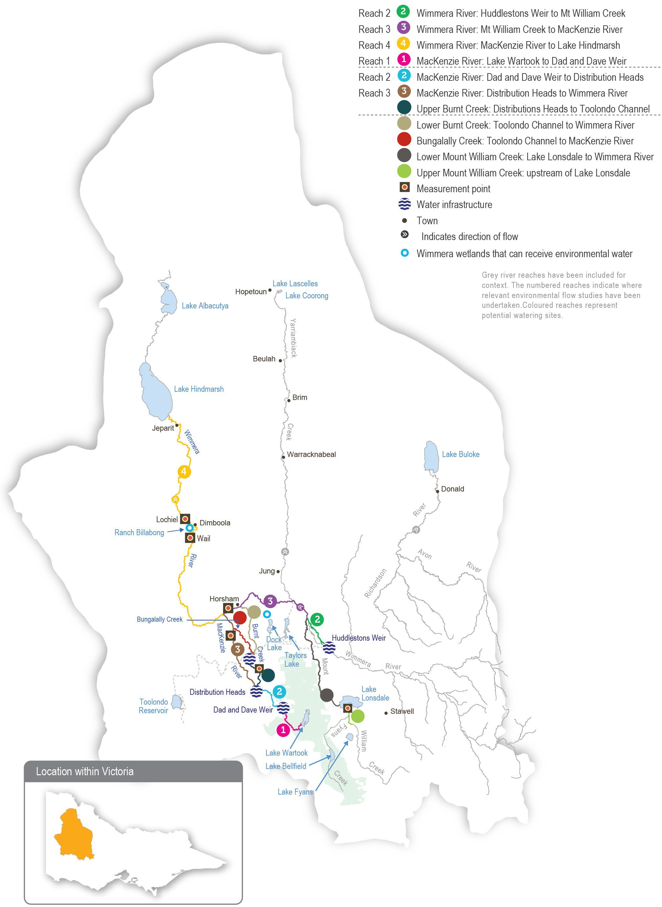
Return to start of section

Environmental values
The Wimmera River supports abundant native fish populations, including one of Victoria’s few self-sustaining populations of freshwater catfish. The Wimmera River also supports native waterbird, turtle, frog and rakali (water rat) populations.
The MacKenzie River contains the only confirmed population of platypus in the Wimmera system and supports locally important populations of native fish, including river blackfish and southern pygmy perch. It also supports populations of threatened Glenelg spiny crayfish, western swamp crayfish and turtles, as well as the critically endangered Wimmera bottlebrush. During dry periods, the middle and upper reaches of the MacKenzie River maintain regular flow (due to managed releases from Lake Wartook for urban supplies and environmental flows) and provide refuge for these populations.
Vegetation along Burnt and Bungalally creeks provides habitat corridors for terrestrial wildlife. Upper Burnt Creek contains an important native fish community and a population of threatened western swamp crayfish, which is also becoming established in lower Burnt Creek. Mount William Creek supports regionally important populations of obscure galaxias, southern pygmy perch and rakali (water rats).
Dock Lake is a natural wetland that was modified and used as part of the Wimmera-Mallee System Headworks until 2010. When it is wet, Dock Lake supports large populations of feeding and breeding waterbirds and frogs.
Ranch Billabong is a small wetland near Dimboola that supports river red gums, a variety of aquatic plant species, waterbirds and frogs.
Environmental watering objectives in the Wimmera system

Icon | Environmental objectives in the Wimmera system
 | Protect and increase populations of native fish, including one of Victoria’s few self-sustaining populations of freshwater catfish
 | Maintain the frog population by providing feeding and breeding habitat
 | Maintain channel capacity and diversity and prevent the colonisation of waterways by terrestrial plant species
 | Increase the abundance and distribution of platypus populations by providing places to breed and feed, as well as opportunities for juveniles to disperse
 | Maintain the turtle population by providing feeding and breeding habitat
 | Improve the condition, abundance and diversity of native aquatic, emergent and streamside vegetation
 | Increase the waterbird population by providing roosting, feeding and breeding habitat in floodplain wetlands
Increase the abundance and diversity of waterbugs to break down dead organic matter and support the waterway’s food web
Maintain crayfish populations by providing feeding and breeding habitat
 | Maintain water quality to provide suitable conditions for waterbugs, native fish and other water-dependent plants and animals

Traditional Owner cultural values and uses
The Wimmera’s waterways are important to the Wotjobaluk Nations, and there are heritage values throughout the landscape. Native title is held along much of the lower Wimmera River, reinforcing the cultural significance of these values. In planning for environmental flows in the Wimmera River, the Barengi Gadjin Land Council and Wimmera CMA considered these values as well as opportunities to enhance contemporary cultural events (such as the Wotjobaluk festival).
Increasing the involvement of Traditional Owners in the planning and management of environmental flows and ultimately providing opportunities to progress towards self-determination within the environmental watering program is a core commitment of the VEWH and its agency partners. This is reinforced by a range of legislative and policy commitments, including the Water Act 1989, the Victorian Aboriginal Affairs Framework, the 2016 Water for Victoria and in some cases, agreements under the Traditional Owner Settlement Act 2010.
Return to start of section

Where Traditional Owners are more deeply involved in the planning and/or delivery of environmental flows for a particular site, their contribution is acknowledged in Table 4.3.1 with an icon. The use of this icon is not intended to indicate that these activities are meeting all the needs of Traditional Owners but is incorporated in the spirit of valuing their contribution and indicating progress towards deeper involvement.

Watering planned and/or delivered in partnership with Traditional Owners to support cultural values and uses
In the Wimmera system, Wimmera CMA and the Barengi Gadjin Land Council, on behalf of the Wotjobaluk Nations, work in partnership to provide Aboriginal environmental outcomes at Ranch Billabong. The delivery of water for the environment at Ranch Billabong aims to return to a more natural flooding regime, restore indigenous plant species (such as old man weed and sneezeweed) and animal habitats, control selected weed species and improve the site’s amenity and suitability for gatherings and events (such as earth oven and bark canoe recreations).
Water for the environment has been delivered to Ranch Billabong in each of the last four years: 2018, 2019, 2020 and 2021. Notable ecological enhancements at the site include improved water quality and vegetation condition, consistent with the aspirations of the Traditional Owners. The Barengi Gadjin Land Council manages the site and has controlled weed species and enhanced accessibility by building walking tracks and culvert crossings around the billabong. More projects are planned for the future. Following on from this work, Wimmera CMA and Barengi Gadjin Land Council will continue to work together to deliver environmental water.

Social, recreational and economic values and uses
In planning the potential watering actions in Table 4.3.1, Wimmera CMA considered how environmental flows could support values and uses, including:
- water-based recreation (such as canoeing, fishing, rowing and water skiing)
- riverside recreation and amenity (such as birdwatching, cycling, running and walking)
- community events and tourism (such as fishing competitions at Dimboola, Jeparit and Horsham; Dimboola [rowing] Regatta; Kannamaroo Festival at Horsham, Wimmera River Duck Race; Wimmera River Park Run; Peter Taylor Memorial Barefoot Water Ski Tournament and Night Jump at Dimboola; and supporting small business, including chartered river cruises, pop- up food vendor caravans and general visitation)
- socioeconomic benefits (such as for diverters for irrigation, stock needs and domestic use: water levels and water quality can rely on the delivery of water for the environment, particularly in summer).
If the timing or management of planned environmental flows may be modified to align with a community benefit, this is acknowledged in Table 4.3.1 with the following icons.

Watering planned to support angling activities
Watering planned to support water sports activities (e.g. canoeing, kayaking, rowing, swimming and water skiing)
Water for the environment can be used to temporarily raise water levels in the Horsham, Dimboola and Jeparit weir pools to improve conditions for community events, including fishing competitions and water skiing and rowing events. Water for the environment held in the weir pools is released after the community events to support ecological objectives further downstream when required.

Recent conditions
The Wimmera region had near-average rainfall and above-average temperatures during 2021-22. This follows a run of four very dry years for the region. Consistent rainfall from the start of winter 2021 delivered unregulated flows from the upper catchment between June and December, which was the longest continuous period of unregulated flows in the Wimmera system since 2016. Inflows to storages to the end of January 2022 totalled 73,340 ML. This was slightly more than in recent years, but it did not significantly boost storage levels across the whole Wimmera-Mallee System Headworks. The exception was Lake Wartook, where storage levels increased to their highest level since 2017, so drought contingency plans were not required for the first time since 2018. The Wimmera and Glenelg Rivers Environmental Entitlement 2010 received 59 percent allocation to May 2022. The CEWH did not receive any allocation in the Wimmera system for the fifth year in a row, and carryover from previous years was exhausted in 2019-20.
The Wimmera system was managed in line with a dry climate scenario through 2021-22, with an emphasis on conserving water for carryover given low storage levels. All planned watering actions for the Wimmera River and Burnt Creek were largely met during 2021-22. Passing flows from Huddleston’s Weir delivered most of the required winter/spring low flows and small freshes that connected the length of the Wimmera River. A rain event in November 2021 generated a short pulse of 300-
400 ML per day at Glenorchy, which reportedly triggered spawning behaviour by golden perch and silver perch downstream
Return to start of section

of Horsham Weir. Unregulated flow met most of the planned water requirements in Burnt Creek through winter and spring, and water for the environment was used to maintain refuge habitats in the system from December onwards. Water for the environment was also used to meet planned watering actions in Ranch Billabong.
Planned watering actions in the MacKenzie River and Mount William Creek were only partially met in 2021-22 due to the limited availability of water for the environment in Lake Wartook and poor water quality in Lake Lonsdale. Water for the environment was used to deliver a minimum flow to maintain refuge pools in the MacKenzie River through summer and autumn, and accumulated passing flows were delivered from Lake Lonsdale to top up refuge pools in Lower Mount William Creek from February 2022. The inability to achieve planned watering actions in certain reaches increases the stress on environmental values in much of the Wimmera system. Without significant and sustained natural flows and increased allocations to environmental flow entitlements, the risks to environmental values in the Wimmera system will remain very high.

Scope of environmental watering
Table 4.3.1 describes the potential environmental watering actions in 2022-23, their expected watering effects (that is, the intended physical or biological effects of the watering action) and the longer-term environmental objectives they support. Each environmental objective relies on one or more potential environmental watering actions and their associated physical or biological effects.
Table 4.3.1 Potential environmental watering actions, expected watering effects and associated environmental objectives for the Wimmera system

Potential environmental watering action | Expected watering effects | Environmental objectives
Wimmera River (reach 4)
Winter/spring low flow (30 ML/day during June to November) | - Maintain access to habitat for native fish, waterbugs and in-stream vegetation
Small winter/spring fresh(es) (one to five freshes of 70 ML/day for one to four days during June to November) | - Increase water depth to provide a stimulus for fish movement  - Provide flow variability to maintain water quality and diversity of fish habitats
Medium winter/spring fresh(es) (one to three freshes of 200 ML/ day for one to three days during June to November) | - Provide variable flow during the high-flow season for fish movement  - Provide flow variability to maintain water quality and diversity of fish habitats  - Wet lower benches, entrain organic debris and maintain habitat for waterbugs and fish
Summer/autumn low flow (15 ML/day or natural during December to May) | - Maintain edge habitats in deeper pools and in-stream habitat to support native fish populations and waterbugs  - Maintain soil moisture for streamside vegetation and near-permanent inundated stream channel for aquatic vegetation and prevent the growth of terrestrial plants in the stream bed
Summer/autumn fresh(es) (one to three freshes of 70 ML/day for two to seven days during December to May) | - Flush pools to prevent a decline in water quality and to maintain habitat for fish and waterbugs  - Provide fish passage to allow fish to move through the reach

Potential environmental watering action | Expected watering effects | Environmental objectives
MacKenzie River (reach 3)
Winter/spring low flow (10 ML/day or natural) | - Maintain edge habitats and deeper pools and runs for waterbugs and platypus  - Maintain soil moisture for streamside vegetation and near-permanent inundated stream channel for aquatic vegetation and prevent the growth of terrestrial plants in the stream bed  - Maintain pool habitat for native fish and crayfish populations
Winter/spring fresh(es) (five freshes of 35 ML/ day for two to seven days during June to November) | - Stimulate fish movement by increasing flow rates and water depth and increase habitat availability for platypus and waterbugs  - Flush pools to prevent a decline in water quality  - Maintain soil moisture for streamside vegetation
Summer/autumn low flow (10 ML/day or natural) | - Maintain edge habitats and deeper pools and runs for waterbugs and platypus  - Maintain soil moisture for streamside vegetation and near-permanent inundated stream channel for aquatic vegetation and prevent the growth of terrestrial plants in the stream bed  - Maintain pool habitat for native fish and crayfish populations
Summer/autumn freshes (three to four freshes  of 35 ML/day for two to seven days each during December to May) | - Flush pools to prevent a decline in water quality and to increase habitat availability for waterbugs and native fish
Upper Burnt Creek
Winter/spring low flow (1 ML/day or natural, year-round) | - Maintain edge habitats and shallow-water habitat for waterbugs  - Maintain soil moisture for streamside vegetation and near-permanent inundated stream channel for aquatic vegetation and prevent the growth of terrestrial plants in the stream bed  - Maintain a sufficient area of pool habitat for native fish and crayfish populations
Winter/spring fresh(es) (one to five freshes of 55 ML/day for three to seven days during June to November) | - Allow fish to move throughout the reach  - Flush sediments from hard substrates to increase biofilm production and food for waterbugs
Summer/autumn low flow (1 ML/day or natural, year-round) | - Maintain edge habitats and shallow-water habitat for waterbugs  - Maintain soil moisture for streamside vegetation and near-permanent inundated stream channel for aquatic vegetation and prevent the growth of terrestrial plants in the stream bed  - Maintain a sufficient area of pool habitat for native fish and crayfish populations
Summer/autumn freshes (three freshes of 30 ML/ day for two to seven days each during December to May) | - Prevent a decline in water quality by flushing pools in the low-flow season  - Allow fish to move throughout the reach  - Flush sediments from hard substrates to increase biofilm production and food for waterbugs

Potential environmental watering action | Expected watering effects | Environmental objectives
Lower Burnt Creek
Bankfull fresh (one fresh of 45 ML/day for two days at any time) | - Inundate streamside vegetation to maintain plant condition and facilitate recruitment  - Move organic debris in the channel to support waterbugs  - Maintain the structural integrity of the channel
Overbank fresh (one fresh of 90 ML/day for one day during August to November) | - Inundate floodplain vegetation to maintain plant condition and facilitate recruitment  - Move organic debris from the floodplain to support waterbugs in the channel  - Maintain the structural integrity of the channel and floodplain
Bungalally Creek
Bankfull fresh (one fresh of 60 ML/day for two days at any time) | - Inundate the streamside zone to maintain its condition and facilitate the recruitment of streamside vegetation communities  - Maintain the structural integrity of the channel and prevent the loss of channel capacity
Upper Mount William Creek
Top-up of pools (summer/autumn) | - Maintain edge and shallow-water habitat for native fish and waterbugs  - Maintain water quality
Lower Mount William Creek
Year-round low flow (5 ML/day or natural) | - Maintain edge habitats and shallow-water habitat for waterbugs and endemic fish  - Maintain soil moisture for streamside vegetation and near-permanent inundated stream channel for aquatic vegetation and prevent the growth of terrestrial plants in the stream bed
Winter/spring fresh(es) (one to five freshes of 100 ML/day for one to seven days during June to November) | - Wet benches to entrain organic debris and allow native fish to move throughout the reach  - Flush surface sediments from hard substrates to support waterbugs  - Inundate the streamside zone to maintain its condition and facilitate the recruitment of streamside vegetation communities
Summer/autumn freshes (three freshes of 20-30 ML/day for two to seven days during December to May) | - Prevent a decline in water quality by flushing pools during low flow  - Provide variable flows and allow the movement of fish and waterbugs throughout the reach during the low-flow season
Dock Lake
Winter/spring partial fill | - Trigger the growth and germination of wet-phase wetland vegetation communities  - Support feeding and breeding habitat for waterbirds, frogs, waterbugs and turtles

Potential environmental watering action | Expected watering effects | Environmental objectives
Ranch Billabong
Top-ups (winter/spring and summer/autumn) | - Inundate wetland vegetation to maintain plant condition and facilitate recruitment  - Improve water quality for frogs and waterbirds

Scenario planning
Table 4.3.2 outlines potential environmental watering and expected water use under a range of planning scenarios.

In the Wimmera system, water for the environment is delivered to support specific ecological objectives in the different rivers and creeks. If dry conditions continue in the Wimmera system, the nature of deliveries of water for the environment to individual reaches will likely be influenced by water availability in the storages directly above each target reach. This is
especially true for the MacKenzie River, Bungalally Creek and Burnt Creek (that rely on water from Lake Wartook and Moora Moora Reservoir) and for lower Mount William Creek (which relies on water from Lake Lonsdale).

Wimmera River
The highest-priority potential watering actions in the Wimmera River under all climate scenarios are winter/spring and summer/ autumn low flows. These actions are vital to maintaining water levels and water quality in refuge pool habitat for native fish.
Under the driest scenarios, low flows will be delivered intermittently and at lower magnitudes due to low water availability. The primary objective under drought and very dry conditions will be to minimise the loss of aquatic plants and animals. In a dry scenario, there should be enough water to deliver low flows for part of each season and some small freshes to mitigate
elevated salinity and maintain the current condition of native fish populations. Under average and wet climate scenarios, there should be enough environmental flow and natural catchment flow to deliver continuous low flow throughout each season, as well as some larger, longer-duration freshes to boost the ecological health of the river.

MacKenzie River/Burnt Creek/Bungalally Creek
In the MacKenzie River and Burnt Creek, under drought and dry climate scenarios, the highest priority will be to deliver small volumes of water to critical drought refuges in Burnt Creek and reach 3 of the MacKenzie River. Such flows are vital to protect populations of native fish, platypus and crayfish that have re-established since the Millennium Drought. Under drought to dry scenarios, low flows will be delivered for as long as possible, and freshes may be delivered at less than the target magnitudes to maintain critical habitats while conserving water. Under average and wet conditions, water for the environment will be used to increase flowing habitat in both systems and deliver more frequent freshes in the MacKenzie River, to improve the health of aquatic and emergent vegetation and native fish communities. Maintaining the connection between reach 3 of the MacKenzie River and the Wimmera River is a high priority under average and wet climate scenarios to allow fish to move between the two systems, thereby growing the populations and increasing their genetic diversity. Watering actions for reach 3 of the MacKenzie River typically provide suitable flows to meet objectives in reach 2, but if extremely dry conditions prevent deliveries to reach 3, then small volumes will be delivered in reach 2 to support populations of sensitive species, including river blackfish.
A bankfull flow may be delivered to Bungalally Creek and Burnt Creek under average and wet climate scenarios to improve the health of streamside vegetation. This flow can only be delivered during periods of high flow throughout the system, so it is not considered under drier climate scenarios.

Mount William Creek
Poor water quality (in particular high salinity levels) and low water availability in Lake Lonsdale are likely to prevent the achievement of most recommended watering actions in lower Mount William Creek under drought and very dry climate scenarios. Any available water under these scenarios will be used to deliver low flows for as long as possible and small freshes to the section of lower Mount William Creek near the lake outlet. Water from Lake Fyans may be used to top up refuge pools immediately upstream of Lake Lonsdale (upper Mount William Creek) to improve water quality and habitat availability for native fish populations. Increased water availability under average or wet climate scenarios will be used to deliver a mix of low flows and freshes through the whole lower Mount William Creek system and connect it to the Wimmera River. These larger flows are necessary to allow small-bodied native fish to disperse, to help recover populations that have been affected by multiple years of below-average flow and extended cease-to-flow conditions.
Return to start of section

Ranch Billabong and Dock Lake
Under all climatic conditions, small top-ups are planned to inundate Ranch Billabong to improve water quality and support the ongoing recovery of the river red gum and associated understorey vegetation surrounding the billabong. Environmental flow objectives for Dock Lake require large volumes of water that can only be achieved with significant contributions from natural events, so delivering water for the environment is only a priority at Dock Lake under wet conditions.
Reserving water for carryover into the 2023-24 water year is a priority under all scenarios. Carryover is vital to ensure sufficient water to deliver the highest-priority flows during summer and autumn 2023-24 if there are low allocations during the year. A range of scenarios has been discussed for carryover targets under the Wimmera and Glenelg rivers environmental entitlement. The VEWH will consult with the Wimmera and Glenelg Hopkins CMAs during the season and set a final target when there is sufficient information to do so. The target carryover volume for 30 June 2023 will be based on use during 2022- 23, environmental conditions and seasonal outlooks for 2023-24.

Table 4.3.2 Potential environmental watering for the Wimmera system under a range of planning scenarios

Planning scenario | Drought | Very dry | Dry | Average | Wet
Expected river conditions | - Infrequent, unregulated flow for reach 2 of the MacKenzie River, upper Burnt Creek and lower Mt William Creek  - Regulated releases provide flows at other times and locations | - Periodic, unregulated flow for reach 2 of the MacKenzie River, upper Burnt Creek and lower Mt William Creek  - Regulated releases provide flows at other times and locations | - Periodic, unregulated flow for reach 2 of the MacKenzie River, upper Burnt Creek and lower Mt William Creek  - Regulated releases provide flows at other times and locations, apart from modest passing flow | - Regular, unregulated flow for reach 2 of the MacKenzie River, upper Burnt Creek and lower Mt William Creek  - Reasonable passing flow and unregulated releases for  the Wimmera River and lower Mt William Creek  - Regulated releases provide flows at other times and locations | - Regular, unregulated flow for reach 2 of the MacKenzie River, upper Burnt Creek and lower Mt William Creek  - Frequent passing flow and unregulated releases for  the Wimmera River and lower Mt William Creek  - Regulated releases provide flows at other times and locations
Predicted supply of water for the environment1 | - 25,400 ML | - 32,300 ML | - 43,500 ML | - 54,600 ML | - 64,800 ML

Planning scenario | Drought | Very dry | Dry | Average | Wet
Wimmera River (targeting reach 4)
Potential environmental watering – tier 1 (high priorities) | Tier 1a (can be achieved with predicted supply)
 | - Winter/spring low flow (one month)  - Summer/ autumn low flow (one month) | - Winter/spring low flow (one month)  - Summer/ autumn low flow (two months) | - Winter/spring low flow (two months)  - Small winter/ spring fresh (one fresh)  - Summer/ autumn low flow (three months)  - Summer/ autumn freshes (two freshes) | - Winter/spring low flow (four months)  - Small winter/ spring freshes (three freshes)  - Summer/ autumn low flow (four months)  - Summer/ autumn freshes (two freshes) | - Winter/spring low flow (four months)  - Small winter/ spring freshes (three freshes)  - Medium winter/ spring freshes (two freshes)  - Summer/ autumn low flow (four months)  - Summer/ autumn freshes (three freshes)
 | Tier 1b (supply deficit)
 | - Winter/spring low flow (increased duration)  - Small winter/ spring fresh (one fresh)  - Summer/ autumn low flow (increased duration)  - Summer/ autumn fresh (one fresh) | - Winter/spring low flow (increased duration)  - Small winter/ spring fresh (one fresh)  - Summer/ autumn low flow (increased duration)  - Summer/ autumn fresh (one fresh) | - Winter/spring low flow (increased duration)  - Small winter/ spring freshes (three freshes)  - Medium winter/ spring freshes (two freshes)  - Summer/ autumn low flow (increased duration) | - Winter/spring low flow (increased duration)  - Small winter/ spring freshes (five freshes)  - Medium winter/ spring freshes (two freshes)  - Summer/ autumn low flow (increased duration) | - Winter/spring low flow (increased duration)  - Small winter/ spring freshes (two freshes)  - Medium winter/ spring fresh (one fresh)  - Summer/ autumn low flow (increased duration)  - Summer/ autumn freshes (two freshes)

Planning scenario | Drought | Very dry | Dry | Average | Wet
MacKenzie River (targeting reach 3)2
Potential environmental watering – tier 1 (high priorities) | Tier 1a (can be achieved with predicted supply)
 | - Winter/spring low flow (one month)  - Summer/ autumn low flow (one month)  - Summer/ autumn freshes (four freshes) | - Winter/spring low flow (two months)  - Summer/ autumn low flow (one month)  - Summer/ autumn freshes (four freshes) | - Winter/spring low flow (two months)  - Summer/ autumn low flow (two months)  - Summer/ autumn freshes (four freshes) | - Winter/spring low flow (four months)  - Winter/spring fresh (one fresh)  - Summer/ autumn low flow (four months) | - Winter/spring low flow (four months)  - Winter/spring fresh (one fresh)  - Summer/ autumn low flow (four months)  - Summer/ autumn fresh (one fresh)
 | Tier 1b (supply deficit)
 | - Winter/spring low flow (increased duration)  - Winter/spring freshes (five freshes)  - Summer/ autumn low flow (increased duration)  - Summer/ autumn freshes (three freshes, full magnitude) | - Winter/spring low flow (increased duration)  - Winter/spring freshes (five freshes)  - Summer/ autumn low flow (increased duration)  - Summer/ autumn freshes (three freshes, full magnitude) | - Winter/spring low flow (increased duration)  - Winter/spring freshes (five freshes)  - Summer/ autumn low flow (increased duration)  - Summer/ autumn freshes (three freshes, full magnitude) | - Winter/spring low flow (increased duration)  - Winter/spring freshes (five freshes)  - Summer/ autumn low flow (increased duration)  - Summer/ autumn freshes (four freshes) | - Winter/spring low flow (increased duration)  - Winter/spring freshes (five freshes)  - Summer/ autumn low flow (increased duration)  - Summer/ autumn freshes (four freshes)

Planning scenario | Drought | Very dry | Dry | Average | Wet
Upper Burnt Creek
Potential environmental watering – tier 1 (high priorities) | Tier 1a (can be achieved with predicted supply)
 | - Winter/spring low flow (one month)  - Summer/ autumn low flow (four months) | - Winter/spring low flow (one month)  - Summer/ autumn low flow (four months) | - Winter/spring low flow (one month)  - Summer/ autumn low flow (four months) | - Winter/spring low flow  - Winter/spring freshes (five freshes, small)  - Summer/ autumn low flow (four months) | - Winter/spring low flow  - Winter/spring freshes (five freshes, small)  - Summer/ autumn low flow (four months)
 | Tier 1b (supply deficit)
 | - Winter/spring low flow (increased duration)  - Winter/spring fresh (one fresh, small)  - Summer/ autumn low flow (increased duration)  - Summer/ autumn freshes (three freshes) | - Winter/spring low flow (increased duration)  - Winter/spring freshes (two freshes, small)  - Summer/ autumn low flow (increased duration)  - Summer/ autumn freshes (three freshes) | - Winter/spring low flow (increased duration)  - Winter/spring freshes (three freshes, small)  - Summer/ autumn low flow (increased duration)  - Summer/ autumn freshes (three freshes) | - Summer/ autumn low flow (increased duration)  - Summer/ autumn freshes (three freshes) | - Summer/ autumn low flow (increased duration)  - Summer/ autumn freshes (three freshes)

Planning scenario | Drought | Very dry | Dry | Average | Wet
Lower Burnt Creek
Potential environmental watering – tier 1 (high priorities) | Tier 1a (can be achieved with predicted supply)
 | - N/A |  |  | - Bankfull fresh
Bungalally Creek
Potential environmental watering – tier 1 (high priorities) | Tier 1a (can be achieved with predicted supply)
 | - N/A |  |  | - Bankfull fresh
Upper Mount William Creek
Potential environmental watering – tier 1 (high priorities) | Tier 1a (can be achieved with predicted supply)
 | - Top-ups
Lower Mount William Creek
Potential environmental watering – tier 1 (high priorities) | Tier 1a (can be achieved with predicted supply)
 | - N/A |  |  | - Year-round low flow  - Summer/ autumn freshes (three freshes) | - Year-round low flow  - Winter/spring fresh (one fresh)  - Summer/ autumn freshes (three freshes)
Potential environmental watering – tier 1 (high priorities) | Tier 1b (supply deficit)
 | - Year-round low flow  - Summer/ autumn freshes (three freshes) | - Year-round low flow  - Summer/ autumn freshes (three freshes) | - Year-round low flow  - Summer/ autumn freshes (three freshes) | - Year-round low flow (increased duration)  - Summer/ autumn freshes (increased duration) | - Year-round low flow (increased duration)  - Winter/spring freshes (four freshes)  - Summer/ autumn freshes (increased duration)
Dock Lake
Potential environmental watering – tier 1 (high priorities) | Tier 1a (can be achieved with predicted supply)
 | - N/A |  |  |  | - Winter/spring Partial fill

Planning scenario | Drought | Very dry | Dry | Average | Wet
Ranch Billabong
Potential environmental watering – tier 1 (high priorities) | Tier 1a (can be achieved with predicted supply)
 | - Top-ups (winter/spring and summer/autumn) (one winter and one autumn top-up after drawing down if needed)
Possible volume of water for the environment required  to achieve objectives | - 6,990 ML (tier 1a)  - 29,560 ML (tier 1b) | - 7,990 ML (tier 1a)  - 28,560 ML (tier 1b) | - 11,490 ML (tier 1a)  - 26,440 ML (tier 1b) | - 16,490 ML (tier 1a)  - 21,370 ML (tier 1b) | - 21,490 ML (tier 1a)  - 24,570 ML (tier 1b)
Priority carryover requirements1 | - 14,000 ML | - 19,000 ML | - 23,000 ML | - 28,000 ML | - 32,000 ML

- Volume applies to the shared Wimmera and Glenelg Rivers Environmental Entitlement 2010.
- Potential watering actions ta rgeting reach 3 of the MacKenzie River will also benefit reach 2.

Return to start of section

Wimmera-Mallee wetlands
Waterway managers – Mallee, North Central and Wimmera catchment management authorities
Storage manager – GWMWater
Environmental water holder – Victorian Environmental Water Holder

System overview

The Wimmera-Mallee wetlands include 52 sites on public and private land spread across north-west Victoria (Figure 4.4.1). From the early 20th century until the construction of the Wimmera-Mallee Pipeline Project (WMPP) in 2010, the deeper areas of these wetlands received water most years from the open channels associated with the Wimmera Mallee Domestic and Stock Channel System.
The WMPP replaced stock and domestic supply dams with tanks, and the open-channel distribution system with pipelines, to improve water efficiency. A portion of the water savings from the WMPP was converted to an environmental entitlement to
improve the condition of the area’s flow-stressed rivers, creeks and wetlands; the rest was used to create regional development opportunities and boost the reliability of supply for other users. The WMPP reduced the amount of open-water habitat in largely agricultural areas that were formerly supplied by the open-channel system, so a separate 1,000 ML environmental entitlement was created to water some of the wetlands that were previously supplied through the channel system. There are 52 priority wetlands that can receive water from this environmental entitlement.
Water for the environment can only be delivered to the wetlands when there is sufficient capacity in the Wimmera-Mallee pipeline system, which can be affected by demand from other pipeline customers. The North Central, Mallee and Wimmera CMAs work closely with GWMWater and land managers (including Parks Victoria, the Department of Environment, Land, Water and Planning and private landowners) to take account of pipeline capacity constraints when ordering environmental deliveries to wetlands.
Return to start of section

Figure 4.4.1 The Wimmera-Mallee wetlands

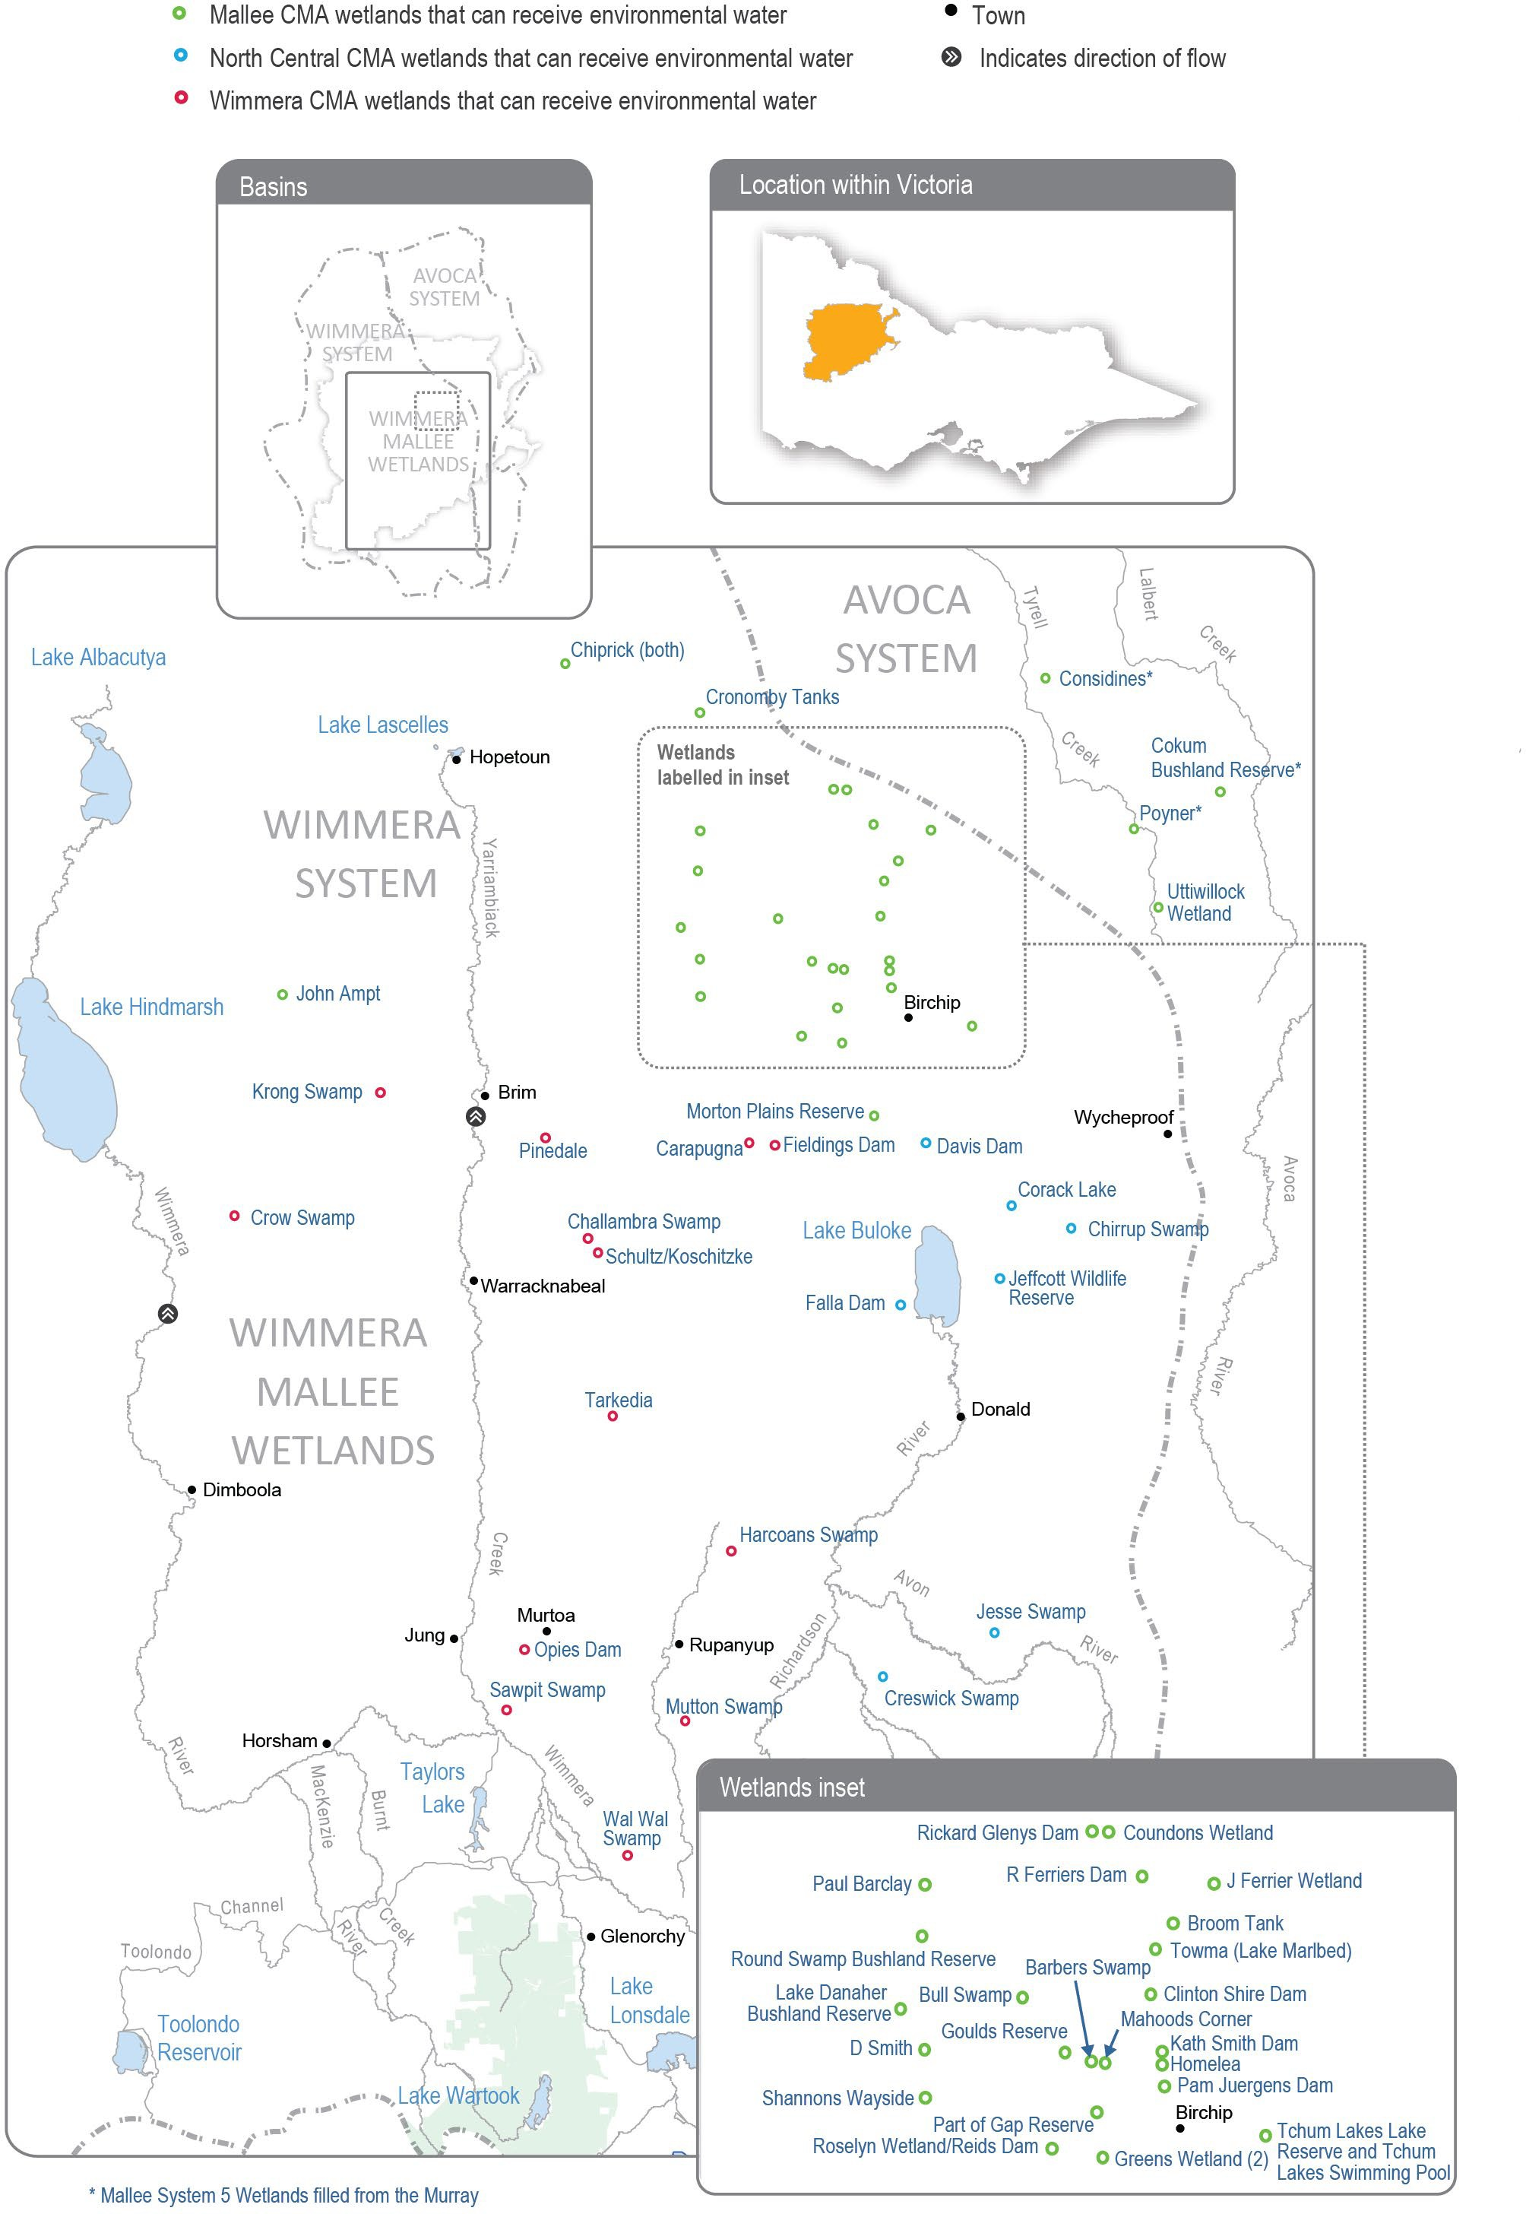
Return to start of section

Environmental values
There are many wetland types in the Wimmera-Mallee wetlands system, including freshwater meadows, open freshwater lakes and freshwater marshes. This diversity provides a range of different wetland habitats for plants and animals across the Wimmera-Mallee region. The wetlands also vary in size and support different vegetation communities. Some support native waterbird populations, including brolgas, egrets, blue-billed ducks, freckled ducks, Australian painted snipes and glossy ibis. The vulnerable growling grass frog, turtles and many other native animals may use the wetlands as drought refuges and drinking holes. Rare and vulnerable vegetation species (such as spiny lignum, ridged water-milfoil, chariot wheels and cane grass (Eragrostis australasica)) are also present in some wetlands.

Environmental watering objectives in the Wimmera-Mallee wetlands

Icon | Environmental objectives in the Wimmera-Mallee wetlands
 | Maintain and increase the population of frogs
 | Maintain and increase the population of turtles
 | Provide watering holes for native animals and terrestrial birds across the landscape
Maintain and improve the condition of aquatic and fringing plants, including lignum, river red gum and black box communities
Improve the diversity of wetland vegetation communities
 | Maintain and increase populations of waterbirds and other native birds by providing resting, feeding and breeding habitat

Traditional Owner cultural values and uses
Spanning a broad geographic area, several Wimmera-Mallee wetlands show indications of the longstanding cultural heritage and importance of these sites to the Traditional Owners of the region, including but not limited to Barapa Barapa Traditional Owners and other Traditional Owner groups represented by the Barengi Gadjin Land Council and the Dja Dja Wurrung Clans Aboriginal Corporation (trading as DJAARA). Some sites have artefacts and scar trees recorded in or adjacent to them, and further cultural surveys could better inform management of water for the environment at those sites.
The Barengi Gadjin Land Council is the Registered Aboriginal Party for a significant land area of the Wimmera-Mallee wetlands. The Barengi Gadjin Land Council represents the Wotjobaluk, Jaadwa, Jadawadjali, Wergaia and Jupagalk peoples.
In recent years, Barengi Gadjin Land Council Aboriginal Water Officers and Wimmera CMA have undertaken monitoring at Sawpit Swamp, Wal Wal Swamp, Carapugna and Mutton Swamp helping to understand environmental flow deliveries and values at the sites.
Barengi Gadjin Land Council and North Central CMA have discussed opportunities for projects that facilitate reconnection with and healing of Country. Recent meetings have highlighted several areas where collaboration is possible including on-Country events and revegetation projects. In 2022, Barengi Gadjin Land Council and North Central CMA are intending to undertake cultural values assessments at the Wimmera Mallee Pipeline wetland sites.
The Barengi Gadjin Land Council has discussed the significance of the wetlands and their aspiration to undertake work at these sites in future, and provided the following statement to Mallee CMA when discussing environmental watering:
The Wimmera-Mallee is living cultural landscape and there is a lack of recorded data regarding the cultural values over many sections of the Wimmera-Mallee Pipeline. Several highly significant places are outlined through our Country Plan, but like all places across our Country, the rivers, creeks, lakes, wetlands and swamps, and all other landscape features in this area are of high cultural significance. We wish to care for Country again through our traditional land management practices and revive and share the ancient narrative of this area. Mapping the cultural values of places along the Wimmera-Mallee pipeline will be essential in contributing to integrated catchment management.
We are unable to identify places of particular cultural values and uses confidently until Aboriginal Water Assessment/ Cultural Heritage Surveys are systematically undertaken across Wimmera-Mallee pipeline sites. All of the swamps, wetlands and soaks of this area are of high cultural significance as they are linked to Traditional trading routes that extend in all directions. It is essential that all of these places are managed correctly and water quality and biodiversity are improved (pers. comm. Barengi Gadjin Land Council, April 2021).
Return to start of section

Further discussions with Barengi Gadjin Land Council are forthcoming regarding the cultural values and uses in and around the Wimmera Mallee Pipeline wetlands (within the Mallee catchment), with an onsite visit planned for May 2022 (during the drafting of this plan).

Social, recreational and economic values and uses
In planning the potential watering actions in Table 4.4.1, the Mallee, North Central and Wimmera CMAs considered how environmental flows could support values and uses, including:
- water-based recreation (such as fishing, kayaking, swimming and yabbying)
- riverside recreation and amenity (such as birdwatching, duck and quail hunting, photography, picnicking and walking)
- community events and tourism (such as citizen science, including the collection of data about bird species and abundance, frog species and microbat recordings).

Recent conditions
Rainfall across the Wimmera-Mallee region was close to the long-term average during 2021-22, but inflows to storages in the Wimmera-Mallee System Headworks were low and did little to replenish storage levels that have been depleted by five consecutive dry years. The Wimmera-Mallee Pipeline wetland environmental entitlement received a one percent allocation as at early May 2022 for the 2021-22 water year. All deliveries of water for the environment to the wetlands in 2021-22 were supplied with water carried over from previous years.
Deliveries of water for the environment to the Wimmera-Mallee wetlands during 2021-22 were made in line with a drought climate scenario. Watering objectives for 2021-22 were almost all achieved through planned watering actions, which were achieved at 37 out of 39 target wetlands during the year. Some wetlands received water once during the season, while others received additional top-ups to maintain their water-dependent values. The only target wetlands not watered were Krong Swamp and Opie’s Dam in the Wimmera CMA region.
Incidental surveys at the Wimmera-Mallee wetlands found that water for the environment provided watering, feeding and breeding habitat for many animals (such as eastern long-necked turtles, frogs, yabbies, rainbow bee-eaters, ducks, grebes and other water and woodland birds and terrestrial species). Many wetlands had a noticeable new growth of aquatic and semi-aquatic plants, including nardoo, water-milfoil, water ribbons and cane grass. Fringing plant species, including black box, chariot wheels (a nationally threatened forb species) and lignum had new canopy growth and greater abundance at some watered wetlands. If dry conditions continue in 2022-23, water for the environment will be essential to maintain aquatic and semi-aquatic plants and provide habitat for water-dependant animal species. Under wetter conditions, water for the environment will be used to complement natural inflows and wet a larger proportion of fringing vegetation (such as black box and lignum), to improve its resilience in future dry years.

Scope of environmental watering
Table 4.4.1 describes the potential environmental watering actions in 2022-23, their expected watering effects (that is, the intended physical or biological effects of the watering action) and the longer-term environmental objective(s) they support. Each environmental objective relies on one or more potential environmental watering actions and their associated physical or biological effects.
Table 4.4.1 Potential environmental watering actions, expected watering effects and associated environmental objectives for the Wimmera-Mallee wetlands

Potential environmental watering action | Expected watering effects | Environmental objectives
Mallee wetlands
Barbers Swamp | - Provide a permanent water source for refuge and to support feeding and breeding opportunities for waterbirds and terrestrial species  - Stimulate the growth of aquatic and fringing vegetation and allow the plants, including ridged water-milfoil, black box and spiny lignum, to complete their life cycles
Bull Swamp
Goulds Reserve
Homelea
Lake Danaher Bushland Reserve
Morton Plains Reserve
Tchum Lakes Reserve (North Lake - wetland)
Tchum Lakes Swimming Pool (North Lake - dam)

Potential environmental watering action | Expected watering effects | Environmental objectives
Cokum Bushland Reserve | - Stimulate the growth of aquatic and fringing vegetation and allow the plants, including ridged water-milfoil, black box and spiny lignum, to complete their life cycles  - Provide a permanent water source for refuge and to support feeding and breeding opportunities for frogs, turtles, waterbirds and terrestrial species
Part of Gap Reserve
Rickard Glenys Dam
Broom Tank | - Stimulate the growth of aquatic and fringing vegetation and allow the plants, including black box and lignum, to complete their life cycles  - Provide a permanent water source for refuge and to support feeding and breeding opportunities for waterbirds and terrestrial species
Clinton Shire Dam
Greens Wetland
J Ferrier Wetland
Considines | - Provide a permanent water source for refuge and to support feeding and breeding opportunities for frogs and turtles
Cronomby Tanks
Newer Swamp | - Stimulate the growth of aquatic and fringing vegetation and allow the plants, including black box and lignum, to complete their life cycles
Chiprick | - Provide a permanent water source for refuge and to support feeding and breeding opportunities for frogs, waterbirds, turtles and terrestrial species
Coundons Wetland
D Smith Wetland
John Ampt
Kath Smith Dam
Mahoods Corner
Pam Juergens Dam
Paul Barclay
Poyner
R Ferriers Dam
Shannons Wayside
Roselyn Wetland | - Stimulate the growth of aquatic and fringing vegetation and allow the plants, including black box and lignum, to complete their life cycles  - Provide a permanent water source for refuge and to support feeding and breeding opportunities for waterbirds, frogs, turtles and terrestrial species
Uttiwillock Wetland
Towma (Lake Marlbed) | - Stimulate the growth of aquatic and fringing vegetation and allow the plants, including black box and lignum, to complete their life cycles  - Provide a permanent water source for refuge and to support feeding and breeding opportunities for frogs, turtles and terrestrial species

Potential environmental watering action | Expected watering effects | Environmental objectives
North central wetlands
Chirrup Swamp | - Provide a permanent water source for refuge and to support feeding and breeding opportunities for frogs, waterbirds and turtles
Corack Lake | - Provide a permanent water source for refuge and nursery habitat for turtles and frogs  - Maintain varying depths of water to support aquatic and fringing plants’ life cycles  - Maintain varying depths of water to support a variety of feeding habitats for waterbirds
Creswick Swamp | - Maintain varying depths of water to support the life cycle of aquatic plants  - Provide a permanent water source for refuge and to support feeding and breeding opportunities for frogs and turtles  - Maintain water levels to prolong wetting and ensure successful waterbird breeding events, if they start
Davis Dam | - Wet black box and rare cane grass to allow plants to complete their life cycles and support juvenile plants  - Provide a semi-permanent water source in the larger wetland footprint to support refuge and feeding and breeding opportunities for frogs  - Provide a permanent water source in the deeper pool section of the wetland for refuge and to support feeding and breeding opportunities for waterbirds and terrestrial species  - Provide a semi-permanent water source to support refuge and feeding and breeding opportunities for frogs and to support feeding and breeding opportunities for waterbirds and terrestrial species  - Maintain varying depths of water to support the life cycles of aquatic and fringing plants
Falla Dam | - Provide a permanent water source for refuge and to support feeding and breeding opportunities for frogs, waterbirds and terrestrial species  - Stimulate frog and turtle breeding by providing deep water in the spring  - Stimulate aquatic and fringing vegetation growth in winter/spring
Jeffcott Wildlife Reserve | - Maintain a minimum depth of water to support the life cycles of aquatic plants  - Provide a permanent water source for refuge and to support feeding and breeding opportunities for frogs, waterbirds and turtles
Jesse Swamp | - Maintain varying depths of water to support aquatic and fringing plant life cycles  - Provide a permanent water source for refuge and to support feeding and breeding opportunities for frogs, waterbirds and terrestrial species
Wimmera wetlands

Potential environmental watering action | Expected watering effects | Environmental objectives
Carapugna | - Provide a permanent water source for refuge and to support feeding and breeding opportunities for frogs, turtles, waterbirds and terrestrial species  - Stimulate the growth of aquatic and fringing vegetation and allow the plants, including chariot wheels, sneezeweed, ridged water-milfoil and spiny lignum, to complete their life cycles
Challambra Swamp
Crow Swamp
Fieldings Dam
Harcoans Swamp
Krong Swamp
Mutton Swamp
Opies Dam
Pinedale
Sawpit Swamp
Schultz/Koschitzke
Tarkedia Dam
Wal Wal Swamp

Scenario planning
Table 4.4.2 outlines potential environmental watering and expected water use under a range of planning scenarios.

The potential watering actions for 2022-23 have been determined by considering the environmental values, watering requirements and recent watering histories of the Wimmera-Mallee wetlands, as well as available water supply and ability to deliver water to individual sites. The list of wetlands to be watered under each scenario was determined according to the following principles.
Under drought conditions, the highest priority is to provide permanent water in the deeper sections of the wetlands to provide drought refuge for waterbirds, frogs, turtles and terrestrial animals and to support the growth and life cycles of wetland plants. Under wetter scenarios, water for the environment may be delivered, depending on the capacity in the pipeline system, to water larger areas of the wetland. Large rainfall events and catchment inflows may partially or completely fill some wetlands, and water for the environment may be used to top up, fill or overtop wetlands to improve fringing wetland plant communities and provide additional habitat for waterbirds, frogs and turtles.
Allocations to the environmental entitlement that supplies the wetlands in the Wimmera-Mallee wetland system are highly variable, and the ability to carry over unused water from one year to another allows waterway managers and the VEWH to effectively manage the systems in dry periods. Reserving water for carryover into the 2023-24 water year will be a priority under all scenarios to ensure sufficient water is available to support critical environmental demands in 2023-24 and beyond. The volume carried over against the Wimmera-Mallee Pipeline wetlands environmental entitlement will be decided in consultation with the North Central, Mallee and Wimmera CMAs during the year. It will be based on use during 2022-23, climactic conditions and seasonal allocation outlooks for 2023-24.
Return to start of section

Table 4.4.2 Potential environmental watering for the Wimmera-Mallee wetlands under a range of planning scenarios

Planning scenario | Drought | Dry | Average | Wet
Predicted supply of water for the environment | - 256 ML | - 273 ML | - 566 ML | - 1,375 ML

Planning scenario | Drought | Dry | Average | Wet
Potential environmental watering –  tier 1 (high priorities) | - Barbers Swamp  - Broom Tank  - Bull Swamp (Bulls Swamp)  - Carapugna  - Challambra Swamp  - Chiprick (both)  - Chirrup Swamp  - Clinton Shire Dam  - Considines  - Corack Lake  - Coundons Wetland  - Creswick Swamp  - Cronomby Tanks  - Crow Swamp  - D Smith Wetland  - Davis Dam  - Falla Dam  - Fieldings Dam  - Goulds Reserve  - Greens Wetland (2)  - Harcoans Swamp  - Homelea  - J Ferrier Wetland  - Jeffcott Wildlife Reserve  - Jesse Swamp  - Kath Smith Dam  - Lake Danaher Bushland Reserve  - Mahoods Corner  - Morton Plains Reserve  - Mutton Swamp  - Newer Swamp (Round Swamp) | - Barbers Swamp  - Broom Tank  - Bull Swamp (Bulls Swamp)  - Carapugna  - Challambra Swamp  - Chiprick (both)  - Chirrup Swamp  - Clinton Shire Dam  - Cokum Bushland Reserve  - Considines  - Corack Lake  - Coundons Wetland  - Creswick Swamp  - Cronomby Tanks  - Crow Swamp  - D Smith Wetland  - Davis Dam  - Falla Dam  - Fieldings Dam  - Goulds Reserve  - Greens Wetland (2)  - Harcoans Swamp  - Homelea  - J Ferrier Wetland  - Jeffcott Wildlife Reserve  - Jesse Swamp  - John Ampt  - Kath Smith Dam  - Lake Danaher Bushland Reserve  - Mahoods Corner  - Morton Plains Reserve | - Barbers Swamp  - Broom Tank  - Bull Swamp (Bulls Swamp)  - Carapugna  - Challambra Swamp  - Chiprick (both)  - Chirrup Swamp  - Clinton Shire Dam  - Cokum Bushland Reserve  - Considines  - Corack Lake  - Coundons Wetland  - Creswick Swamp  - Cronomby Tanks  - Crow Swamp  - D Smith Wetland  - Davis Dam  - Falla Dam  - Fieldings Dam  - Goulds Reserve  - Greens Wetland (2)  - Harcoans Swamp  - Homelea  - J Ferrier Wetland  - Jeffcott Wildlife Reserve  - Jesse Swamp  - John Ampt  - Kath Smith Dam  - Lake Danaher Bushland Reserve  - Mahoods Corner  - Morton Plains Reserve | - Barbers Swamp  - Broom Tank  - Bull Swamp (Bulls Swamp)  - Carapugna  - Challambra Swamp  - Chiprick (both)  - Chirrup Swamp  - Clinton Shire Dam  - Cokum Bushland Reserve  - Considines  - Corack Lake  - Coundons Wetland  - Creswick Swamp  - Cronomby Tanks  - Crow Swamp  - D Smith Wetland  - Davis Dam  - Falla Dam  - Fieldings Dam  - Goulds Reserve  - Greens Wetland (2)  - Harcoans Swamp  - Homelea  - J Ferrier Wetland  - Jeffcott Wildlife Reserve  - Jesse Swamp  - John Ampt  - Kath Smith Dam  - Lake Danaher Bushland Reserve  - Mahoods Corner  - Morton Plains Reserve
 | - Opies Dam  - Pam Juergens Dam  - Part of Gap Reserve (Stephen Smith Dam)  - Pinedale  - Poyner  - R Ferriers Dam  - Rickard Glenys Dam  - Roselyn Wetland/ Reids  - Dam Schultz/ Koschitzke | - Mutton Swamp  - Newer Swamp (Round Swamp)  - Opies Dam  - Pam Juergens Dam  - Part of Gap Reserve (Stephen Smith Dam)  - Paul Barclay  - Pinedale  - Poyner  - R Ferriers Dam  - Rickard Glenys Dam | - Mutton Swamp  - Newer Swamp (Round Swamp)  - Opies Dam  - Pam Juergens Dam  - Part of Gap Reserve (Stephen Smith Dam)  - Paul Barclay  - Pinedale  - Poyner  - R Ferriers Dam  - Rickard Glenys Dam | - Mutton Swamp  - Newer Swamp (Round Swamp)  - Opies Dam  - Pam Juergens Dam  - Part of Gap Reserve (Stephen Smith Dam)  - Paul Barclay  - Pinedale  - Poyner  - R Ferriers Dam  - Rickard Glenys Dam

Planning scenario | Drought | Dry | Average | Wet
 | - Shannons Wayside  - Tarkedia Dam Tchum  - Lakes Lake Reserve (North Lake - wetland)  - Towma (Lake Marlbed)  - Uttiwillock Wetland  - Wal Wal Swamp | - Roselyn Wetland/ Reids Dam  - Schultz/Koschitzke  - Shannons Wayside  - Tarkedia Dam  - Tchum Lakes Lake Reserve (North Lake  - wetland)  - Towma (Lake Marlbed)  - Uttiwillock Wetland  - Wal Wal Swamp | - Roselyn Wetland/ Reids Dam  - Schultz/Koschitzke  - Shannons Wayside  - Tarkedia Dam  - Tchum Lakes Lake Reserve (North Lake  - wetland)  - Towma (Lake Marlbed)  - Uttiwillock Wetland  - Wal Wal Swamp | - Roselyn Wetland/ Reids Dam  - Schultz/Koschitzke  - Shannons Wayside  - Tarkedia Dam  - Tchum Lakes Lake Reserve (North Lake  - wetland)  - Towma (Lake Marlbed)  - Uttiwillock Wetland  - Wal Wal Swamp
Possible volume of water for the environment required  to achieve objectives | - 119 ML | - 156 ML | - 213 ML | - 279 ML
Return to start of section

