25 October 2022
COOPERATIVE PLANS TO IMPROVE WETLANDS, REDUCE RABBITS AND INCREASE AGRICULTURAL PRECISION

Landcare Facilitators working within the upper Wannon & Hopkins River catchment area have secured funding for two new projects under the Victorian Government’s Our Catchments Our Communities program.

The OCOC project focuses on improving catchment health and climate resilience through activities that support wetland cultural knowledge, health and connectivity in the upper Wannon and Hopkins River catchments.

Funding was recently announced for two major regional projects to be delivered by four Landcare facilitators will focus on improving rabbit control and precision agriculture around wetlands.

The large scale partnership projects between four Landcare facilitator areas and will include participation by landholders within the Beyond Bolac Catchment Action Group, the Upper Hopkins Land Management Group, and the Panyyabyr, Mirranatwa, Bunnugal, Glenthompson, Mooralla, Bulart, Beaufort, Skipton, Lake Goldsmith and Stoneleigh Landcare groups.

The $80,000 Protecting Wetlands Together with effective, efficient landscape scale rabbit control project will help community work together to reduce rabbit populations in a cooperative, humane, effective and efficient manner over the next two years.

Landholders will identify, mark and map warrens, for contractors to undertake control works and landcare facilitators coordinate the approach when it is undertaken in February to April next year, followed by ongoing monitoring for 12 months to reduce reinfestation.

The 8-month Protecting Wetlands Together with Precision Ag project has been funded for almost $40,000 as part of the Our Catchment Our Communities Landscape Scale Grants.

This project aims to provide clarity on what precision ag strategies and software is currently being used within the OCOC region and inspire cropping farmers and agronomists to consider precision ag strategies to protect and manage wetlands. A survey will be circulated to cropping farmers to during October and November to gather this information.

Those wanting to be part of the OCOC Precision Ag Advisory Group will have the opportunity to learn about the latest technology available for precision ag by attending the Agrifutures Evoke AG ‘Down to Earth’ conference in Feb 2023 and workshops to explore what precision ag strategies could be used to protect and manage wetlands within a cropping system.

Landholders wishing to participate in these projects should contact their local Landcare facilitator.

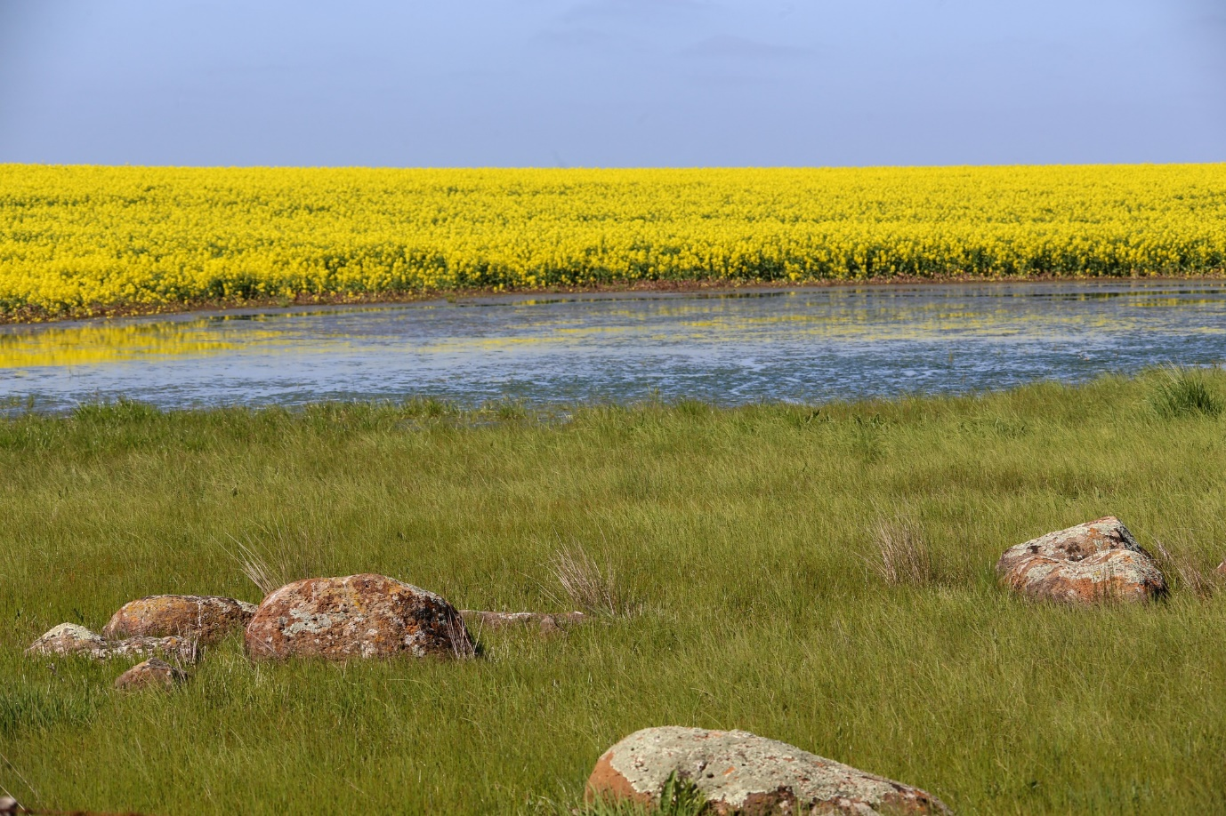
CAPTION: Using precision agriculture techniques to help farmers crop around wetlands, rather than through them is a focus of a new cooperative project in Victoria’s southwest.

