OCOC Landscape Scale Grants - Round 2
Guidelines for Applications

Purpose of grant:
The Glenelg Hopkins CMA’s Our Catchments Our Communities project focuses on looking after Country – valuing wetlands in the agricultural landscape of the Greater Grampians (Gariwerd) through strategic partnerships to improve catchment health.

The Our Catchment Our Communities (OCOC) Landscape Scale grants are to enable Landcare groups to work together and deliver or facilitate the delivery of landscape scale projects to improve stewardship of wetlands, including seasonal herbaceous wetlands and build on the legacy of the previous OCOC program and draw on the outcomes of (1) social science study of farming and cropping behaviour (2) the wetland connectivity study carried out across the Greater Grampians region.

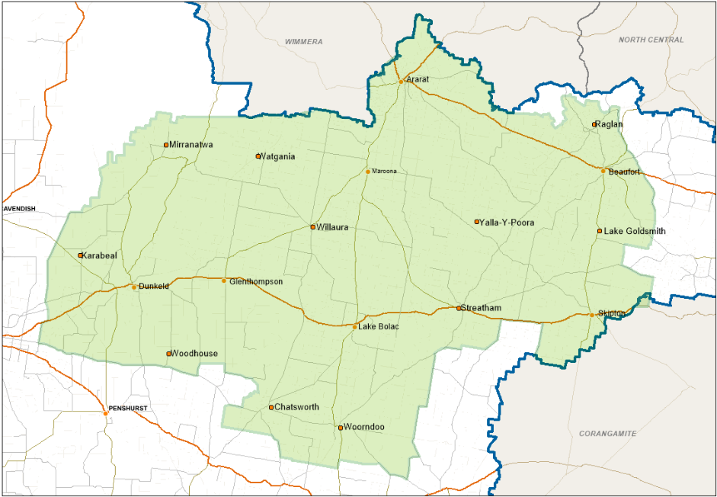
Figure 1. The Our Catchments Our Community Glenelg Hopkins CMA focus area (green) eligible for the OCOC Landscape scale grants
The grants will be for projects of up to 13 months (finishing by 31st May 2024) for a minimum of $20,000 and a maximum of $60,000 GST exclusive.
Collaboration of multiple Landcare groups across the focus region is encouraged.

Projects must be in the OCOC (Greater Grampians Region) focus region (green area figure 1).
Project areas of focus must align with the following funding output activities:

- On ground outputs that lead to improved management and condition of wetlands and wetland connectivity (landscape scale pest and weed management, hydrological restoration/investigation, fencing and revegetation alongside other key environmental management actions)
  - Non-woody weed and pest animal (herbivore) control: area in hectare where control implemented
  - Native indigenous vegetation planting: area in hectares planted
- Implementation of sustainable agricultural practice and agricultural practice change – removal or modification of cropping on wetlands, reintroduce groundcover, nutrient management, removal of drainage.
- Cultural Understanding - support the protection of cultural heritage and inclusion of cultural values in wetland management.
- Wetland assessment including ecological, threatened species, flora and fauna
- Increase understanding of the economic value and benefit of (cost/benefit data) sustainable agriculture practice and wetland management
  - Investigate or research the contribution of wetlands to agriculture
  - Gather data, information and case studies that evidence the cost/benefit of the contribution of sustainable agriculture and wetlands to agricultural productivity.

NB: Any wetland hydrological restoration will need an approved implementation plan from Glenelg Hopkins CMA.

Out of scope activities:
On-ground works on or around wetlands outside of the OCOC project focus area are deemed out of scope. Works that could cause adverse effects on wetland function or integrity or are not aligned with environmental best practice will not be considered for funding under this project.
Engagement events that do not support NRM knowledge, Traditional Owner and Cultural Heritage knowledge or highlight environmental achievements, current projects and innovations will not be considered for funding.
What will not be funded
- Amenity and beautification projects
- Boundary fencing
- Barbed wire fencing
- Non-indigenous vegetation
- Vegetation corridors less than 10 metres wide. Minimum project width of 10 metres is required (minimum 10 metres from the top of the bank in riparian areas)
- Purchase of capital items over $3,000
- Project management or administration costs that collectively total more than 15% of total funding requested
- Computers, laptops, and smartphones
- Purchase of goods for competitions, prizes, giveaways, vouchers, or alcohol
- Any other action of activity determined by the Assessment Panel through the assessment process to be an inappropriate or unsuitable use of the funds.
Eligible Landcare Groups
These grants are available to community-based Landcare groups working within the OCOC focus region (see map). Eligible Applicants: must be an incorporated body, community based, not-for-profit Landcare group or network or other volunteer community environmental organisation such as “Friends of....” etc.
Ineligible Applicants: Proprietary limited companies, committees of management, individuals, non-government organisations (NGOs) and government authorities.

More than one project grant application can be submitted by a group/network.

These projects require effective management and oversight, if Landcare groups identify that this work is above their current activity commitments there is up to 15% of the total project budget to fund project management. Groups should include this in their proposals.

How to apply
- Provide a description (<500 words) of the proposed project and the activities you are seeking funding for.
- Provide a simple timeline of the stages/milestones of the project, demonstrating completion of the project by 31st May 2024 and provision of the final report before 30th June 2024.
- Details of the number and type of engagement events and publications (written or visual), these outputs will form part of the assessment and final contract deliverables.
- Provide a detailed budget, both in-kind and funds requested, and a short description of each activity. Include any quotes, estimates and calculations for how you have arrived at project costs.
- Provide a risk assessment for delivery of the project and how it will address any potential conflicts of interest.
- Provide a MERI plan outlining how project outputs and outcomes will be measured
- Groups can submit more than one application or be a partner in more than one application.
- Complete application form and submit to tenders@ghcma.vic.gov.au10th March 2023.
- The OCOC Project Manager will be available to provide general advice on activity eligibility and the application process.
- The OCOC Project Manager will remain removed from the assessment process.
- Applicants may be contacted by the grant assessment panel for clarification and/or refinement of the grant application

Indicative grant timeline
Applications open | 13th January 2023
Applications close | 10th March 2023
Applications assessed | 17th March 2023
Outcome notification | 27th March 2023
Contracts signed | 28th April 2023
Projects completed | 31st May 2024
Final report submitted | 30th June 2024

Criteria
Applications will be assessed by an assessment panel against the following criteria:

Extent to which the project builds on previous OCOC work or studies across the OCOC focus area - evidence that the project is needed.
The area (Ha) that will, through direct investment, have improved agricultural practice (for relevant projects)
The number of Landcare groups involved, and area of focus region covered
Is the proposal practical and appropriately planned
The adequacy of the risk assessment for delivery of the project and how it will address any potential conflicts of interest.
Experience in managing and delivering large grants and shows a capacity to deliver in the required timeframe.
Demonstrates good value for money, including realistic costs and a clear justification for requested budget items.

All selection criteria are weighted equally.

Cultural Heritage
All Aboriginal cultural heritage places and objects in Victoria are protected by law under the Aboriginal Heritage Act 2006. It is against the law to disturb, damage or destroy an Aboriginal cultural heritage place or object.
As part of the Grant process all proposed activities in areas of cultural heritage sensitivity (generally but not exclusively on waterways) will require that a cultural heritage search (ACHRIS) is undertaken, to identify if registered cultural heritage places or objects exist in the works area. CMA will support the ACHRIS search for funded projects.
Where registered cultural heritage is found to be present, proposed activities must be modified or moved so that disturbance or damage does not occur, or a Cultural Heritage Management Plan (CHMP) developed. Further advice will be sought from the relevant Registered Aboriginal Party (Eastern Maar Aboriginal Corporation or Wadawurrung Aboriginal Corporation) or First Peoples-State Relations (formerly Aboriginal Victoria).
Landowner Support
Where possible you will need to provide landowner details (name and address) in your application for all private properties where on-ground works will be taking place. If your application is successful, you will be required to confirm that you can provide, upon request, evidence of private landowner’s consent for on-ground works to take place.

Reporting Requirements
A mid and end of financial year project report will be required, with Glenelg Hopkins CMA providing relevant templates.

Occupational Health and Safety
You must have a safe system of work in place for your project to protect the health and safety of your group, volunteers and anyone else on the project site. You can find resources on OHS tailored to community groups on:
- Victorian Landcare Gateway
- Victorian Workcover Authority

If Your Application is Successful
If your organisation is successful then you will have ten working days after receipt of the letter of offer, including the funding agreement, to submit your organisation’s signed funding agreement, and any other documentation outlined in the letter of offer. If the documentation is not submitted within this timeframe, the funding may be reallocated to other projects.

Successful applicants will receive payment once all paperwork has been completed and submitted.

Funding Conditions
Successful applicants are required to:
- Enter into a funding agreement with Glenelg Hopkins CMA.
- Be responsible for meeting contractual obligations to delivery the project by 31st May 2024, and submit the final report by 30th June 2024.
- Adhere to all relevant legislation including Occupational Health and Safety requirements
- Acknowledge the GHCMA and Victorian Government funding in publications and promotions.

Monitoring of performance and project delivery will occur regularly over the course of the contract. GHCMA can cancel the contract at any time due to under performance.

Reports from the previous OCOC program referred to above are:

Curtis, J., Meis-Harris, J. (2020). Cropping and wetlands in south-west Victoria: Exploring opportunities for cropping and wetland protection to co-exist on private land. BehaviourWorks Australia, Monash University.

DELWP (2021) DELWP Output Data Standard, core standard for Natural Resources Management Reporting. Department of Environment, Land, Water and Planning, Victoria State Government. DELWP_Output_data_Std_v3.0_Final_Web_Approved_1.pdf (water.vic.gov.au)

Farrington L, Cranswick R, Elotrovic E and Kerr G (2020). Wetlands Spatial Analysis. Report for Glenelg Hopkins CMA. Nature Glenelg Trust, Mount Gambier, South Australia.

For further information or copies of these reports please contact:

Jan Barton, Land health Officer, Glenelg Hopkins CMA
Phone: 0436 628 541 or 5571 2526
Email: j.barton@ghcma.vic.gov.au

