Swamp Stewardships: Greater Grampians Region

Expressions of Interest
Do you live in the Greater Grampians region (Figure 1)? Do you have swampy/boggy areas on your farm? Did they wet up last year after being dry? Would you like to know how to manage them to benefit your farm productivity? Would you like hear about how you can be paid to manage them?
The Glenelg Hopkins CMA’s Our Catchments Our Communities (OCOC) project can help with that through partnerships to support stewardship of temporary swamps.
The OCOC region is also a landscape of swamps where agriculture is important in. Swamps are the sumps of the farm, providing drainage, summer green pick and habitat not only for brolgas and frogs but animals and insects that eat crop pests. Healthy swamps can still be part of a productive farm, and with the right support can be achieved quite easily.
Funding is available to farmers who own property in the green area in Figure 1 to manage their temporary swamps and increase sustainable production. The support is for assessing and better understanding swamps on your farm through to stewardship agreements with longer term financial incentives for wetland management and/or restoration.
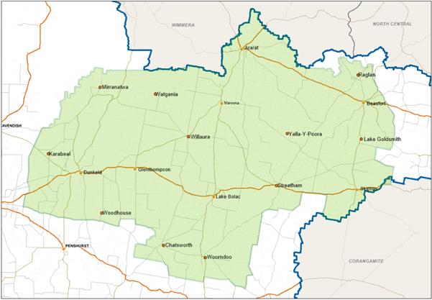
Figure 1. The Glenelg Hopkins CMA Our Catchments Our Community focus area (green) eligible for the OCOC swamp stewardships.

Expression of Interest
Farmers interested in financial support or learning more can complete this expression of interest form and the OCOC project manager will be in touch to discuss the opportunities for your farm.
I own a farm in the OCOC target region and I am interested in support to understand or manage swamps on my property in the following ways (tick any that you are interested in):
Property assessment to identify swamps
Weed, herbivore control
Planting native vegetation
Swamp / whole farm management
Cultural heritage assessment
Swamp water, plant and animal assessments
Swamp restoration
Long term protection – Swamp Stewardships

Contact and Property Details
First Name
Surname
Property Address
Postal Address
(if different)
Phone Number
(business hours):
Email:
Farm use (circle what applies to you) | Cropping or mixed or grazing

For further information Contact:

Jan Barton, Land Health Officer, Glenelg Hopkins CMA
Phone: 0436 628 541 or 5571 2526
Email: j.barton@ghcma.vic.gov.au

