April 5, 2023
Benefits of a decade of environmental flows discussed at Nelson
The Glenelg River has been receiving environmental flows for the best part of a decade, and recently, the community group who participates in the decision making around the river’s flows noted how the positive outcomes of those flows were now becoming evident.
The Glenelg River Environmental Water Advisory Group (GREWAG) members represent a range of community and government body stakeholders from across the catchment. The group provides guidance and feedback to the Glenelg Hopkins Catchment Management Authority (CMA) on the use of environmental water in the Glenelg River system.
At the recent meeting at Nelson, participants noted the continued improvement seen in the Glenelg River over the last decade, particularly increases in native fish range up the river, improved flow and water quality due to the removal of barriers in the river and smarter use of environmental water to link deep water locations in the river and reduce salinity in the upper reaches.
However, it was also noted there were still issues that need to be addressed such as river regulation and out of system water diversions, carp numbers, impacts from sand moving from the upper reaches, and flow monitoring on the river and its tributaries.
Chair of GREWAG, landholder Justin Weaver, Coleraine, said there was a lot of discussion about the need to manage the river in a broader landscape context and consider how it can continue to benefit the whole region.
"GREWAG plays an important role in ensuring that the community's voice is heard when it comes to the management of environmental water in the Glenelg River," he said.
"Using environmental water at the right times and in the right ways can help to protect the river and ensure that the communities along it all benefit."
Mr Weaver said the meeting discussed the challenges the Glenelg River faces and the potential benefits of using environmental water to address key issues along the waterway.
By working closely with the CMA, the GREWAG helps to ensure that the river's ecological health and resilience as well as the community values along the river are supported.
GREWAG members highlighted the benefit of returning to face-to-face engagement opportunities and put a focus on getting out into communities again, particularly working with schools, fishing clubs and land managers to discuss the importance of the Glenelg River and its flows.
To find out more about the Glenelg River, environmental water or to register an interest in joining one of our community advisory groups, contact the Glenelg Hopkins CMA or visit www.ghcma.vic.gov.au.
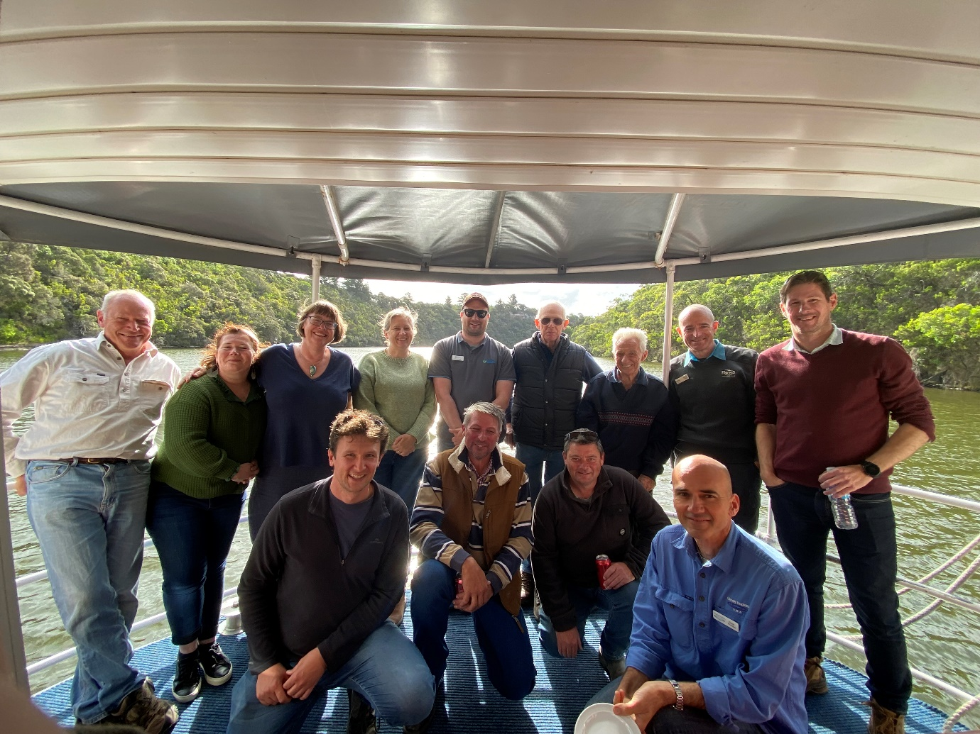
CAPTION: Members of the Glenelg River Environmental Water Advisory Group on a boat tour to see the benefits of environment flows to the river as part of their face-to-face meeting held at Nelson recently.

