28 April 2023
BUGGING IN THE WATER BEFORE FLAGSHIP WORKS

Knowing what’s in the waterways before beginning any project work is a key part of the Glenelg Hopkins CMA’s understanding of how its projects influence native species.

But it’s not always about the big things in the waterways.

For the Rivers of Warrnambool Flagship Project on the Merri and Hopkins Rivers and Brucknell Creek, finding which of the smallest creatures are already living there has been the focus of recent activities.

Glenelg Hopkins CMA staff and Austral Research and Consulting have been on the hunt for aquatic insects and waterbugs that live in these waterways to create baseline knowledge.

Rivers of Warrnambool project manager, Chris Wilson, said these aquatic macroinvertebrates – more commonly referred to simply as waterbugs – were often overlooked but were important to understand.

“Whilst being an essential part of the food chain for our native instream species, macroinvertebrates can also help give an indication of the condition of our waterways,” he said.

Mr Wilson said nine sites were sampled this Autumn to gather baseline data for the project.

“This will help us monitor and understand any condition change over time in response to the project river restoration activities, such as weed control, stock exclusion fencing and native tree planting.”

Mr Wilson said a total of 52 different types of waterbugs were found across the nine sites planned for upcoming works.

“Although no clear patterns are available between sites at this stage, preliminary results have shown high numbers of sensitive families within Brucknell Creek, including mayflies, stoneflies and caddisflies, reflecting the overall high quality of this waterway,” Mr Wilson said.

These monitoring surveys are a part of overall $1.02 million Victorian Government investment in the Rivers of Warrnambool Flagship Project, to protect, improve and restore the health of the waterways surrounding Warrnambool.

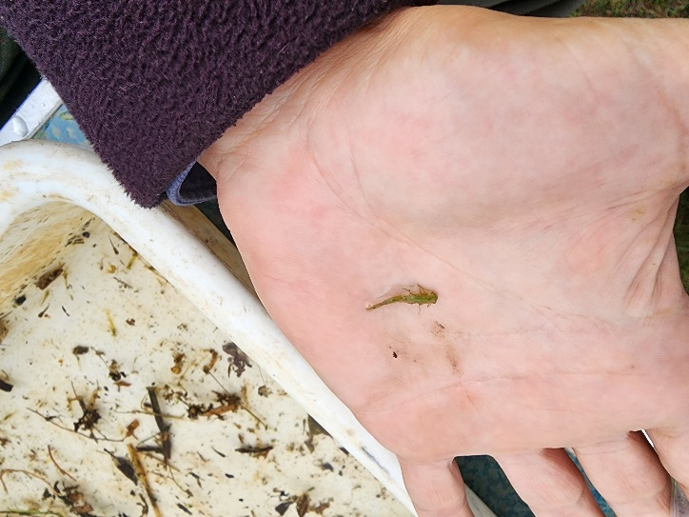
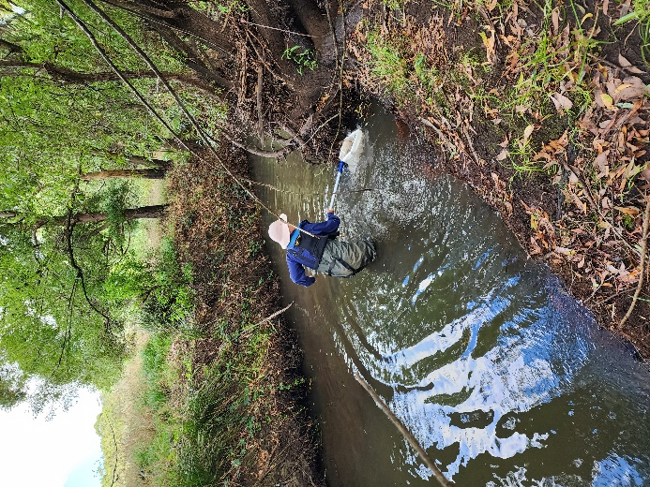
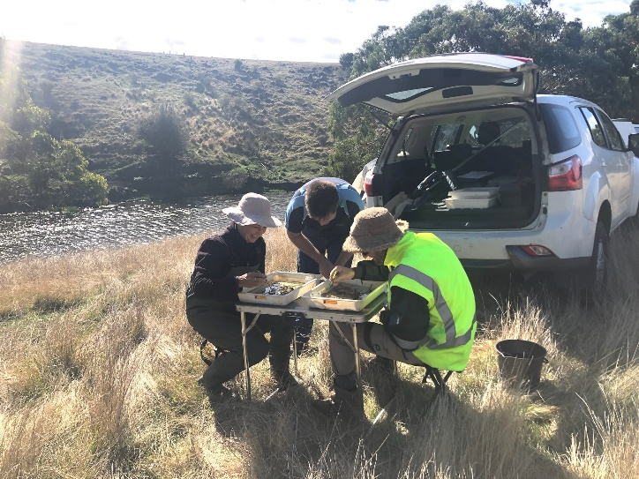
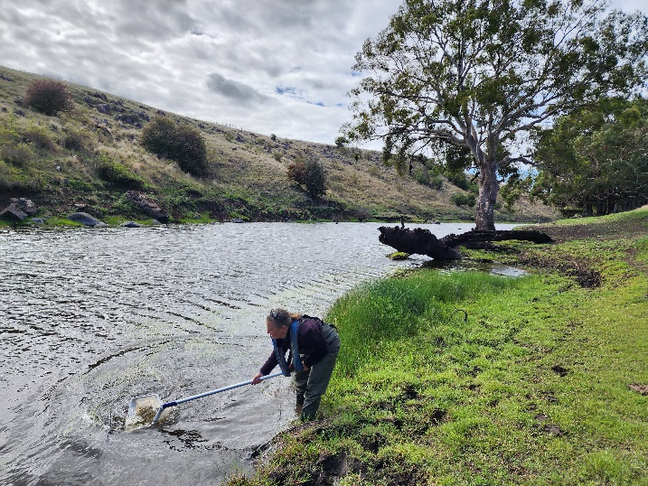
ENDS
CAPTION: Aquatic macroinvertebrates surveying has required the team from the CMA and Austral Research and Consulting to get out in the field and onto the banks of waterways around Warrnambool.

