XX April 2023
TREE GUARD PARTNERSHIP BENEFITING MORE THAN JUST REVEGETATION PROJECTS

Many hands are making light work of setting up the 8000 tree guards needed for the Glenelg Hopkins CMA’s Rivers of Warrnambool Flagship Waterways project.

Glenelg Hopkins Catchment Management Authority (CMA) has partnered with WDEA Works Social Enterprises to support revegetation projects in the region.

The WDEA Works Social Enterprise team has developed a streamlined process of assembling tree guards and support stakes, bundling them together, and packing them into bulker bags for delivery to project sites.

This system enables Glenelg Hopkins CMA to easily transport and distribute the pre-staked guards to planting sites, eliminating the need for time-consuming assembly on-site. This is especially beneficial during cold spring days when handling stakes with cold hands can be challenging, even with gloves on.

The latest batch of 8000 tree guards will be used in conjunction with 14,000 native plants to be planted on public and private land along the banks of the Hopkins and Merri rivers and Brucknell Creek as part of the Rivers of Warrnambool Flagship Waterways Project.

The project, funded by the Victorian Government through the Waterway Health Funding program, aims to restore and protect waterway health in the region over the next four years.

The partnership between WDEA Works Social Enterprises and Glenelg Hopkins CMA goes beyond just improving efficiency. The WDEA Works Social Enterprises team become an integral part of the revegetation projects, fostering a sense of community ownership and engagement in the works.

“This collaboration not only helps Glenelg Hopkins CMA achieve the project revegetation goals, but also strengthens positive relationships between landholders and the broader, regionally significant project,” a WDEA Works Social Enterprises spokesperson said.

Rivers of Warrnambool Project Manager, Chris Wilson, said the partnership with WDEA works had been a fantastic opportunity to involve participation from people with all abilities whilst also creating significant project efficiencies.

“This is a really good example of how working together to achieve common goals tailored to everyone’s strengths can create even greater benefits than just for our projects alone,” he said.

“The completed guards can now simply and easily be delivered and placed around our native plants giving them a greater chance of successful establishment.”

The partnership between WDEA Works Social Enterprises and Glenelg Hopkins CMA demonstrates the power of collaboration in supporting the community and the environment.

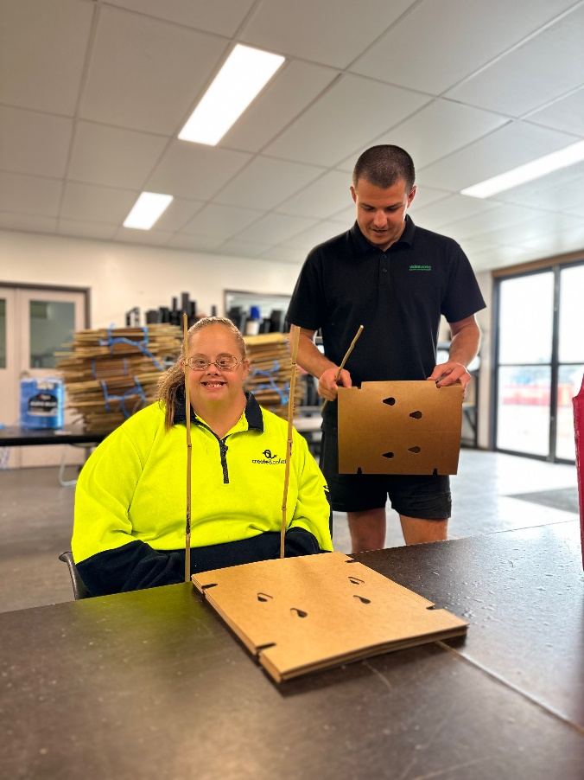
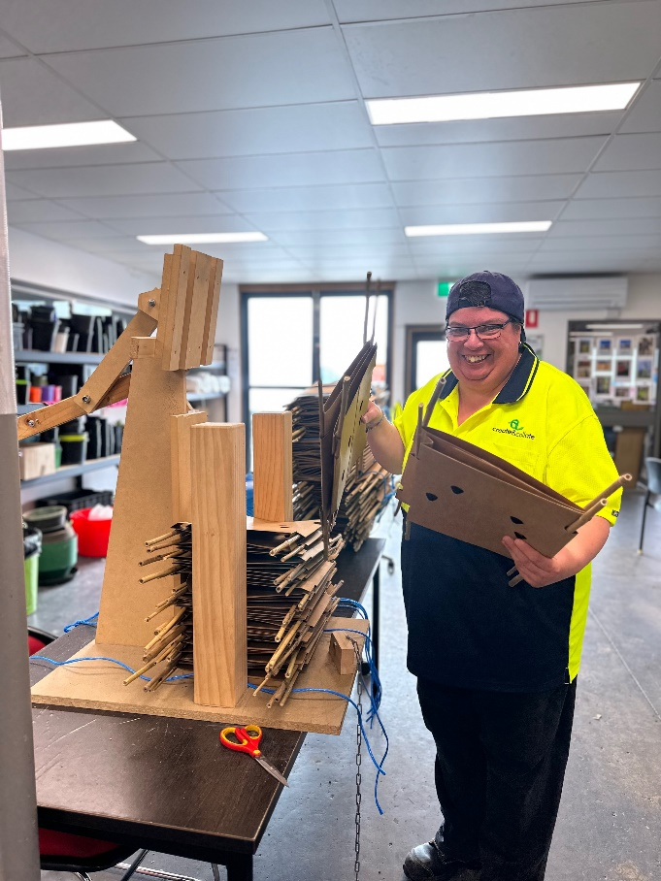
ENDS
CAPTION: Team members from WDEA Works Social Enterprises have created a system to pre-stake tree guards for Glenelg Hopkins CMA’s Rivers of Warrnambool Flagship Waterway project.

