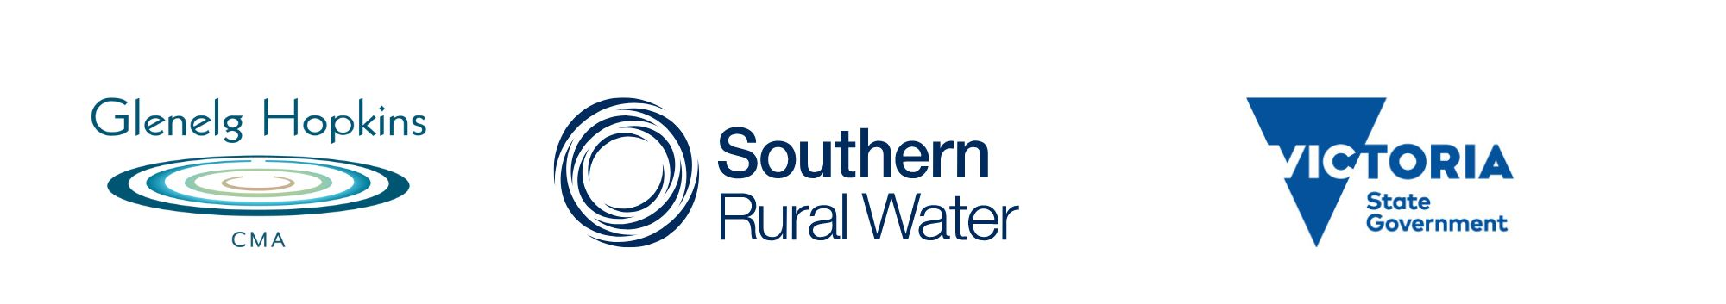
2023

Southwest Irrigation Development Guidelines

Glenelg Hopkins CMA

Acknowledgement of Country
GHCMA works across the lands of the Barengi Gadjin, Eastern Marr, Gunditj Mirring and Wadawurrung peoples.
They are our regions first citizens and have never ceded their rights or responsibilities to these lands.
We acknowledge their leadership in caring for our country and openly welcome their experience and knowledge in continuing to develop sustainable irrigation practices across the GHCMA region.
Table of Contents
Abbreviations in this document 1
Glossary of terms 2
PART A- What are the Irrigation Development Guidelines 4
1 Introduction 5
1.1 Purpose 5
1.2 process 5
1.3 When these Guidelines apply 6
1.4 When the Guidelines do not apply 6
1.5 Review and AMENDMENTS of the Guidelines 7
1.6 other aspects 7
2 Irrigation development assessment process 9
2.1 General overview 9
2.2 When an IDP is required 9
2.3 Application response times 10
2.4 Costs associated with the processing of applications 10
2.5 complaints process 10
2.6 appeals process 10
3 Roles and responsibilities 11
3.1 The Applicant 11
3.2 Referral Committee 11
3.3 Irrigation Development Coordinator (IDC) 12
3.4 water corporations 12
3.5 DEPARTMENT OF ENERGY, ENVIRONMENT AND CLIMATE ACTION (DEECA) 12
3.6 Agriculture Victoria (AGVIC) 12
3.7 Catchment Management Authorities (CMAs) 13
3.8 Local Government 13
3.9 Parks Victoria 13
3.10 Registered Aboriginal Parties and First Peoples - State Relations
( previously aboriginal victoria) 13
3.11 environment protection authority (EPA) 13
4 Information requirements and technical assessments 14
4.1 Public Land Manager Consent 14
4.2 Works Plan to inform the Works Licence 14
4.3 Irrigation Drainage Plan that informs the TUL 15
4.4 protecting biodiversity 18
4.5 Further information 20
5 Other approvals required for irrigation development 21
5.1 Aboriginal Heritage 21
5.2 Local government requirements 22
5.3 Planning permits 22
5.4 Environmental Protection and Biodiversity Conservation 24
5.5 Flora and Fauna conservation 24
5.6 Environment Effects Act 1978 24
5.7 Wildlife protection and conservation 24
5.8 Floodplain Management and Works on Waterways 24
6 References 26
PART B- The Irrigation Development Guideline Process 27
PART C- Appendices 39
1 Appendix 1: Legislative framework and regional catchment strategy context 39
Overall framework 39
Links to key legislation 39
Victorian Water Act 1989 39
Catchment and Land Protection Act (CaLP) 1994 42
Overarching legislation 42

Abbreviations in this document

AHD Australian Height Datum
AUL Annual Use Limit
AGVIC Agriculture Victoria, which is part of the Department of Jobs Precincts and Regions
CHMP Cultural Heritage Management Plan
CMA Catchment Management Authority
DEECA Department of Energy, Environment and Climate Action
EC Electrical Conductivity
FPSR First Peoples - State Relations (previously Aboriginal Victoria)
GWMWater Grampians Wimmera Mallee Water
Ha Hectare
Ha/yr Hectares per year
ID Irrigation Development
IDA Irrigation Development Application
IDC Irrigation Development Coordinator
IDG Irrigation Development Guidelines
IDP Irrigation and Drainage Plan
LWMP Land and Water Management Plan
MAR Maximum Application Rate
ML Megalitre
ML/Ha Megalitres per hectare
NRM Natural Resource Management
PLM Public Land Manager
PV Parks Victoria
RAP Registered Aboriginal Party
RC Referral Committee
RCS Regional Catchment Strategy
SRW Southern Rural Water
TUL Take and Use Licence
VCAT Victorian Civil and Administrative Tribunal
VWR Victorian Water Registry
VPP Victorian Planning Provisions
VWR Victorian Water Register
WC Water Corporation
WL Works Licence
WP Works Plan
WUL Water Use Licence

Glossary of Terms
Annual Use Limit (AUL): The maximum volume of water that in any twelve-month period may be applied to the land specified in a water use licence, water use registration or Take and Use Licence.
Applicant: Landholder or representative of landholder who is the Applicant for an irrigation development.
Approved Polygon: The irrigation footprint that is defined by the map/design of the irrigable area or shape file on an approved Irrigation Drainage Plan that is required for, and referred to, as a condition on a Take and Use Licence. This may be the whole property title or an approved shape within a title.
Biodiversity: The variety of all life forms – the different plants, animals and micro-organisms, the genes they contain, and the ecosystems of which they form a part of.
Catchment Management Authority (CMA): Statutory body established under the Catchment and Land Protection (CaLP) Act 1994. CMAs have responsibilities under both the CaLP Act 1994 and the Water Act 1989, which include river health, regional and catchment planning and coordination, and waterway, floodplain, salinity and water quality management.
Delegate: A person to whom the power is delegated under the instrument of delegations.
Designated Waterway: Designated waterways are named or unnamed, permanent or seasonal, and range in size from a river to a natural depression. Designated waterways are declared under the Water Act 1989.
EC Units: Measure of electrical conductivity in µS/cm. Electrical Conductivity provides a fast and convenient way to measure salinity. Sea water has a salinity of about 50,000 EC Units at 25 degrees Celsius. Sometimes salinity is measured as TDS (Total Dissolved Salts in mg/L) or by constituent salt components such as sodium.
Groundwater: Subsurface water in soils and geological formations that are fully saturated.
Irrigation Development Application (IDA) form: a form supplied by Water Corporation to a potential applicant, for the applicant to provide relevant information for initial assessments.
Irrigation Development Guidelines (IDG): The Southwest Irrigation Development Guidelines, which is this document.
Irrigation and drainage plan (IDP): The IDP must provide the information necessary to demonstrate how the development meets the necessary standards to minimise the impacts of water use on other persons and the environment (in particular waterlogging, salinity and nutrient impacts). Unless meeting exemption conditions, an application for a new Take and Use Licence or for a variation to a Take and Use Licence must be accompanied by an irrigation and drainage plan.
Land and Water Management Plan (LWMP): A land and water management plan may be prepared by a Catchment Management Authority under the Regional Catchment Strategy.
Maximum Application Rates (MAR): The maximum application rates (in megalitres per hectare per year), which are to be used in conjunction with irrigated areas (in hectares) to determine annual use limits on water use licences. The MAR are defined in Schedule 2 of Standard Water Use Conditions which apply to all water use licences.
Megalitre (ML): 1 million litres.
Ministerial Water Use Objectives: The objectives for water use licence conditions as described in the Policies for Managing Take and Use Licences. These are a) managing groundwater infiltration, b) managing the disposal of drainage, c) minimising salinity, d) protecting biodiversity, e) minimising the cumulative effects of water use.
Referral Committee (RC): Committee of agency representatives that coordinates the approval process for irrigation development applications.
Regional Catchment Strategy (RCS): The Regional Catchment Strategy prepared by the relevant Catchment Management Authority. These are the primary integrated planning framework for the management of land, water and biodiversity resources.
Rules, Rosters and Restrictions: Access to allocation is governed by rules, rosters and restrictions as set out in the relevant Local Management Plan or Streamflow Management Plan.
Seasonal Water Allocation: The amount of water available for a water year, determined by the Water Corporation and expressed as a percentage of a water share or licenced volume. Sometimes this term is shortened to ‘allocation’.
Standard Water Use Conditions: The standard conditions, set in accordance with section 64P, 64Y(1) and 64AI of the Water Act 1989 that apply to all water use licences and Take and Use Licences including an annual use limit to ensure irrigation is carried out in accordance with Ministerial Water Use objectives. In addition to these there can be conditions recorded on each water-use licence are specific to local areas.
Take and Use Licence (TUL): Issued under section 51 of the Water Act 1989. A fixed term entitlement to take and use water from unregulated water systems such as: a waterway, catchment dam, spring, soak or aquifer. Each licence is subject to conditions set by the Minister and specified on the licence. Water Corporation (WC): Corporation established under Part 6 of the Water Act 1989 that have responsibilities to supply water for urban, irrigation, domestic, stock, and commercial use in irrigation districts and water districts. Some corporations also have delegated responsibilities for controlling the diversion of water from waterways, passing flows and the extraction of groundwater. In the Southwest region, as applicable to these Guidelines, the relevant water corporation is Southern Rural Water. The northern part of the area is covered by Grampians Wimmera Mallee Water.
Water Act: Referred to as ‘The Act’ in this document. The Water Act 1989 (Vic) provides the legal framework for managing Victoria’s water resources. The main purpose of the Water Act is to promote the equitable and efficient use of Victoria’s water resources, to conserve and properly manage them for the benefit of all Victorians and increase community involvement in conserving and managing the water resources.
Water Entitlements: A generic term that encompasses water shares and Take and Use Licences.
Water Register: The public register of all water-related entitlements in Victoria where water licences and entitlements are created and stored in the register.
Water share: A water share is a legally recognised, secure share of the water available for use in a defined water system. A water share is specified as a maximum volume of seasonal allocation that may be made against that share. Water shares may be high or low reliability.
Water Use Licence (WUL): Not applicable in the Southwest part of Victoria. A licence that authorises the use of water from a declared regulated system (not applicable in Southwest) for the purposes of irrigation on the land specified under that licence. The licence sets out the conditions for use, such as how much water can be used on the specified parcel of land in a single irrigation season. A WUL is needed to irrigate the property and the licence is tied to the land.
Works Licence (WL): Issued under section 67 of the Water Act 1989. A licence that authorises the construction, alteration, operation, removal or decommissioning of any works (each type of works requiring their own licence) on a waterway, or a bore, or a dam belonging to a prescribed class of dams (Multiple applications may be required for each works undertaken).
Works Plan (WP): A plan prepared by the applicant outlining the location of infrastructure to service an irrigation development. A WP must clearly describe the type and location of irrigation infrastructure required to be constructed to extract water from the water source and the intended pathway to deliver it to the farm. A WP must include: Siting map of proposed works, Construction plan, Decommissioning Plan, and Operation Plan. It must demonstrate how the risks associated with construction and ongoing operation of the infrastructure will be mitigated.

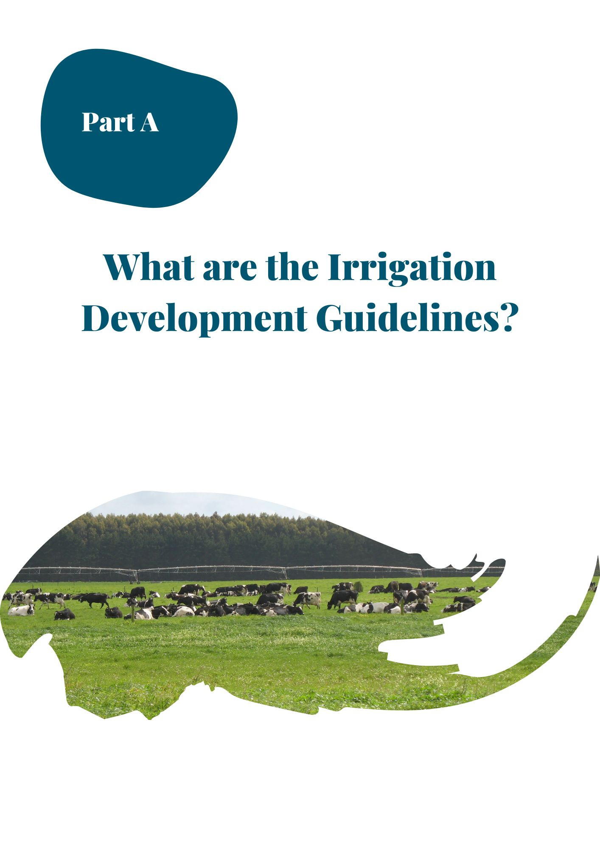

Introduction

Purpose
The Southwest Irrigation Development Guidelines provide guidance for government agencies to work together to process applications for new or varied irrigation development. This includes:
- The roles and responsibilities of agencies
- The commitment by relevant Water Corporations (WC) and Catchment Management Authorities (CMA) to participate in the Referral Committee (RC), which will outline the steps decision-makers can take to assist the applications process and engage with relevant referral agencies.
- The relevant legislation and Ministerial Policies that underpins the approval to issue new or revised, planning approvals, works licences, or Take and Use Licences with site specific conditions (including annual use limits when applicable to Take and Use Licences) that reflect the outcomes of the approvals processes
- The approval processes used by agency staff
- The development standards and licence conditions required to manage impacts on the environment and other values
- Acknowledgement of the applicant's requirements to satisfy other legislative requirements
- The process post approval is that the WC commits to send a copy of the licence to the RC. The RC may have recommended the WC to impose conditions for approved licences.
The Guidelines ensure the statutory requirements for each agency are fully considered and addressed. Noting where there is a change in policy direction, from the date they come into effect the current Ministerial or legislative requirements override the Irrigation Development Guidelines (i.e., Irrigation Development Guidelines are subordinate and where there is inconsistency, the higher documents are observed.)

process
Interagency cooperation is integral to the assessment and approval process. These Guidelines propose a Referral Committee (RC) is formed with representatives from the relevant rural water corporation (Southern Rural Water (SRW) or Grampians Wimmera Mallee Water (GWMWater)) and the Glenelg Hopkins Catchment Management Authority (Glenelg Hopkins CMA). Assisting agencies such as Agriculture Victoria (AG VIC) will play an important support role to the RC. The purpose of the proposed RC is to improve communication processes across agencies in considering the water use aspects of a proposal and application of these guidelines.
This purpose aims to compliment referral processes as required under section 40 of the Water Act 1989. Supporting this core group will be other representatives that will be convened on an ‘as needs basis’ depending on the type of proposals being considered and their potential impacts. The onus is on the applicant of an irrigation development to provide the required information.
Other supporting representatives can include on matters of relevance:
- Department of Energy, Environment and Climate Action (DEECA)
- Parks Victoria (PV)
- The relevant Registered Aboriginal Party (RAP)
- Local Government
- Urban Water Authorities
- Environment Protection Authority (EPA)
An Irrigation Development Coordinator (IDC) from the Glenelg Hopkins CMA coordinates the RC and it is expected to meet on an ‘as needs basis’ to discuss new applications and relevant issues.
The Guidelines provide a process for the informed consideration of applications relating to an irrigation development. Agencies will provide their advice to SRW on applications. SRW will then consider this advice when assessing applications and setting conditions for a Works Licence (WL) and a Take and Use Licence (TUL) if supply is from an unregulated water source and/or an undeclared surface system.
Once a proposal has been assessed, provided cultural heritage approvals are in place to comply with Aboriginal Heritage Act 2006 and the Aboriginal Heritage Regulations 2018, the Water Corporation is then able to, subject to its own requirements, consider issuing the WL and/or WUL/T&UL. Refer to 5.1 Aboriginal Heritage below for further information.
Cultural heritage approvals are required prior to developmental approval by SRW. But the remaining approvals, such as native vegetation, public land manager’s consent and planning permits can be finalised after the WL and WUL/T&UL are issued.
Under the Water Act 1989, the issue of a licence does not remove the need to apply for any authorisation or permission necessary under any other Act with respect to anything authorised by the licence.
It is not the responsibility of the Delegate Authorities, WCs or CMAs to ensure the applicant has met the requirements of other legislative frameworks. The issue of a licence and its conditions does not remove the need to apply for other authorisations or permissions necessary under other relevant Acts, such as the Environment Protection and Biodiversity Conservation (EPBC) Act 1999 and the Cultural Heritage Management Plans (CHMP) required by the Aboriginal Heritage Amendment Act 2016, for examples.
It is strongly recommended that proof of complying is submitted with an application
In assessing an application and advising on conditions for an irrigation development approval, agencies should consider information provided by the applicant and ensure the information is adequate in demonstrating that the development complies with all relevant legislation and meeting the Ministerial Water Use Objectives that are listed in the Ministerial Policies for TUL for:
- Managing groundwater infiltration
- Managing disposal of drainage
- Minimising salinity
- Protecting biodiversity
- Minimising cumulative effects of water

The applicant must comply with the Ministerial Policies for Take and Use Licences. The policies outline the requirements for an Irrigation and Drainage Plan (IDP) and identifies standard conditions for new or varied TULs.
The Guidelines assist in processing applications for new, or variations to existing TULs. Also relevant are the Ministerial Policies for Managing Works Licences.
The process is designed to reveal the legislative requirements to the applicant and to enable an applicant to provide sufficient evidence that legislative requirements have been satisfied. An application, which does not satisfy legislative requirements will be refused, unless the applicant:
- Provides more evidence that development will be compliant with legislation.
- Amends or revises the proposed development so that it meets all Water Act 1999 legislative requirements

When these Guidelines apply
The Guidelines apply to previously unirrigated land for which there is no existing TUL, or when redevelopment would result in a change in the conditions of the existing TUL of which the TUL is greater than 20ML. Also, if the Water Corporation considers an application to be an expansion of an existing licence that may not meet Ministerial Objectives or conditions, the application triggers an approval process under these Guidelines. The RC will convene and provide a recommendation to the WC about what additional information will support an application response. A low risk categorised application (i.e. lesser than 20 ML) will be dealt with by the WC, all other applications will be passed on the IDC and to the RC.
The Guidelines apply to a new TUL application, on land that has not been previously irrigated. The Guidelines also apply to TUL applications for expansion of an existing Take and Use Licence, wither as an increase in the amount of water (licenced volume) applied or where there is a request to irrigate further areas of land previously not identified as irrigated under previously held licences.
If the size of the previously irrigated land area of an existing licence cannot be determined then the RC may apply a risk assessment, which will inform a recommendation to the water corporation on whether the Irrigation Development Guidelines apply and whether an Irrigation and Drainage Plan (IDP) can be modified or waived. This risk assessment will be guided by Table 2-1 and high-risk proposals will trigger the Irrigation Development Guidelines and require IDPs.
Significant redevelopment might involve an increase in the annual use limit (annual use limit can be applied to a TUL) or licenced volume that applies within the existing irrigated approved polygon. In this case, the salient question to determine if the redevelopment is significant, and to determine whether the Guidelines apply, is: would the proposed volume have been agreed to at the time the TUL was originally issued without any change in other conditions?
- If “yes” then the Guidelines do not apply
- If “no” or “uncertain” then the Guidelines do apply
- If the RC do not agree on either of the above, then the decision on whether to apply the Guidelines is referred to the above dispute resolution process.
All surface and groundwater sources and TUL volumes; noting new TUL volumes, should not exceed the AUL held on the same property. When a change in irrigation infrastructure occurs, this may require going through the works approval process for a new or amended works licence. This is covered in the next section.
Works Licences (WL)
A Section 67 works licence is required to construct and operate works on a waterway, groundwater bore and certain private dams. A works licence is generally required to pump water from a waterway or aquifer. A works licence can authorise a person to enter onto and install works on Crown Land; but it does not authorise the applicant to lay pipes on freehold land or to remove vegetation.
The Guidelines are used to inform the assessment of a works licence application and consider the appropriate standard and, where appropriate, particular conditions required to authorise the take, use, conveyance, and storage of water from Victorian waterways. The Guidelines will apply for works licence applications if:
- New works are required to deliver water to the land specified in a new or changed S51 TUL
- Existing works are being modified to deliver water to land specified in a new TUL licence application.

When the Guidelines do not apply
The Irrigation Development Guidelines, will not apply:
- For procedural matters that do not normally trigger referral obligations under the Act, regarding the sale of land (land subdivision or land consolidation) that requires the issuing of a new TUL on land already being irrigated, provided there is no net increase in the AUL/licenced volume or change in the approved polygon that is allowed to be irrigated.
- When further land is developed within the approved polygon provided the AUL/licenced volume specified in the TUL is not exceeded.
The requirement to prepare Irrigation and Drainage Plans (IDP) and meet the standard conditions for new or varied TULs will not apply in the following circumstances:
- Where a TUL is cancelled because part of the land to which it refers is transferred to a different party – new licences may be issued for each part of the land without the imposition of any extra conditions, provided that each licence has an appropriate share of the previous AUL/licenced volume, and the sum of the new AUL/licenced volume is no greater than the previous AUL/licenced volume.
- Where irrigation is to be intensified on some land already covered by a licence and an increase in the AUL/licenced volume on the licence is sought but is below the maximum application rates deemed for the location by the CMA (Section 4.3.3). TULs will apply, but with such modifications that are considered necessary by the Minister (or delegate).
- With the written approval of the CMA. Usually, a risk assessment guided by Table 2-1 would be undertaken by the CMA to ascertain that the proposal is low risk and the IDP can be modified or waived. The situation for when an IDP is waived, is covered in Section 2.2. However, if the Guidelines do apply and an IDP is waived, conditions on the licence and other steps outlined in the Guidelines are still required.
- For a TUL a delegate may modify or waive the requirement for an IDP where: the annual use limit in the TUL is less than 20 ML; and in the delegate’s view, any adverse impact from the use of water under the licence is likely to be minor.
An application for a works licence being renewed, amended, or transferred may not necessitate the requirement of preparing a Works Plan if the Water Corporation deems that the works licence does not have significant deficiencies or amendments. The delegate may determine which, if any, of the standard conditions for works licences should be added to the licence.
Except for Cultural Heritage requirements, the issuing of a TUL licence or a works licence cannot be withheld based on the requirements of other Acts of Parliament. However, it is important for applicants to be aware that the proposed developments may not proceed without first obtaining all necessary approvals (DSE, 2010).
The granting of a Take and Use Licence does not remove the need to apply for any authorisation or permission necessary under any other Act with respect to anything authorised by the licence. The process outlined in these guidelines is designed to prevent the situation where a water corporation issues a licence without the necessary approvals under other legislation that would cause a problem for the applicant and other agencies.

Review and AMENDMENTS of the Guidelines
The Glenelg Hopkins CMA is the custodian of this Guideline document, which is reviewed and updated every five years, or on an as needs basis. Each review is led by the Glenelg Hopkins CMA, , in consultation with the agencies involved in their implementation, as listed in Section 1.2.
The revised document will be required to be endorsed by the Boards of directors for SRW, and Glenelg Hopkins CMA, and the DEECA Executive Director State-wide Infrastructure and Rural Strategy.
Due to the small area of responsibility within the southwest region, GWMWater may choose if they wish to be part of the endorsement process.
The Guidelines may be amended within this timeframe to improve clarity and accuracy. These are considered to be editorial in nature and will not require broad consultation or Board signoff but will be endorsed by the RC.
Further information about the application of the Guidelines or the irrigation development process can be obtained by contacting the IDC, Glenelg Hopkins CMA office at Hamilton.

other aspects

future changes
In applying licence conditions, and endorsing irrigation development applications, approval agencies, and referral agencies, must consider the information provided by applicants, and they must ensure that information adequately demonstrates that the development complies with all relevant legislation while also meeting the Minister’s Water Use Objectives for:
  - Managing groundwater infiltration
  - Managing disposal of drainage
  - Minimising salinity
  - Protecting biodiversity
  - Minimising cumulative effects of water use.
These objectives are assessed by the RC considering the information provided by the applicant, risk levels of the development and according to the Ministerial Policies for Take and Use licences.
Irrigation technologies, and the knowledge used to inform best management practices for irrigation, are constantly evolving in response to research, innovation, monitoring, regulation, and other factors. The process for implementing the Irrigation Development Guidelines will therefore continue to be adapted to ensure irrigation is sustainable and the Water Use Objectives are met. Where necessary the Guidelines may be updated as per Section 1.7.
Within the bounds set by the Water Act 1989, the development or redevelopment of irrigation will be assessed with consideration of risk and precautionary approaches. It should be noted that a suite of tools and policies may be used alongside the Guidelines, including the Regional Catchment Strategy, possible development of land and water management plans and possible irrigation extension activities. By using a mix of these tools, agencies will be able to support irrigators in implementing best management practices for irrigation.

Risk management
Under the precautionary principle, risks arising from irrigation redevelopment in existing areas and irrigation development in new areas must be proactively managed. Land and water management plans and extension, as well as these Guidelines, where triggered, will be used to encourage the adoption of best management practices in order to minimise risk.
As technologies change and irrigators take more innovative approaches to enterprise management, the types of irrigation redevelopment may become more complex to assess and, as a result, require broader input in the assessment process.
Therefore, the relevant water corporation (SRW or GWMWater), should seek advice from relevant parties where the application poses a potential risk to the achievement of the Minister’s Water-Use Objectives. This will usually be via the Irrigation Development Coordinator (IDC), and the RC. It may also include, when appropriate, regional committees, short-term working groups or similar.
When determining licence applications, the water corporation, in addition to legislative obligations to refer the application to other agencies, should also consider obtaining advice/support/guidance from other agencies and/or the RC for (but not limited to) the following aspects:
- When uncertain about environmental impact/s or approval process
- When an alternative water resource is proposed for use to irrigate a property that has previously been irrigated with another resource, for example when adding groundwater irrigation to a licenced area historically irrigated with surface water or vice versa
- Where there are potential cumulative impacts associated with using multiple irrigation water sources
- Where there are land use changes, particularly those involving increased cultivation
- If the water requires treatment to ameliorate the effects of water quality issues
- Where the proposal may trigger protection requirements for native vegetation or cultural heritage
- The corporation has insufficient data/knowledge to make informed licensing decisions (for example if there is no understanding of the annual volumes of water available for extraction).
This collaborative, precautionary approach will better integrate the key tools to support sustainable irrigation redevelopment by:
- Ensuring the assessment process is consistent and transparent and commensurate with the level of risk the application poses
- Increasing landholder awareness or access to extension services and regional projects
- Generating a common understanding of the proposed development across agencies
- Promoting the adoption of best irrigation management practices and irrigation technologies
- Minimising the risk of adverse impacts to cultural heritage, the environment or third parties e.g., waterlogging, salinisation, or water quality degradation
- Meeting the Minister’s Water-use Objectives.

wastewater and industrial water for irrigation
Some irrigators are seeking to diversify their sources of water. Depending on location, a property may have access to recycled water or wastewater from treatment plants, large processing plants (e.g., milk factory) or other commercial enterprises.
The EPA oversees the use of wastewater and industrial water reuse. The EPA can be contacted on 1300 372 842 (1300 EPA VIC), and general advice is provided at https://www.epa.vic.gov.au/about-epa/publications/168.
While the Irrigation Development Guidelines do not apply in the licensing or approval of wastewater or industrial water use, the information contained in Irrigation Development Guidelines may be useful.
It is strongly recommended that the total annual volume of water use from all sources should not exceed the annual use limit/maximum application rate on, nor go outside the polygon approved by, existing Take and Use Licences, through the additional use of wastewater or industrial water reuse. And, where possible, the approval processes for irrigation with wastewater, industrial water reuse should meet or exceed the standards specified in these Guidelines.
For irrigation developments where recycled water is to be used, the documentation and plans as required by the EPA, may be accepted as an Irrigation and Drainage Plan. Further information on EPA requirements for the use of reclaimed water can be found in the Victorian Guideline for Water Recycling (publication 1910) (2021) and the Technical Information for the Victorian Guideline for Water recycling (publication t1911) (2021).
Using effluent for irrigation
Many dairy farmers may seek to utilise their irrigation infrastructure to apply animal effluent as a fertiliser. Further information is available at <https://www.epa.vic.gov.au/for-business/find-a-topic/about-dairy-farm-effluent>. The EPA has compliance responsibility for effluent discharge practices.
The CMA, collaboratively with AG VIC, can provide advice and support on how and where to use effluent through Irrigation Drainage Plans (IDPs). The RC may request a IDP to support best management practice of the site and use of water under a TUL. It is the WC’s and CMA’s responsibility under the Water Act 1989 to ensure environmental duty is applied in consideration of a TUL.
On site water treatment
Irrigation Development Guidelines may be triggered if on-site water treatment changes the irrigation or drainage practices that are permitted within a TUL where this impacts upon the Minister’s Water Use Objectives. An example may be disposal of a brine stream from desalination into a drain. EPA licensing may also apply in these instances.

water corporation areas
A map of water corporation and CMA boundaries are shown below in Figure 1-1..
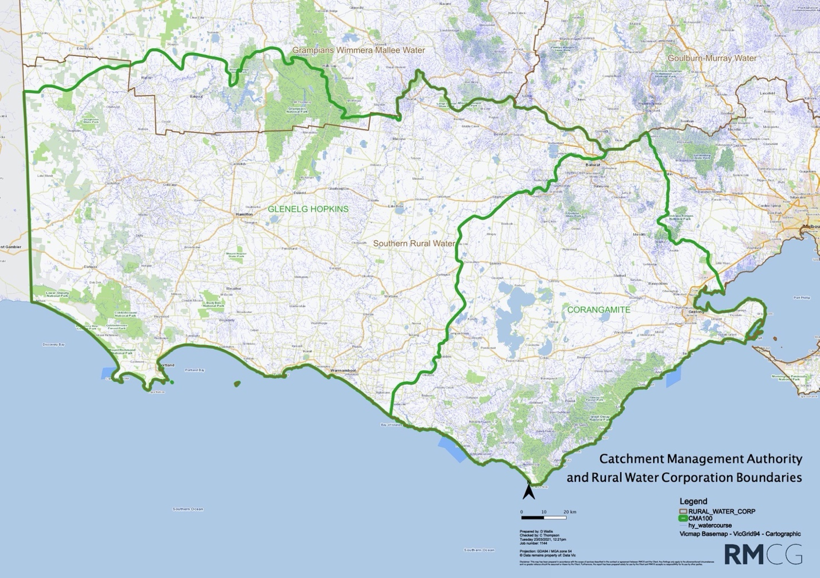
Figure 2-1: CMA and Rural Water Corporation boundaries

Irrigation development assessment process

General overview
It should be noted that this process and flowchart has been designed for a high risk/complexity application, as determined by the RC. It is expected that most applications will be simpler, as some referrals will not be required
The process for assessing Irrigation Development (ID) applications is presented in Table 2-1. To facilitate the process a dedicated IDC operates as a conduit between the applicant and the government agencies from the start to the completion of the approvals process.
Simple applications may only involve the ‘swim lanes’ for the applicant, CMA, RC, and Water Corporation. The actual process employed will be tailored to the complexity and risk of the individual application by the RC.
The information and requirements for approval will be dependent upon the complexity and level of potential risk identified for the proposed development. A proposed development that has identified impacts on the environment such as groundwater rise, native vegetation removal, or large-scale land-use changes, for example, may be required to provide more comprehensive information and employ suitably qualified experts. While for redevelopment scenarios where the risks may be much lower, a simpler application process with less information would apply. The level of risk is assessed early in the investigation phase to assist with determining the level and type of information required to inform the process.
While the IDC and DEECA can provide some guidance on information requirements, ultimately the agencies that the proposal is referred to provide the definitive advice about the information needed for their risk assessments. These Guidelines do not describe internal business procedures for each agency, as that is the responsibility of each agency.

When an IDP is required
Except for circumstances when an IDP is waived by the licencing delegate an Irrigation Drainage Plan (IDP) will be required for:
- Land parcels that do not currently have a TUL.
- Land parcels which have an existing TUL and on which an applicant is applying for an increase in the AUL/licenced volume and/or the approved polygon.
Under the Ministerial Policies for TUL an IDP can be waived by the licencing delegate when:
- The annual use limit in the TUL is less than 20 ML; and in the delegate’s view, any adverse impact from the use of water under the licence is likely to be minor, or
- It has the written approval of the CMA after undertaking the risk assessment outlined below.
As a guide, the applicant’s requirement to prepare an IDP for an existing TUL licence is indicated as per the table below. But this table is a guide only and individual applications will be assessed on a case-by-case basis as per the requirements of the Water Act 1989 in particular the following Water Use Objectives: Managing Groundwater Infiltration, Managing Drainage, Minimising Salinity, Protecting Biodiversity and Minimising the Cumulative Effects of Irrigation.
The approved IDP will include a reference code to be provided by Water Corporation and used by the RC and any other advising agencies.

Table 2-1: Guidance on risk-based use of IDP
Risk of offsite impact | annual irrigation ML/ha loading | requirements
Minimal risk | 1-3 ML/ha | - IDP is preferable  - Appropriate method of irrigation scheduling (e.g., soil moisture monitoring, evapotranspiration, etc)  - The applicant must be able to demonstrate that they have considered their irrigation water requirements and therefore be able to demonstrate how the volume of water they are applying for will be utilised effectively on their property  - Depending on site – may require demonstrable means of preventing or capturing irrigation runoff and demonstrable means of preventing excess deep drainage.
Moderate risk | 3-5 ML/ha | - IDP is preferable  - Irrigation layout should be matched to soil type (e.g., spray or high flow flood on higher permeability soils)  - Demonstrable means of preventing or capturing irrigation runoff  - Demonstrable means of preventing excess deep drainage  - Appropriate method of irrigation scheduling (e.g., soil moisture monitoring, evapotranspiration, etc)  - The applicant must be able to demonstrate that they have considered their irrigation water requirements and therefore be able to demonstrate how the volume of water they are applying for will be utilised effectively on their property.
High risk | >5 ML/ha  and/or the application has area of sensitivity (e.g., remnant vegetation, waterway, cultural significance) within the potential zone of influence of the irrigation development | - Must have and provide a copy of IDP  - Irrigation setup must be matched to soil type (e.g., spray or high flow flood on higher permeability soils)  - Flood irrigators must have demonstrable means of limiting deep drainage (e.g., appropriate flow rates and bay sizes)  - Flood irrigators must have demonstrable means of capturing irrigation runoff (e.g., a reuse dam)  - All irrigators must demonstrate an appropriate method of irrigation scheduling (e.g., soil moisture monitoring, evapotranspiration, etc)  - The applicant must be able to demonstrate that they have considered their irrigation water requirements and therefore be able to demonstrate how the volume of water they are applying for will be utilised effectively on their property.

Application response times
The IDC and all agencies involved in assessing applications will work together, as per the process described in Error! Reference source not found. to ensure applications are reviewed and assessed in a timely manner. To aid the efficiency and effectiveness of the application process all agencies will apply a 30 calendar-day response time (the statutory response time for a referral) from the time they receive an application, to review, provide comment and request additional information. If further information is required, the process will not proceed until the information is provided.
In total, depending on the complexity, scale and likely environmental impacts that need to be assessed, typically it takes between 2 and 6 months to obtain all the necessary information required with the application. Proposals with potentially large impacts and requiring detailed investigations to support the application may take two years.
SRW will also ensure that applicants are regularly updated on the progress of their application during its review.

Costs associated with the processing of applications
There are fees and charges associated with the processing of TUL and WL forms by SRW and/or GWMWater.
Other authorities may have fees and charges associated with assessing an irrigation development application e.g., Local Planning permit etc. These fees and charges are to be paid by the applicant.
Fee schedules can be obtained by contacting the relevant agencies.

complaints process
There is a two-step process in place for applicants that are not satisfied with how the Guidelines have been applied to their irrigation development application. These steps include:
- Step 1: if an applicant is dissatisfied with the outcome of the application, or the process, standards, or timelines applied in this process, the applicant will first request an appointment to meet and discuss their grievance with the IDC and the relevant organisation
- Step 2: if Step 1 does not resolve the issue, the applicant can write to the Chief Executive Officer (CEO) of the relevant CMA to seek a review of the process. The CEO may refer the issue to an independent arbiter.

appeals process
Where the relevant legislation allows for an appeal to be lodged, the applicant may lodge an appeal to the Victorian Civil and Administrative Tribunal (VCAT).
VCAT deals with disputes between people and government (State/Local) bodies about planning and land valuation, licences to carry on a business and many other Government decisions.

Roles and responsibilities

The Applicant
The applicant:
- Is defined in these Guidelines as the owner of the land on which the proposed development is to occur and to whom the licence is granted, or a person/s who has been authorised by the landowner to undertake the development on the owner’s behalf
- Completes and forwards all necessary documentation in relation to the proposed development
- Ensures that the legal responsibilities under all relevant acts of Parliament and legislation such as the Aboriginal Heritage Act 2006, Planning and Environment Act 1987, Environment Protection and Biodiversity Conservation Act 1999, Flora and Fauna Guarantee Act 1988, Flora and Fauna Guarantee Act Amendment 2019 and Wildlife Act 1975 are complied with.
The onus is on the applicant to provide the evidence that demonstrates how any potential impacts on the environment, or third parties are to be mitigated and how they have met requirements under legislation. This is consistent with the ‘beneficiary pays’ principle. The IDC provides a signpost to various agencies who can support the Applicant in obtaining this evidence. The relevant water corporation will assess an application in accordance with the Water Act 1989 and other relevant legislation, supported by the information contained in these Guidelines.
An applicant may choose to employ an advocate or a consultant to represent their interests and assist in the preparation and progression of their irrigation development proposal.
There are various fees and charges associated with the processing of forms by the Water Corporation and other government agencies. These fees and charges are to be paid by the applicant. There may be additional costs associated with the production of planning documents and technical investigations associated with the requirements of the licencing process.

Referral Committee
Interagency cooperation is an integral part and requirement of the irrigation development application review process. The RC provides a forum to collaborate, evaluate and work through complex irrigation development proposals and is integral to a cost efficient and effective process.
The RC:
- Meets at least once each year to review the Irrigation Development Guidelines process. It also meets on an 'as needs' basis (as advised by the IDC via email) to review applications. Meetings can be face-to-face, by phone or by virtual/video conference
- Provides guidance and advice to the licensing delegate, government agencies and the IDC about irrigation development matters
- Provides agency support on the Southwest Victorian irrigation development approval process to ensure regional compliance with the Water Act 1989 & Ministerial Policy Guidelines
- Assists irrigation developers and participating agencies to implement the Southwest irrigation development approval process as documented in these Guidelines
- Ensures irrigation development applications are processed in a timely and cost-effective manner
- Endorses IDPs as part of the approvals process
- Provides advice through the IDC to the Water Corporation in formulating conditions on works licences and TUL
- The RC may request the Water Corporation follow up on particular conditions for approved licences. In particular, they may request monitoring data from developed properties where monitoring has been a condition on the licence (e.g., groundwater levels and quality). This can help inform regional environmental trends and future decisions.
- Ensures the statutory requirements for each agency within the RC are fully considered and addressed and provides advice and guidance to the relevant CMA on any reviews of these Guidelines with the aim of keeping the document up to date with current legislative requirements and government policies and strategies. Noting where there is a change in policy direction, from the date they come into effect the current Ministerial or legislative requirements override the Irrigation Development Guidelines (i.e., Irrigation Development Guidelines are subordinate and where there is inconsistency, the higher documents are observed.)
The RC is coordinated by the IDC and meets at least annually, or as required to address issues that arise. The RC is made up of several key government agencies for which there is a core working group comprised of:
- IDC (Glenelg Hopkins CMA)
- SRW and/or GWMWater (depending on the relevant water corporation for the location of the proposed area for a development and includes specialists such as hydrogeologists, licencing etc.
- Agriculture Victoria
- Other appropriate officer/s from the relevant CMA: floodplain and waterways engineers and project officers.
At times the RC may need to consult further with the following government agencies:
- Urban water corporations
- Parks Victoria
- First Peoples - State Relations
- Registered Aboriginal Party
- DEECA Water and Catchments and/or Natural Environment
- DEECA Planning & Approvals and/or Land and Built Environment
- EPA
- Local Governments.
These agencies may attend meetings less frequently or on an as needed basis, or the IDC can be tasked by the RC with obtaining specific advice. Agriculture Victoria provides support on IDPs.

Irrigation Development Coordinator (IDC)
The IDC plays a crucial role in the implementation of the Guidelines. This includes:
- Providing private landowners and referral authorities with a preliminary assessment of potential environmental issues and offsite impacts of water use and irrigation of the proposed development through the irrigation development process
- Collecting and recording data associated with irrigation developments in accordance with agreed standards as documented in the RC Terms of Reference
- Providing a point of contact for all Southwest Victorian irrigation development related matters for applicants and partner agencies
- Ensuring applications are guided/supported through the irrigation development assessment (or application) process as per the Guidelines in a timely manner
- Convening and chairing the inter-agency RC meetings in order to ensure that all matters relevant to irrigation development are being efficiently and effectively addressed
- Documenting discussion for each RC meeting as minute taker
- Tracking and reporting IDA progress to the RC and applicant by maintaining the Irrigation Development Guidelines as a contemporary and fit for purpose document.

water corporations
The Minister for Water or the Minister’s delegates are responsible for the issue of Water Use Licences (which are not applicable in the Southwest), works licences and TULs in accordance with the Victorian Water Act 1989 and associated Ministerial Determinations. A Water Corporation may not approve the issue of a works licence, WUL and or the TUL to new developments unless the statutory requirements of the Water Corporations, and other stakeholder organisations, have been documented, evaluated, and approved. Agencies and authorities with statutory responsibility have agreed to work with the water corporations in applying these Guidelines.
In determining relevant licence applications, the Delegate should:
- Determine if resource is available to service the proposed development
- Be satisfied with the standard of the IDP and/or WP accompanying the application
- Follow the requirements outlined under the ‘Policies for Managing Take and Use Licences’ and the ‘Ministerial Guidelines for Groundwater Licensing and Protection of High Value Groundwater Dependent Ecosystems’ when issuing a TUL, in particular to the Water Use Objectives that are contained within these policies.
- Formulate suitable conditions for the works licence or TUL after consultation with the required agencies: The relevant CMA, DEECA, AG VIC Irrigation Officer, Parks Victoria and other agencies as required. Suitable conditions will be specified by agencies and discussed and endorsed at the RC meeting. The standard conditions will be included as conditions on all licences. Particular conditions identified during the application process may be included on the licence following RC consideration.
After licences have been issued the Water Corporation is responsible for compliance with, and enforcement of, licence conditions. For example, meeting specified buffers, monitoring corrective action thresholds, and implementing corrective action procedures – where they are a condition of the TUL.

DEPARTMENT OF ENERGY, ENVIRONMENT AND CLIMATE ACTION (DEECA)

Planning and Approvals
DEECA Planning & Approvals (P&A) is a referral authority for advising Local Government on native vegetation and Crown Land issues through the planning permit application process. DEECA P&A seeks advice from DEECA Natural Environment Program in assessing impacts on biodiversity including native vegetation removal, and buffers.
DEECA Land and Built Environment (LBE) teams in regions manage licensing and authorise the use of or activities on Crown Land and are responsible for issuing public land manager’s consent to allow applicants to apply for a planning permit.
They have a role in identifying the appropriate public land manager (PV or DEECA). P&A may coordinate a joint response to proponents on behalf of PV and DEECA as public land managers.
DEECA Planning and Approvals can:
- DEECA LBE assess, and if appropriate, provide public land manager consent to apply for a planning permit and works licences on Public Land as a delegate of the Landowner unless a planning permit application that would be referred to DECCA is associated as above in which case P&A may co-ordinate.
- P&A, in consultation with DEECA Natural Environment Programs, provide advice on the implementation of the Native Vegetation Guidelines including avoid, minimise, and offset requirements and any other relevant biodiversity impacts.
- DEECA LBE, and/or P&A, may refuse consent to works on Crown land. DEECA P&A may, or may not, object to planning permits.

DEECA Water and Catchments Group
- Provides high level policy advice to the CMAs and other agencies on the preparation and endorsement of the Guidelines through the Irrigation Development Guidelines Advisory Note
- Provides an oversight role and funding to support implementation of the guidelines to support the West Gippsland CMA in the undertaking of the IDC role
- Provides specialist assistance, advice and guidance on water availability and system-scale constraints
- Is a signatory to the authorisation of a works licence
- Provides advice and interpretation of Ministerial policies and administrative requirements.

Agriculture Victoria (AGVIC)
The AG VIC Irrigation Officer provides advice to the Water Corporations and the CMA (Irrigation Development Coordinator) on the technical aspect of IDPs, including:
- Reviews independent soil survey results from applicants. As part of the assessment process the AG VIC Irrigation Officer may make environmental-based recommendations mainly concerning off site impacts that may threaten downstream water quality or remnant native vegetation
- Provides, where relevant, information on irrigation best management practices including integration of system design with water quality and quantity, landscape features and management considerations and soil amelioration strategies.

Catchment Management Authorities (CMAs)
The Catchment Management Authority:
- Is the lead agency for ensuring the Guidelines are up to date with current legislation and are consistent with the RCS and the LWMP as well as any other government policy directive.
- Is a referral authority for advising agencies, Local Government and individuals on lakes, rivers, wetlands and floodplain issues and matters, particularly as part of the planning permit approval process undertaken by statutory authorities.
- As regional manager of the environmental water reserve, CMAs advocate for the environment.

Local Government
Issue planning permits in accordance with the Planning and Environment Act 1987 such as applications relating to land development, drainage, flooding, native vegetation, waterways, cultural heritage, and earthworks, and:
- Is responsible for the application of the Victorian Planning Provisions locally where each Council has a local planning scheme which includes state planning policy framework and a local planning policy framework, as well as zones and overlays that control the use and development of land
- Enforces compliance of planning permit conditions.

Parks Victoria
Parks Victoria:
- Under the Parks Victoria Act 2018, Parks Victoria has primary responsibility for the protection, conservation, and enhancement of Parks Victoria managed land
- Is a land manager of Crown Land administered under the National Parks Act 1975 and the Crown Land Reserves Act 1978
- Provides land managers advice to DEECA in its role as a referral authority in dealing with Planning Permit applications, Public Land Manager’s Consent and Planning Scheme Amendments in accordance with the Planning and Environmental Act 1987
- Is responsible for the issue of Section 27 consent, under the National Parks Act 1975
- Operates under Parks Victoria Act 2018.

Registered Aboriginal Parties and First Peoples - State Relations (previously aboriginal victoria)
Cultural Heritage Management Approvals must be in place before any other approval process can be completed. As discussed in more detail in Section 5.1, this typically takes the form of a Cultural Heritage Management Plan (CHMP) as required by the Aboriginal Heritage Amendment Act 2016. A Registered Aboriginal Party (RAP) may elect to approve a CHMP. Where the RAP declines to do so, or where there is no appointed RAP, then the Secretary, Department of Premier & Cabinet (DPC) will assess an application for approval of a CHMP. This work is usually undertaken by the Secretary's Delegate within First Peoples State Relations Group, DPC.

environment protection authority (EPA)
EPA develops and reviews environmental policies and regulations. This is done with the Department of Energy, Environment and Climate Action (DEECA). In particular:
- A new legal framework came into effect on 1 July 2021. The Environment Protection Amendment Act 2018 is the general environmental duty (GED), which requires Victorians to understand and minimise their risks of harm to human health and the environment, from pollution and waste. EPA will work with industry to help them understand how to fulfil their obligations, by providing guidance, advice, and other support. Complying with the GED is about taking reasonably practicable steps and employing good environmental work practices. The GED is defined as:
"A person who is engaging in an activity that may give rise to risks of harm to human health or the environment from pollution or waste must minimise those risks, so far as reasonably practicable." Where reasonably practicable means putting in controls that are proportionate to the risk. It relates to the chance of harm occurring and potential impacts on the environment. It also relates to what controls are available, their cost, and considers what an industry generally knows about the risk and control options.”
- Other relevant duties under the EP Act may include:
  - Duty to Manage Contaminated Land,
  - Duty to Notify of Contaminated Land,
  - Duty to Notify of Pollution Incident,
  - Duty to Take Action to Pollution Incident

Information requirements and technical assessments

Public Land Manager Consent
Works within the Public Conservation and Resource Zone and Public Park and Recreation Zone require consent from the public land manager prior to applying for a planning permit.
Privately owned river pumps and associated infrastructure are sometimes located within the Public Conservation and Resource Zone and Public Park and Recreation Zone along the rivers. In order to construct, alter, operate, remove or decommission any works from Victorian water systems, consent from the public land manager is required first and before an application is made for a planning permit or a Works Licence.
For the Southwest most water courses associated with irrigation are managed through the CMA’s Works on Waterways permit (not to be confused with a Works Licence).
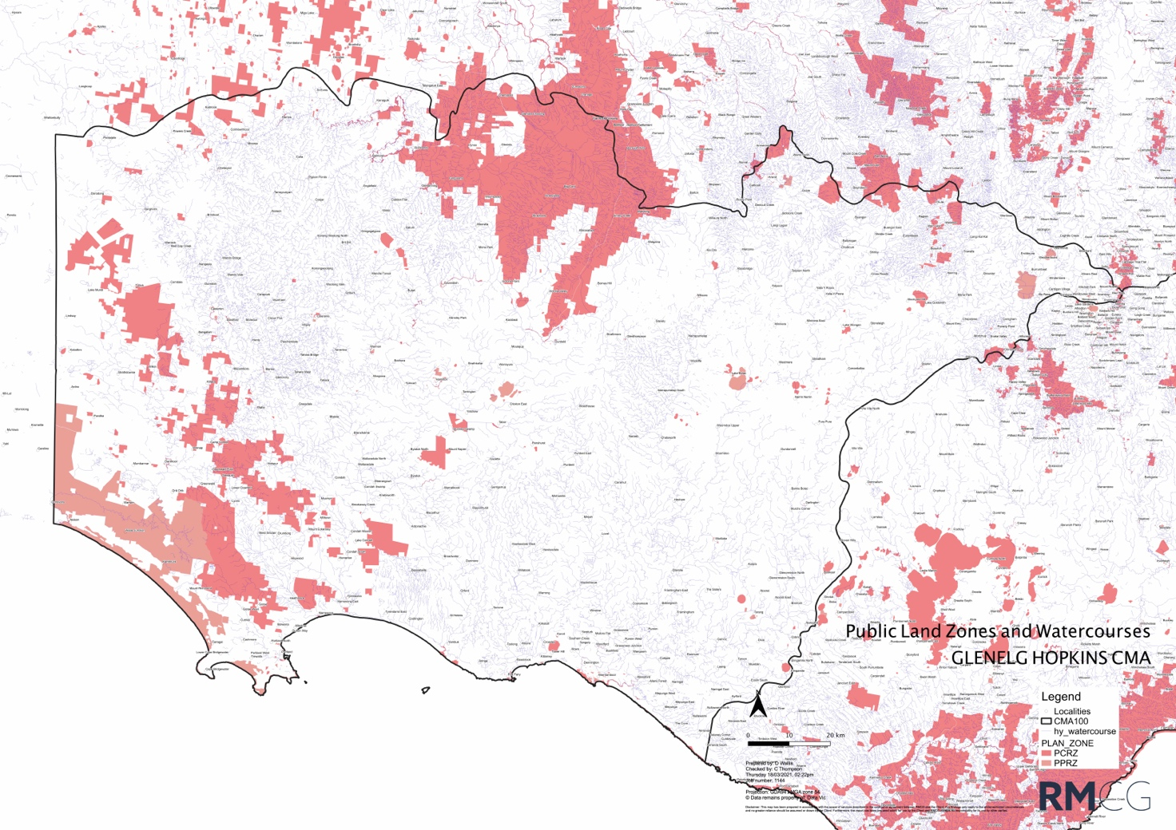
Figure 4-1: Public Land Zones
The above map is provided as a guide to the locations of the Public Conservation and Resource Zone and Public Park and Recreation Zones but should be used as a guide only and is not authoritative.
Further information is available at Siting and Design Guidelines for Water Diversion Works across Crown Land (NRE, 2001).

Works Plan (WP) to inform the Works Licence
The purpose of a Works Plan is to protect the aesthetic, archaeological, cultural and conservation values of the riverine and riparian environment and public land areas.
Pumps, pump houses, pipelines, access tracks and associated water diversion works must meet the standards necessary to minimise their impacts on other persons and the environment. This must involve an assessment of local conditions and the appropriate siting, construction, operation, and maintenance of water diversion works.
The works licence for private diverters also employs strategies to minimise impacts on other water users by placing limitations on an extraction share and extraction rates during periods of rationing or other restriction, required to be specified as part of the Works Plan.
Parks Victoria’s policy is that Crown Land access should only occur if there are no other existing water supply options. Sometimes there are existing water supply channels that Parks Victoria would prefer to be used first. Parks Victoria also may suggest alternative supply routes to minimise impacts to Park values. Also:
- All permanent pipelines must be underground, and Parks Victoria must be advised whether the proposal is for the pipeline to be buried in a trench or under bored
- No overhead powerlines are allowed
- Applicants must advise Parks Victoria how they plan to meet the pump shed, and access track, requirements and how they plan to minimise any impacts on natural values
- Applicants must also outline their basic rehabilitation plan once construction is complete.
A Works Plan (WP) must clearly describe the type and location of irrigation infrastructure required to be constructed to extract water from the supply point and the intended pathway to deliver it to the farm. A WP must include:
- Siting map of proposed works
- Construction plan
- Decommissioning plan
- Operation plan.
Consideration must be given to what mechanisms will be undertaken to meet the standards necessary and to minimise the impacts on other persons and the environment during construction as well as ongoing operation of the water delivery infrastructure into the future. For further details on the information requirements refer to https://www.water.vic.gov.au/managing-dams-and-water-emergencies/dams/guidance-notes.

Irrigation Drainage Plan that informs the TUL

IDP requirement
Part 3 (Section 18) of the Minister’s Policies for Managing Take and Use Licences (2014) calls for an IDP to accompany applications for a new or varied TUL.
The IDP is prepared by the application and must provide the information necessary to demonstrate how the development meets the necessary standards to minimise the impacts of water use on other persons and the environment (in particular, water logging, salinity, sediment, and nutrient impacts). The IDP must involve an assessment of local conditions and appropriate design of irrigation systems. The key purpose of an irrigation and drainage plan is to match the way land is irrigated and drainage managed/disposed of, with the characteristics of the landscape and soil, in order to efficiently meet the objective of minimising harmful side-effects of irrigation.
The IDP is a useful resource for other approval processes and its preparation can assist the developer to optimise the cost and benefit from the development.
For the new or varied Take and Use Licence to be granted, the irrigation and drainage plan must:
- satisfy agencies that risks are adequately identified and managed before being endorsed by the RC
- once endorsed, be referenced, and recorded as part of the TUL, including the polygon approved for irrigation.

Assessments that inform the IDP
This section is drawn from the Ministerial Policies. And applies to applications where the IDP is not waived by the risk assessment in Section 2.2.
A. Map
A map of the proposed development is to be prepared which clearly identifies at an appropriate scale:
- Property boundaries
- Areas to be irrigated
- Type and location of crops to be planted
- Location of existing features e.g., buildings, roads, channels, drains, fences, water storages, reuse systems
- Location of water resources (including depth to groundwater)
- Location of proposed features
- Existing and proposed native vegetation, wetlands, waterways, buffer zones and other environmental features.
- A range of planning overlays or management zones such as cultural heritage sensitivity areas, floodway overlays, potable water supply catchments, etc.
B. Topographical survey, including elevation data and suitable contours is to be prepared
For surface irrigation i.e., check-bank, flood and furrow irrigation systems, the maximum slope allowable is 1:50.
C. Soil assessment
There are different requirements for pressurised and surface irrigation systems.
Pressurised irrigation systems:
A soil survey is undertaken to provide information to assist the developer/ applicant in the preparation of an efficient irrigation design. This means the irrigation system is capable of applying accurate and uniform irrigation volumes to match the volume of readily available water that can be held in the soil. This helps to maximise productivity whilst minimising the risk of off-site impacts.
Information required for the area proposed to be irrigated is provided by a suitably qualified soil surveyor on an overlay of a map of the property and soil data sheets and includes physical and chemical soil characteristics.
Spacing for the soil sampling for pressurised irrigation is undertaken on a 75 by 75 metre grid however broader spacing may apply for less intensive agriculture after a risk assessment demonstrating that this is justified.
The soil sampling can be undertaken in a minimum pit depth of 1.5 m or soil core to 1.8 m. Measurements of pH and soil salinity (EC) to be obtained at representative soil types. Soil salinities should be measured for each distinctive horizon to 1.5 m.
The soil survey information is provided in a written report that includes:
- Clear property identification/identifiers (Crown Allotment etc.)
- Description of topography, hydrogeology, and previous land use
- Key aspects of climate
- Soil profile descriptions – soil texture of each layer, depth of each layer, depth of potential rootzone, readily available water, soil colour, mottling, pedality, dispersion index and coarse fragments.
- Factors affecting potential root-zone depth
- Soil/water interactions e.g., drainage, permeability, infiltration
- Readily available water
- At least 10% of the pits are to be characterised for soil chemistry (including EC, pH and Boron)
- Land capability
- Amelioration recommendations.
An overlay of soils grouped into similar irrigation management units is also required.
Where necessary, an AG VIC Irrigation Officer undertakes an independent assessment of all irrigation development soil surveys conducted in the region; this may include an onsite inspection of soil pits and review of the completed soil survey maps. As part of the assessment process the Irrigation Officer together with the soil surveyor, irrigation designer and hydrogeologist, will review the soil survey information and identify areas at risk of developing: perched water tables, lateral movement of irrigation drainage, and surface pooling that may affect crop productivity and/or the health of native vegetation. This group will recommend where shallow groundwater table monitoring bores should be located and nominate a monitoring frequency for early detection of groundwater table build-up.
These recommendations will in part be based on the recorded depth to water-impeding layers, including depth to clay and/or hardpans which may be a potential risk. The preliminary assessment will be considered to ensure groundwater monitoring bores are installed in areas that will assist in early detection of water table development before impact upon native vegetation. Additional recommendations may be made about soil amelioration or intersecting surface drainage to protect environmental values including stands of native vegetation. The recommendations are forwarded to the RC in an assessment report. The WC will include the recommendations (in whole or part) as conditions on the TUL.
Surface irrigation system:
An understanding of soil variability in the region from previous soil maps and land capability maps can be used to determine the required intensity of soil sampling. The required information includes:
- Soil layers and depths
- Any impervious layers
- Soil texture
- Hydraulic conductivity (permeability)
- Soil pH
- Salinity/sodicity
- Nutrient availability – nitrogen, phosphorus, potassium.
The soil survey information is to be provided in a written report that includes:
- Clear property identification/identifiers (Crown Allotment etc.)
- Description of topography, hydrogeology, and previous land use
- Key aspects of climate
- Soil profile descriptions – soil texture of each layer, depth of each layer, depth of potential rootzone, readily available water, soil colour, mottling, pedality, dispersion index and coarse fragments
- Factors affecting potential rootzone depth
- Soil/water interactions e.g., drainage, permeability, infiltration
- Readily available water
- At least 10% of the pits are to be characterised for soil chemistry (including EC, pH, and Boron)
- Land capability
- Amelioration recommendations.
An overlay of soils grouped in similar irrigation management units is also required.
D. Irrigation design
All developments:
The irrigation design must be completed by a suitably qualified irrigation designer to industry standards and provide information on anticipated crop water requirements and proposed maximum application rates, irrigation system specifications, and a map identifying delivery supply point and the area to be irrigated. Irrigation design will need to consider buffer requirements from retained native vegetation and waterways/wetlands.
The proposed irrigation scheduling arrangements should be specified.
Additional requirements for horticultural developments:
The general principle in the design is that the irrigation system should be capable of applying an irrigation depth equivalent to or less than the readily available water of the soil, appropriate to the crop. Areas of similar readily available water are to be grouped as irrigation management units and supplied separately, based on the results of the soil survey.
Flood and furrow irrigation should not occur where the calculated minimum depth that can be applied (taking into account infiltration rates, slopes, length of irrigation runs and discharge rate) exceeds the readily available water within the estimated crop root-zone.
Management and monitoring of irrigation:
Performance standards for irrigation management, monitoring and reporting is required to be included as part of the IDP. These standards provide managers of the irrigation system and regulators with information that allows routine assessment of environmental risk.
In addition, the applicant should supply plans for nutrient monitoring and salinity monitoring, as below.
The applicant is responsible for implementing the monitoring plan and reporting results to the Water Corporations. If these requirements are adequately translated into conditions on the TUL a graduated enforcement process is available under the Water Act 1989 Section 64 AF. That process can ultimately lead to TUL revocation in the event of repeated failure to comply with conditions.
Plan for nutrient monitoring:
A plan for monitoring nutrient balance (nutrients applied versus nutrient exported) and nutrient movement will be required. This should cover nitrogen and phosphorus export via rainfall runoff, irrigation tailwater and subsurface flows. In some cases, this may also include farm chemicals, pesticides, herbicides, fungicides, etc.
Plan for salinity monitoring:
A plan for monitoring groundwater levels and quality will be required as part of the IDP.
Shallow groundwater monitoring bores may be required to monitor water tables between the proposed irrigation development and sensitive sites. Normally these will only be required if the sensitive site is downslope of the irrigation area.
Monitoring of shallow groundwater monitoring bores will provide an early indication of groundwater tables and the need for a drainage system to be installed.
F. Arrangements for drainage disposal
Developers are responsible for their own drainage disposal. The IDP must therefore include an appropriate contingency drainage design.
The need for a subsurface and/or surface drainage scheme and re-use system must be considered. A design is to be developed for the appropriate system, and it must include:
- Details on the volume of water to be collected
- Details of any approved on-site disposal site and/or details of any off-site disposal site
- Details of approvals for any proposed re-use schemes and/or irrigation storages
- Details of sediment and nutrient management structures (e.g., sediment traps)
- Location of pumps, discharge, or re-use points.
If the weighted soil salinity is greater than 600 EC the IDP must include a preliminary sub-surface drainage plan identifying an appropriate contingency area for evaporative disposal in the event that subsurface drainage is required. Any land identified as being required for evaporative disposal must not be developed for irrigation.
G. Biodiversity protection arrangements
The IDP must identify those parts of the property and adjacent land where the use of water for irrigation poses direct and ongoing risks to wetlands, native vegetation, or the habitat of native animals. Depending on the RC’s assessment of the risks involved, this assessment may need to be done by a suitably qualified person/consultant for example a Cert V Arborist. Specific requirements would be advised by the relevant Local Government or DEECA.
In the case of wetlands, which can include floodplain depressions and billabongs, irrigation works could be harmful to wetlands in the area by changing inundation frequency, duration, timing, rate of filling, drying and/or extent. These impacts could make the wetland more wet than natural condition, or more dry.
For those areas, the IDP must specify mitigating measures and suitable monitoring parameters, as well as appropriate monitoring equipment and locations for the equipment to be installed. The IDP must also specify equipment maintenance standards, data reading, recording, reporting, and auditing requirements, corrective action thresholds, corrective action procedures, and corrective action time limits.
Note: The granting of a Take and Use Licence does not remove the need to apply for any authorisation or permission necessary under any other Act with respect to anything authorised by the licence.
It should be noted that the State Planning Policy Framework (SPPF) outlines Victoria’s policy objectives and strategies relating to the protection and management of native vegetation. This is covered in Section 4.4.1.

maximum application rates
Annual use limits can apply to TULs. The annual use limit must be less than or equal to the maximum application rate for the specified crop, where crop water requirements are consistent with “Crop evapotranspiration – Guidelines for computing crop water requirements”, FAO Irrigation and Drainage Paper 56.
Schedule 2 of the Standard Water Use Conditions sets out the maximum application rates (in megalitres per hectare per year), which are to be used in conjunction with irrigated areas (in hectares) to determine annual use limits.
The maximum application rates account for:
- All sources of water used on the property (including groundwater and surface water)
- Annual crop irrigation requirements (including evapotranspiration and leaching)
- Soil hydraulic conductivity
- Uniformity of water application / irrigation system efficiency.
The maximum application rates take into account some regional considerations, notably variations in evapotranspiration and rainfall.
However, where the applicant can show, using the principles and methodology set out in the above publication, that – because of local conditions, special crops, or an individual irrigation and drainage system – the application rate can safely be higher than the relevant one set out here, then the Minister may employ such higher application rate in determining the annual use limit.
Schedule 2 of the Standard Water Use Conditions lists maximum application rates for water use licences in different parts of Victoria.
The irrigation demand in Southwest Victoria is lower than the areas specified in Schedule 2 for Northern Victoria and can be variable and therefore the method specified for north-eastern Victoria will be used. This is:
“In north-eastern Victoria, irrigation is used primarily to supplement rainfall. Both evaporation and rainfall vary significantly across these regions. Therefore, maximum application rates, in ML/ha, will vary. They will be calculated using the following formula:
(a) subtract average rainfall in the period October to April inclusive (measured in millimetres) from average evapotranspiration in the same period (as calculated excluding the highest 10% of years); then
(b) multiply the difference by a crop coefficient for the specified crop (either the crop coefficient set out in FAO Irrigation and Drainage Paper 56 or another reasonable coefficient approved by the Minister); then
(c) divide the product by 100 (to express the result in ML/ha).”
Figure 4-2 can be used as a guide to indicate average annual perennial pasture irrigation requirements and regional variability.
Annual Use Limits or TUL licence volumes are usually set at a higher value than average requirements, they typically are set to cover an 80th percentile demand year, which has lower rainfall and irrigation requirements. These drier years will frequently have more than 200 mm/y higher irrigation demand than shown in Figure 4-2 below.
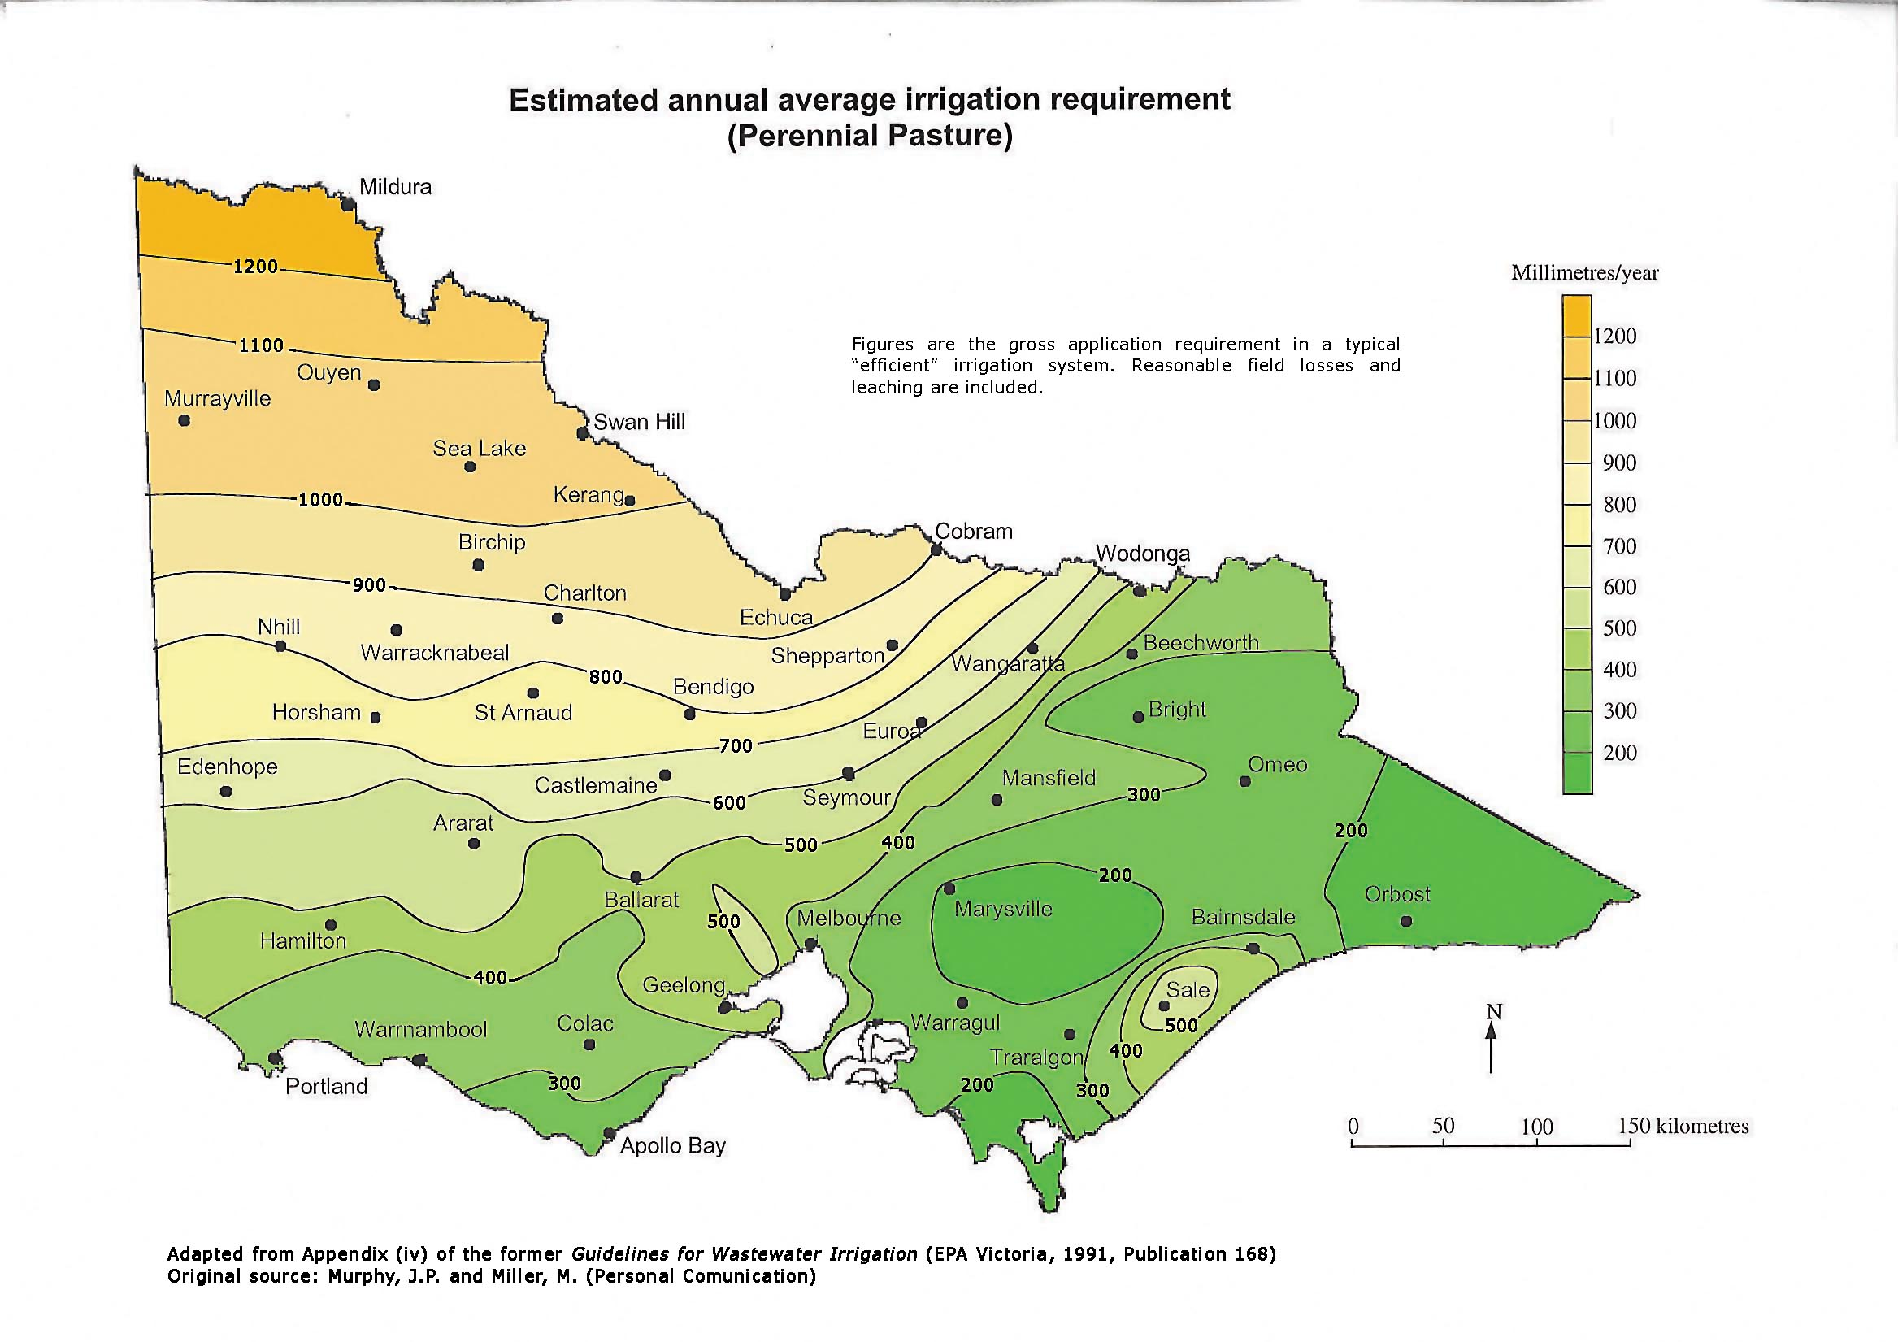
Figure 4-2: Perennial pasture average irrigation requirements across Victoria

Seasonal adjustment of annual use limits
The Ministerial Policies for Managing Take and Use Licences – Schedule 2: Standard Conditions for Take and Use Licences – Clause 21 – standard condition 31 (Managing groundwater infiltration) refers to the ability to adjust annual use limits on account of seasonal conditions.
Schedule 2 of the Standard Water Use Conditions for Water Use Licences describes the mechanism and states that:
“Unless the Minister, with the written agreement of the relevant Catchment Management Authority, has declared a seasonal adjustment to an annual use limit or limits to accommodate exceptionally high evapotranspiration, the maximum volume of water that may be applied to the land specified in the licence in any 12-month period from 1 July to 30 June will be the annual use limit.”

protecting biodiversity
All applicants must demonstrate they have considered the impacts on all biodiversity, including the risk of consequential or cumulative losses and that they have avoided the removal, destruction or lopping of native vegetation and groundwater dependant ecosystems.
The IDC should discuss these requirements with the applicant at an early stage. It is more effective for applicants to develop proposals that avoid loss if they consider this from the outset and plan for it.
The IDC and DEECA will provide guidance about avoiding the loss of trees and other native vegetation to help applicants understand these requirements at the start of the process. A loss assessment and offset is not automatically going to mean approval, whereas avoiding loss can expedite approvals and the requirements for a planning permit. However, these Guidelines cannot specify everything that will need to be planned for, and instead aims to signpost to supporting information to assist the applicant and IDC in planning to avoid loss of biodiversity and native vegetation.

Vegetation protection and buffers
General
It should be noted that the Planning Policy Framework (PPF) outlines Victoria’s policy objectives and strategies relating to the protection and management of native vegetation. Specifically, the following clauses give policy context and inform decision making:
- 12.01 Biodiversity
- 12.05 Significant environment and landscapes
- 13.04 Soil degradation
- 13.02 Bushfire
- 14.02 Water
- 15.03 Heritage (includes Aboriginal cultural heritage).
Clause 12.01 Biodiversity provides specific direction regarding the protection and management of biodiversity and native vegetation in Victoria. A key strategy identified in Clause 12.01 is to ensure that there is no net loss to biodiversity as a result of the removal, destruction or lopping of native vegetation.
This is achieved through the following three-step approach, in accordance with the Guidelines (DELWP 2017):
  - Avoid the removal, destruction or lopping of native vegetation
  - Minimise impacts from the removal, destruction or lopping of native vegetation that cannot be avoided
  - Provide an offset to compensate for the biodiversity impact from the removal, destruction or lopping of native vegetation.
Clause 12.01 references the Guidelines (DELWP 2017) and the following key policy documents which planning and responsible authorities must consider as appropriate:
- Protecting Victoria’s Environment – Biodiversity 2037 (Department of Environment, Land, Water and Planning, 2017)
- Any applicable biodiversity strategies, including the relevant Regional Catchment Strategy prepared under Part 4 of the Catchment and Land Protection Act 1994
- State-wide biodiversity information maintained by DEECA.
The requirement for a planning permit to remove native vegetation is detailed in the following two Particular Provisions:
- Clause 52.16 Native vegetation precinct plan
- Clause 52.17 Native vegetation – This clause outlines the requirement for a permit to remove, destroy or lop native vegetation, including dead native vegetation.
In addition to the requirements set out in the Guidelines (DELWP 2017), other legislation may apply when native vegetation is removed, or habitat for state (FFG Act) or nationally (EPBC ACT) listed species is degraded or destroyed. This could include:
- Flora and Fauna Guarantee Act 2019
- Environment Protection and Biodiversity Conservation Act 1999 (Commonwealth).
Note: The above information has been sourced directly from the Guidelines for removal, lopping or destruction of native vegetation (DELWP 2017 p4-5) which can be found at: https://www.environment.vic.gov.au/__data/assets/pdf_file/0021/91146/Guidelines-for-the-removal,-destruction-or-lopping-of-native-vegetation,-2017.pdf.
Further information on the regulations can be found in Section 5.4.3. It is noted that the Guidelines (DELWP 2017) may be reviewed and updated during the life of the Irrigation Development Guidelines and therefore applicants and staff are advised to contact DEECA and Council early in the planning stage, to ensure up to date information for your application.

What does this mean for irrigation developments?
An Irrigation Development Application (IDA) must consider all of the above biodiversity (and habitat) protection requirements through liaison with the IDC and the responsible authorities. For example, the application must demonstrate how the proposed use or development has been sited or designed to ensure the three-step approach (e.g., avoid, minimise, offset).
It is the applicant’s responsibility to ensure all approval requirements are addressed. For example, the IDP must identify those parts of the property and adjacent land where the use of water for irrigation poses direct and ongoing risks to all native vegetation as defined in the Guidelines (DELWP 2017). Depending on the RC’s assessment of the risks involved, this assessment may need to be done by a suitably qualified person/consultant as outlined in the Guidelines (DELWP 2017).
Relevant approvals are required to be included in the package of information presented to the RC and will be considered during the process of endorsement by the RC. Conditions on the TUL (and the planning scheme approval) provide the vehicle for compliance for protecting against “direct and ongoing risks” to biodiversity from “the use of water for irrigation”. For example, for areas identified as a risk to biodiversity, the IDP must specify mitigating measures and suitable monitoring parameters, including (where applicable) appropriate monitoring equipment and locations for the equipment to be installed. Where the latter is required, the IDP must also specify equipment maintenance standards, data reading, recording, reporting, and auditing requirements, corrective action thresholds, corrective action procedures, and corrective action time limits.
Buffers
When planning an irrigation development, the plan can demonstrate best practice by incorporating design buffers (vegetated or non-vegetated) as a mitigating measure, for the protection of biodiversity and waterway health. The adoption of buffers reduces potential impacts from:
- Water tables
- Surface runoff quality (e.g., nutrients and suspended solids) into waterways
- Spray drift
- Encroachment and damage caused by operating machinery
- Soil erosion and surface water movement
- Weed invasion.
Buffers must be managed for the benefit of biodiversity in a farming system, which will include various management requirements (e.g., stock management, ecosystem services, species selection). Advice should be sought prior to approval of the irrigation development where it includes buffers, to ensure long-term management. Where needed, responsible / referral authorities may specify conditions in any applicable planning permits.
The buffers are specified in Table 4-1.
Table 4-1: Vegetation requirements for irrigation developments
ENVIRONMENTAL ASSET/VALUE | REQUIREMENTS (E.G. BUFFERS)
Land administered under the National Parks Act 1975 and significant reserves under the Crown Land (Reserves) Act 1978. | Up to 200 m or as advised by Parks Vic.
Waterways including mapped wetlands and waterways in potable water supply catchments. | 30 metres (State Planning Policy Framework Clause 14.02).
Any vegetation which meets the definition of native vegetation as per 52.17. | Tree Protection Zone (For example, 12x diameter at breast height at 1.3m) (up to 15 m maximum) which will be determined by the responsible authority on a case-by-case basis.

Further information
There are a number of resources that can be used to guide delegates and applicants through the renewal, amendment or transfer of a works, or Take and Use Licence, including:
- Development Information Packages (factsheets, application forms, Ministerial Guidelines); available from WC and the IDC
- Guidance document (DELWP 2017) – Exemptions from requiring panning permit to remove, destroy or lop native vegetation https://www.environment.vic.gov.au/__data/assets/pdf_file/0018/91251/Exemptions-from-requiring-a-planning-permit-to-remove,-destroy-or-lop-native-vegetation-Guidance.pdf
- Clause 14.02-1S of the VPP (Catchment Planning and Management) and associated policy documents as listed therein. See: https://planningschemes.dpcd.vic.gov.au/schemes/vpps/14_02-1S.pdf
- Clause 14.02-2S of the VPP (Water Quality) and associated policy documents as listed therein. See https://planningschemes.dpcd.vic.gov.au/schemes/vpps/14_02-2S.pdf
- Dam information available from DEECA. See https://www.water.vic.gov.au/managing-dams-and-water-emergencies/dams/guidance-notes

Other approvals required for irrigation development

Aboriginal Heritage
Under the Aboriginal Heritage Act 2006 and the Aboriginal Heritage Regulations 2018, no agency can issue approvals without ensuring the developer has fully met the requirements of this Act.
With regard to the issuing of a Take and Use Licence or a Works Licence, a water corporation cannot, except for the above, withhold the licence based on the requirements of other Acts of Parliament; however, it is important for applicants to be aware that the proposed development may not proceed without first obtaining all necessary approvals. i.e., a licence could be issued but the development may not be legal or able to proceed, the purpose of the Irrigation Development Guidelines process is to avoid this untenable situation.
Aboriginal Heritage Act 2006 and the Aboriginal Heritage Regulations 2018 provides for the protection and management of Victoria’s Aboriginal heritage (e.g., Aboriginal places, objects and human remains etc.) on private land as well as public land.
Irrigation development activities (e.g., construction of river pumps, pipeline, and channel routes), in culturally sensitive landscapes can cause significant harm to Aboriginal cultural heritage. Given the primacy of these approvals, after receiving an application, the IDC will request advice from the relevant CMA’s cultural adviser about any specific areas, or sensitive overlays, to avoid disturbing.
The approval agencies / decision makers that are issuing statutory authorisations for works are responsible for ensuring that the applicant is complying with the Act. This may mean having an approved CHMP lodged with the planning application. A Cultural Heritage Permit (CHP) may be required where an exempt activity or a low impact activity may be planned that will or is likely to harm an Aboriginal place. The CHMP must cover the entire development proposal at the outset – even if the development will be carried out incrementally.
The requirements for a CHMP are defined by the Act. Under regulation 7 of the Regulations, a cultural heritage management plan is required for an activity if all or part of the activity area is an area of cultural heritage sensitivity and if all or part of the activity is a high impact activity.
In that context, irrigation developments will be ‘high impact activities’ if “the works are a linear project that is the construction of a pipeline with a length exceeding 500 metres; or the works are a linear project with a length exceeding 100 metres (other than the construction of an overhead power line or a pipeline with a pipe diameter not exceeding 150 millimetres); or the works affect an area exceeding 25 square metres”.
If the proposed development meets any of these criteria it will require a CHMP.
The following points apply to CHMPs:
- An applicant can use a cultural heritage advisor to undertake due diligence with regard to the need for a CHMP, but this does not provide certainty. Where it is unclear whether an approved CHMP is required a Preliminary Aboriginal Heritage Test (PAHT) may be undertaken. The PAHT is a voluntary process, which allows for the Secretary to the Department of Premier and Cabinet (Secretary) to certify whether a CHMP is required for the proposed activity. This provides certainty about whether a CHMP is required.
- For irrigation developments a CHMP can be triggered by earthworks that are defined as a utility installation. This can include land new pipelines or channels.
- Irrigation developments will be in an area of cultural sensitivity where it is on sand dunes, ancient lakes, sand sheets, lunettes and/or within 200 m of a named waterway or across Parks Victoria land
- Other triggers for a CHMP (where a high impact activity is proposed) include activity areas that include areas within 50 m to of known or registered Aboriginal places, such as scarred trees, shell middens and artefact scatters. Also, part or all of an activity area that falls within a park (as defined, for e.g., in the National Parks Act 1975).
- A Registered Aboriginal Party (RAP) may elect to approve a CHMP. Where the RAP declines to do so, or where there is no appointed RAP, then the DEECA Secretary (that is, First Peoples - State Relations) will assess an application for approval of a CHMP. Maps of RAP areas are included in Appendix 1 – Figure 9-1 and Figure 9-2.
- A CHMP is prepared by a heritage advisor who is engaged by the applicant
- A voluntary CHMP can put a worthwhile risk management process in place
- There are exemptions under the Act to doing a CHMP. For example, where all of the land for the proposed activity has been subject to ‘significant ground disturbance’ an exemption may apply. If there is part of an area of cultural heritage sensitivity (other than a cave) that has been subject to 'significant ground disturbance' that part is no longer an area of cultural heritage sensitivity. ‘Significant ground disturbance’ is defined as disturbance of:
    - The topsoil or surface rock layer of the ground
    - A waterway
    - By machinery in the course of grading, excavating, digging, dredging or deep ripping, but does not include ploughing other than deep ripping:
- Ploughing (other than deep ripping) to any depth is not significant ground disturbance. The types of machinery referred to does not include most historic machinery but is intended to refer to machinery used in the modern-day sense.
- Deep ripping is defined in the regulations to mean ‘ploughing of soil using a ripper or subsoil cultivation tool to a depth of 60 centimetres or more’. The burden of proving that an area has been subject to significant ground disturbance rests with the applicant for a statutory authorisation for the activity. The responsible authority may assist by providing the applicant access to any relevant records it has about past land use and development.
Note: even where significant ground disturbance has affected the land, if Aboriginal cultural heritage is present, it is protected by the Act. An applicant must then apply for a CHP or prepare a voluntary CHMP, where harm to Aboriginal cultural heritage cannot be avoided.
An application for a cultural heritage permit (CHP) may be required if a proposed activity or works will harm or is likely to harm Aboriginal cultural heritage (Aboriginal place or object). A Heritage Advisor can prepare and apply for a CHP on the applicant's behalf. This is usually for individual Aboriginal places.
For all activities there are reporting and compliance requirements that need to be met when undertaking works. This includes:
- Stopping work immediately and contacting the Victorian police and State Coroner's Office if suspected human remains are discovered. Human remains should not be touched or removed
- If suspected Aboriginal cultural heritage place or objects on any public or private land in Victoria are found, they must be reported promptly to First Peoples - State Relations under the Aboriginal Heritage Act 2006
- Notify First Peoples - State Relations of a discovery by completing a Preliminary Report form
- Avoid harm to any suspected Aboriginal place or objects
- Do not remove any Aboriginal cultural heritage
- Contact First Peoples - State Relations regarding management and protection of Aboriginal places.
Further information is available at:
- Aboriginal Heritage Act 2006: https://w.www.vic.gov.au/aboriginalvictoria/heritage/aboriginal-heritage-act-2006-and-the-aboriginal-heritage-regulations-2018.html
- Aboriginal Heritage Regulations 2018: https://www.vic.gov.au/aboriginalvictoria/heritage/heritage-tools-and-publications/guides-forms-and-practice-notes-for-aboriginal-heritage-management.html
- First Peoples- State Relations (https://www.firstpeoplesrelations.vic.gov.au)
- General enquiries – 1800 762 003
- Information Victoria Call Centre – 1300 366 356
- Heritage Division, Department of the Environment, Water, Heritage, and the Arts http://www.environment.gov.au/heritage/about/indigenous/index.html
- Aboriginal Heritage Act 2006 (amended 2016) (http://www.vic.gov.au/aboriginalvictoria/heritage/aboriginal-heritage-act-2006-and-2016-amendment.html)
- Aboriginal Heritage Act 2006 – Information sheets
- Aboriginal Heritage Regulation 2007
- Guide to Preparing Aboriginal Cultural Heritage Management Plans
- Cultural Heritage Management Plan Tool
- The Aboriginal Heritage Act 2006 – Advisory note – June 2007
- Aboriginal and Torres Islander Heritage Protection Act 1984
- Local Governments planning and building permits and Cultural Heritage Management Plan.
- Cultural heritage guide for volunteer groups developed by Landcare. This provides a clear explanation of when a CHMP is required: https://www.landcarevic.org.au/assets/Uploads/Aboriginal-Cultural-Heritage-Guide-Oct-2019-compressed.pdf.

Local government requirements
Land use and development are controlled by “responsible authorities”, usually local government authorities, under planning schemes. Planning schemes set out policies and requirements for the use, development, and protection of land. There is a planning scheme for every municipality in Victoria. Planning schemes throughout Victoria consist of:
- A Planning Policy Framework
- A Local Planning Policy Framework (containing a Municipal Strategic Statement)
- Zone and overlay provisions
- Particular provisions
- General provisions
- Definitions.
The Planning Policy Framework covers both broad issues/policies and local issues/policies/direction/vision This section provides the long-term directions for land use and development in the local municipality.
The Zone, Overlay and Particular Provision requirements provide the controls over the type of use and development allowed in each zone. This is primarily the information with which irrigation developers will be concerned.
There may also be local laws that could affect a development; for example, a local law may prohibit the discharge of water on to Council land, such as roadsides.

Planning permits

overarching requirements
It is not easy to make generalisations about when planning permits are required and when they are not. This will differ between municipalities and will depend on the land in question and the activity proposed. Each Zone, Overlay and Particular Provision will require different information to be submitted with a planning application.
For example, a parcel of land may be zoned Farming, allowing general agricultural pursuits while requiring a permit for more intense uses such as a piggery. The parcel may also be subject to a Salinity Management Overlay that may require a permit for earthworks, and a Rural Floodway Overlay, which may require a permit to construct or carry out any works. The proposed development may also be subject to a particular provision relating to, for example, signage or a local law may apply.
There are requirements in all planning schemes, both in farming zone and flood overlays, regarding earthworks and the impact on flooding and drainage e.g., earthworks which change the rate of flow or the discharge point of water across a property boundary trigger the need for approval. In the Shepparton Irrigation Region, there are floodplain management Guidelines for whole farm plans to meet the drainage and flooding requirements. These are available at:
https://www.gbcma.vic.gov.au/downloads/FloodplainManagement/Mar2003_FinalWFPGuidelines.pdf.
These Guidelines can be useful for landholders in the Southwest to refer to and can assist in ensuring that the proposed works comply with the relevant sections of the Water Act 1989. In particular, proposed works must not:
- cause or interfere with a reasonable flow (s 16 & 20)
- affect flood behaviour in areas declared as liable to flooding, or for which flood levels, flood fringe areas or building lines have been declared (s 203–210); or
- obstruct or interfere with flows in Declared Drainage Schemes (s 218).
Prospective developers having identified a parcel of land, should in the first instance contact their Local Government’s local planning department or ask the IDC about specific requirements.
The planning approval process can vary in time depending on the complexity of the development and the level of referral required. Local Government may need to refer the application on to another agency, such as DEECA, the relevant CMA, the Water Corporation or VicRoads. In some cases, the agency must be given twenty-eight days to respond, before Local Council can make a decision.
Most irrigation developments will occur within existing Farming Zones and pump/pipeline infrastructure from some Rivers (with Crown frontages) will occur within the Public Conservation and Resource Zone. The type of activities controlled in Zones will vary depending on the applicable overlays. Overlays contain special planning controls that protect special features of land covered by the overlay. There are a number of types of Planning Scheme Overlays that are likely to affect rural land:
- Environmental significance
- Vegetation protection
- Significant landscape
- Erosion management
- Salinity management
- Floodway
- Land subject to inundation
- Special building
- Bushfire management
- Heritage.

Uses and developments which may require a planning permit
This is a list of examples only and may not be complete. Please contact your relevant Local Government Authority for advice:
- Rice growing or other ponded irrigation
- Cattle Feedlots
- Native Vegetation Removal (including limb lopping and impacts to the Tree Protection Zone (root system) of trees)
- Pump and/or pipelines on or across Crown Land
- Earthworks (including laser grading)
- Road crossings or under boring
- Timber production
- Intensive animal husbandry
- Subdivision
- Constructing a building or other construction or carrying out works.
Where the removal of native vegetation is proposed to facilitate an irrigation development, any planning permit issued granting approval to remove native vegetation may be conditioned to require evidence that the requirements of the Water Act have been met. For example:
“No removal of native vegetation is to occur until evidence of a [Take and Use Licence] and/or [a Works Licence] having been issued under the Water Act 1989 in relation to the [proposed irrigation development] and/or [proposed works to construct a pump and pipeline to extract water from a regulated waterway] is provided to the responsible authority and/or [DEECA region].”

Local Government planning approval and appeals
Application may be approved subject to conditions or may be refused. If refused, an applicant may appeal the decision to VCAT.

Native vegetation regulations
A planning permit is required to remove, lop or destroy native vegetation under Clause 52.17 of all planning schemes in Victoria (and also can be triggered under an Overlay).. All applications to remove native vegetation must demonstrate they have followed the three-step approach and also in accordance with the Guidelines for Removal, Destruction or Lopping of Native Vegetation (DEWLP, 2017).
  - Avoid the removal, destruction or lopping of native vegetation
  - Minimise impacts from the removal, destruction or lopping of native vegetation that cannot be avoided
  - Provide an offset to compensate for the biodiversity impact from the removal, destruction or lopping of native vegetation.
The application must demonstrate how the proposed use or development has been sited or designed to avoid and minimise impacts on native vegetation, and that no feasible opportunities exist to further avoid and minimise impacts on native vegetation without undermining the key objectives of the proposal.
Biodiversity offsets compensate for the loss in biodiversity value when native vegetation is removed. An offset is delivered by protecting and managing native vegetation at an offset site. This protection and management improve the security and condition of the native vegetation, resulting in ‘gain’. This gain is used to meet the offset requirements when native vegetation is removed.
There are three types of offsets:
- A species offset (Species Habitat Unit) is required when the removal of native vegetation has a significant impact on habitat for a rare or threatened species
- A general offset (General Habitat Unit) is required when the removal of native vegetation does not have a significant impact on habitat for a rare or threatened species
- Large tree attribute – offsets must include one large tree for every large tree to be removed.
Following approval of a planning permit, required offsets must be secured prior to the removal of any native vegetation. As part of the planning permit application, evidence must be provided that the required offset is available:
- For purchase from a third party
- Will be established as a new third party offset site
- Can be met by a first party offset.
First party offset sites are on land owned by the holder of a permit to remove native vegetation. They are used to meet landowners’ own offset requirements.
First party offset sites must have a ten-year management plan and must be secured in perpetuity with either:
- An agreement with the Secretary to DEECA under section 69 of the Conservation, Forests and Lands Act 1987
- An agreement with a responsible authority under section 173 of the Planning and Environment Act 1987
- An agreement with Trust for Nature to register an offset covenant under the Victorian Conservation Trust Act 1972.
Prior to progressing first party offset sites, applicants must receive the written agreement from the statutory body that they will enter into a security agreement.
Third party offsets are established on land not owned by the permit holder. Third party offsets are purchased as a single, once-off transaction through a vegetation broker. Evidence that a third-party offset has been secured is a credit extract allocated to the permit from the Native Vegetation Credit Register. Further information is available at: https://www.environment.vic.gov.au/native-vegetation/native-vegetation and https://www.environment.vic.gov.au/__data/assets/pdf_file/0018/90360/Permitted-clearing-of-native-vegation-Biodiversity-assessment-Guidelines.pdf.

Environmental Protection and Biodiversity Conservation
The Environment Protection and Biodiversity Conservation (EPBC) Act 1999 is the Australian Government’s central piece of environmental legislation and is administered by the Commonwealth Government’s Department of the Environment and Energy. It provides a legal framework to protect and manage nationally and internationally important flora, fauna, ecological communities and heritage places defined in the Act as matters of national environmental significance.
Species can be listed because they are threatened and/or migratory species (including species under the 3 Bilateral Agreements and Bonn Convention). For example, any proposal that has potential to impact a Ramsar site must be assessed under EE Act (Vic) and EPBC Ac (Cwlth).
If a proposed project could impact on any matters of national environmental significance, it must be referred to the Commonwealth Government under the EPBC Act. The Significant Impact Guidelines outline a self-assessment process to determine if a referral is required. If a project is referred, the Commonwealth will advise if the project is a Controlled Action requiring assessment against the requirements of the EPBC Act.
It is the applicant’s responsibility to ensure their actions will not impact on a matter of national environmental significance and to ensure they have all necessary approvals before taking an action.
Further information is available at:
- Department of the Environment and Energy: 1800 803 772
- Environment Protection and Biodiversity Conservation Act (EPBC) 1999 and Regulations 2000
- Significant Impact Guidelines: http://www.environment.gov.au/epbc/publications/significant-impact-Guidelines-11-matters-national-environmental-significance.

Flora and Fauna conservation
The Flora and Fauna Guarantee Act (FFG) 1988 and FFG Amendment Act 2019 is the key piece of Victorian legislation for the conservation of threatened species and communities and for the management of potentially threatening processes.
A Protected Flora Permit for works on public land must be obtained from DEECA if the works may affect plants or communities listed in the Protected Flora List (DELWP 2017). More information is available at:
https://www.environment.vic.gov.au/conserving-threatened-species/flora-and-fauna-guarantee-act-1988/protected-flora-controls

Environment Effects Act 1978
If the proposed development could have a significant effect on the environment, it must be referred to the Victorian Minister for Planning for a decision on whether an Environmental Effects Statement is required. The criteria for referral include clearing 10 hectares or more of native vegetation, potential impacts on threatened species, important wetlands (including Ramsar and the Directory of Important Wetlands of Australia), and/or Aboriginal cultural heritage.
Pre-referral consultation with the DEECA Planning & Approvals Referrals Coordinator is encouraged. Further information is also available on the environmental effects referrals website.
The bilateral agreement between Victoria and the Commonwealth Government avoids duplication of assessment processes. Victoria can assess proposals that the Commonwealth has determined as controlled actions under the EPBC Act, and are also likely to have a significant impact on the environment under the Victorian EE Act. The Commonwealth will still make the approval decision under the EPBC Act, following review of the assessment material prepared by the relevant Victorian decision maker and provision of extra information as required. Further information is also available on the environmental effects referrals website.

Wildlife protection and conservation
The purpose of the Wildlife Act 1975 is to establish procedures in order to promote the protection and conservation of wildlife, the prevention of taxa of wildlife from becoming extinct and the sustainable use of and access to wildlife; and to prohibit and regulate the conduct of persons engaged in activities concerning or related to wildlife. All native wildlife in Victoria is protected under the Wildlife Act 1975. For some developments a Wildlife Management Plan may be required, for example:
- Where there is a significant land use change and a sustainable approach is required to manage wildlife populations (non-destructive control methods), for example changes from dryland agriculture to irrigated horticulture
- Where measures to protect, salvage and translocate native fauna are required during the removal of native vegetation. Wildlife handling, including the capture and translocation of fauna, requires a permit from DEECA known as a Wildlife Management Authorisation.

Floodplain Management and Works on Waterways

Statutory planning responsibilities
CMAs have statutory planning responsibilities under the Planning and Environment Act 1987; as well as being the regional caretaker of river health. Activities include statutory planning and flooding referrals, works on waterways permitting, flood and river health awareness, development of and support for flood studies, including support for cost-effective flood mitigation measures and flood warning systems.
These waterway and floodplain statutory actions/responsibilities are underpinned by the Regional Catchment Strategy and underpinning Waterway Strategies.

Flood level advice
Flood advice for a specific property can be obtained from the relevant CMA. Flood advice helps landowners to understand their risks and is useful for considering irrigation or other development:
Most works within a defined flood prone area require a planning permit from the local government (see 5.3 or 5.4). Local government will refer these development proposals to the relevant CMA for advice and/or its approval. CMAs encourage landowners/developers to obtain flood level advice early so that any development proposal identifies and mitigates potential risks associated with flooding.
The Victorian Planning Provisions (VPPs) provide the basis for all statutory land use planning controls in Victoria. The main mechanisms of the VPPs with respect to floodplain mapping and control are contained in the following zones and overlays:
- Urban Floodway Zone (UFZ)
- Special Building Overlay (SBO)
- Environmental Significance Overlay (ESO)
- Design and Development Overlay (DDO)
- Floodway Overlay (FO)
- Land Subject to Inundation Overlay (LSIO).
There are specific controls relating to buildings and works proposals contained within the overlay control. There are also extensive Guidelines that the responsible authority must consider before deciding on an application. All applications must be referred to the relevant floodplain management authority (CMA), unless in the opinion of the responsible authority the proposal satisfies requirements or conditions previously agreed in writing between the responsible authority and the floodplain management authority.

Works on waterways
Many work practices in the past have caused major degradation of waterways, including wetlands on public and private land. To protect and rehabilitate rivers and creeks there is a need to ensure that any works undertaken on designated waterways do not adversely affect the health of those waterways. Works and activities within the bed and banks of designated waterways require a permit from the relevant CMA. Works and activities may include:
- Bridges
- Culverts
- Fords
- Service crossings
- Storm water outlets
- Drop structures
- Stream deviations
- Extractions e.g., sand mining
- Bed and bank stabilisation
- Large woody debris removal or realignment
- Vegetation management.
Further information regarding these matters can be obtained from the relevant CMA.

References
Allen R.G. (1998) Crop evapotranspiration – Guidelines for Computing crop water requirements, FAO Irrigation and Drainage Paper 56.
ANCOLD (2002) Guidelines on Assessment of the Consequences of Dam Failure.
DELWP (2017) Guidelines for removal, lopping or destruction of native vegetation https://www.environment.vic.gov.au/__data/assets/pdf_file/0021/91146/Guidelines-for-the-removal,-destruction-or-lopping-of-native-vegetation,-2017.pdf.
DELWP (2019) Draft Advisory Note- September 2019 Irrigation Development Guidelines- Victoria.
DSE (2007) Your Dam Your Responsibility, A Guide to the Managing of Safety of Farm Dams.
DSE (2010) Advisory Note on Irrigation Development Guidelines in Victoria (Version 2.0).
North Central, Goulburn Broken and North East Regional Catchment Strategies.
Loddon Campaspe Irrigation Region, Shepparton Irrigation Region, and North East Land and Water Management Plans.
North Central, Goulburn Broken and North East Waterway and Floodplain Management Strategies.
Minister for Water (2007) Ministerial Determinations.
Victorian Planning Provisions https://planning-schemes.api.delwp.vic.gov.au/schemes/vpps/14_02-001S.pdf?_ga=2.8932214.290041624.1606288748-975258564.1544147380.

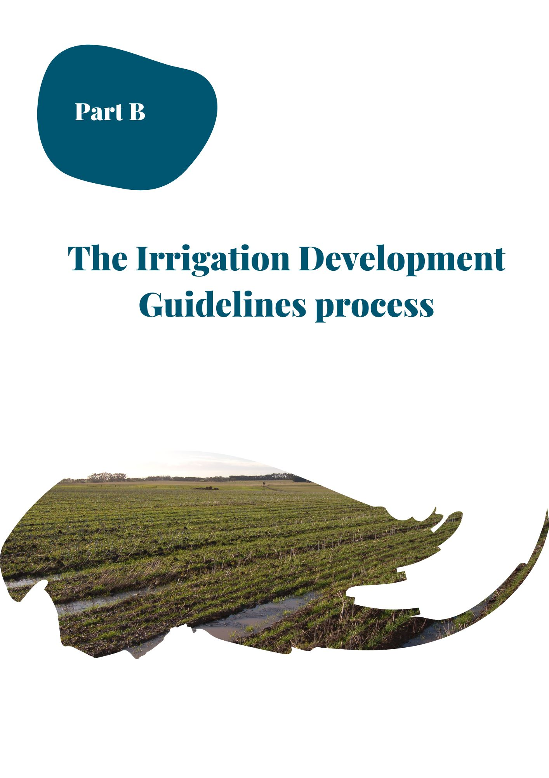

step | responsiblity | Explanation of ACTIVITY
INITIAL CONTACT, APPLICATION SUBMISSION & INVESTIGATION PHASE
1 | Applicant | Applicant initiates contact with agencies.  Initial contact can be made by a potential Applicant via a number of different avenues including the Water Corporation, CMA, Local Council, AgVic etc. All agencies are required to refer the enquiry directly to the WC by providing the Applicant with the WC contact details or forwarding the Applicant’s details to the WC.
2 | Water Corporation | The WC seeks information from the Applicant on the types of works, property location, scale of development, crop type, water requirement and the detail required in their preliminary map*, etc. The WC then provides the relevant application forms to the Applicant.  *The preliminary map needs to be of sufficient detail for agency staff to identify location, proximity to public land, proposed pipeline routes, native vegetation, volume and land proposed to be irrigated.  Alternatively, the Applicant can engage consultants (at their own cost) to assist with the Application. Consultants could include Heritage Advisors, Hydrogeologists or Irrigation specialists. AgVic provides some of these services, so it worthwhile that the Applicant contacts them also.  The WC or IDC may be able to give an indication at this stage if resource & delivery constraints can be met but only an indicative overview.  STOP & CHECK  Applicant checks cultural heritage.  It is the Applicant’s responsibility to seek a cultural heritage assessment check. This is done by contacting the First Peoples – State Relations and using their Aboriginal Heritage Planning Tool. This checks whether a Cultural Heritage Management Plan is required for a proposed activity. Alternatively, the Applicant can engage a Heritage Advisor at their own cost.  The Applicant is strongly advised to supply the WC with copies of documentation for the cultural heritage assessment. Any planning requirements articulated by the assessment will need to be addressed in an updated Application to the WC.
3 | Applicant | Applicant commences an application for new or varied WL and/or TUL (separate form to the IDA)  Each WC has their own application forms relating to requests to issue, transfer and/or renew Take and Use Licences (TUL) and Works Licences (WL). The Applicant downloads the WL and/or TUL form/s from the Water Corporation website. They should discuss the information required to complete the forms with the WC.  The Applicant can commence work on the Works Plan, Irrigation Drainage Plan; Planning Permit; any/all other required that will be advised by authorities and the IDC.  Applicant submits relevant Application Forms to WC:  Section 51 Take and Use Licence:  - Application for a licence to take and use groundwater and to operate works  - Application for a licence to take and use surface water and to operate works  - Application to transfer water entitlement (Take and use licence)  Section 64 Water Use Licence:  - Form 23 Application for a Water-Use Licence or Water-Use Registration  - Form 24 Application to Vary a Water-Use Licence or Water-Use Registration  Section 67 Works Licence  - Form 29 Application for the Issue of a Works Licence (in a declared system)  - Form 31 Application to Amend, Renew and/or Transfer a Works Licence  Note: The formal IDG assessment process commences on submission of the relevant completed application forms
INITIAL REFERRALS PHASE
4 | Water Corporation | WC continues to gather information based on progressive assessment.  WC refers application to relevant agencies including:  - CMA: Irrigation Development Guidelines, Works on Waterways, Flood Assessments  - Local Government: Planning permits in accordance with the Planning and Environment Act 1987 and relevant Planning Schemes.  - Urban Water Authorities: for water quality/resource impacts with potable water supply catchments.  - DEECA/PV: Environment Effects Act and Fauna Guarantee Act (impacts on protected flora). Native vegetation investigation and offset plan, biodiversity buffers and Public Land Manager / Landowner consent.  - EPA  - RAP  - Australian Govt – Dept. of Agriculture, Water and the Environment  - Others as required: e.g., power. road crossings, coastal boards, etc.  WC are to allow agencies 30 calendar days to respond from the date of referral.  Note: The onus is on each individual organisation to respond to the referral within the required timeframe. It is not the role of WC or the Irrigation Development Coordinator to follow up responses from other referral agencies.  RESOURCE AND DELIVERY ASSESSMENT, EARLY CHECK FOR SHOWSTOPPERS AND FURTHER INFORMATION REQUIREMENTS  The WC determines if there are any water resource, extraction share or delivery share constraints and advise proponent of delivery infrastructure requirements.  The WC also determine what additional requirements the applicant will need to meet, e.g. Hydrogeological Assessment, Cultural Heritage Management Plan and/or Irrigation Development Guidelines.  Where Guidelines are triggered, the WC provides the IDC with information similar to a ‘vendor statement’ with regard to any existing TUL or works licence associated with the property in question. This is ensuring that the total volume of water proposed to be used, and the source/s of that water, is understood from the outset.  To determine if the IDGs are triggered, the following checks are completed (refer to Section Error! Reference source not found. and 4 of the Guidelines for further details):  The delegate (WC) may modify or waive the requirement for an IDMP where, in the delegates view, any adverse impact from the use of water is likely to be minor AND the application fits into one of the following categories:  - T&UL or AUL volume is less than 20ML  - The application is a one-year temporary AUL increase OR a one-year temporary T&UL transfer  - The application is a 1-5-year T&UL temporary transfer AND leads to an increase in total licenced volume of less than 20%  NB: If the application requires a new (previously unirrigated) parcel of land to be added to an existing licence, then this is an automatic trigger for referral (i.e., greenfield developments)  Where the above criteria are met, there is no requirement for the WC to refer the application on the grounds of the IDG. However, there may be other matters that necessitate referral to the CMA and/or other agencies (e.g., Section 40 matters) > IDG PROCESS ENDS.  Where the above criteria are NOT met, or if there is any doubt > Proceed to next step.  If there is doubt that the Guidelines are triggered, the Referral Committee (RC) determines if the Guidelines are triggered (WC refers to RC through the IDC).
PRELIMINARY IDG RISK ASSESSMENT

5 | Water Corporation | Resource and delivery assessment, early check for ‘showstoppers’ i.e., WC refuses application, further information requirements.  The WC determines during the initial conversations with the Applicant if there are any water resource, extraction share or delivery share constraints and provides initial advice to the Applicant of delivery infrastructure requirements. Additional requirements may include hydrological assessment, Cultural Heritage Management Plan and/or Irrigation Drainage Plans. This is the earliest that the WC can advise whether an application is likely to progress.
6 | CMA (Irrigation Development Coordinator) | On receipt of initial contact from WC and Applicant, the IDC will use the WC assigned project number (for consistency across agencies) to create a secure project file and then commence the internal checklist to document and monitor the application progress.  Preliminary Environmental Risk Assessment – A preliminary risk assessment against the 5 Ministerial Water Use Objectives (objectives supplied in the Development Information Pack) and cultural heritage is required.  This preliminary assessment will determine if there is sufficient existing data available to provide the evidence and certainty to categorise the level of risk. The IDC will consult with other agencies/expertise as required. A preliminary IDG risk assessment is required to determine whether the area is at risk of creating off site impacts, e.g., nutrient pollution to waterways.  The assessment will categorise the development as either:  - LOW RISK and NO further information required – In some cases, where the information provided can confirm the development is low risk, the CMA may waive any further requirements and respond to the WC accordingly. Proceed to Step 9b.  - LOW RISK but further information required – In this case the CMA will contact the developer directly to seek further information. In some cases, a site visit may be warranted. Once information is provided and risk is confirmed as low, the CMA may waive any further requirements and respond to WC accordingly. Proceed to Step 9b.  - MEDIUM RISK – Continue onto site visit  - HIGH RISK – Continue onto site visit  A check of the property titles and relevant water licence numbers is also undertaken.
 | CMA, AgVic & WC | SITE VISIT  The WC and IDC will coordinate a site visit with the Applicant to discuss the proposal directly with the developer. This will assist in identifying issues that may have a bearing on the risk assessment, and the type and level of information required to be presented by the Applicant. Following the site visit the CMA will finalise the Preliminary IDG Risk Assessment for review by the RC. The IDC will coordinate this process and seek additional specialist/expert help if required.
7 | Applicant to DEECA& PV  (If application identifies crown frontage licence) | STOP & CHECK  The WC or IDC may advise the Applicant to refer to DEECA Planning and Approvals for Public Land Manager consent and Native Vegetation pre-plan assessment.  This advice is given when the application identifies crown frontage licence/s.  The Applicant contacts DEECA Planning and Approvals to receive preliminary advice if their application causes issues with access or impacts on public land may occur. DEECA Planning and Approvals will advise whether Parks Victoria or DEECA is the correct manager to issue Public Land Managers (PLM) consent to apply for the planning permit and Landowners Consent (LOC) to occupy Crown Land. Early consultation with the DEECA Planning and Approvals Officer will assist in determining the type of assessments required to gain PLM consent.  The type of water delivery assessments, water infrastructure installation and operation will be determined by the scope of works and how they will impact on the environment and the usability of the surrounds.  To determine the level of environmental risk, a Siting and Design Plan, or Site Environmental Management Plan must be submitted to DEECA. Where removal of native vegetation is proposed, preliminary advice will be provided regarding this.
8 | Referral Committee | RC confirms Guidelines are triggered or not and reviews: cultural heritage advice, and environmental risks to identify any pre-existing issues.  If Guidelines are not triggered, then the application is referred back to WC. The application and preliminary information collected during the site visit and with the preliminary environmental risk assessment, and any need for further information (i.e., not met by the preliminary hydrogeological and pollution risk assessments, cultural assessments etc.), will be presented to the RC by the IDC either to each member, or during a convened meeting. The RC will discuss the intentions of the application, including how risk issues are intended to be addressed and identify any remaining gaps in information.  This provides an early opportunity for the RC to identify if there are any pre-existing or known ‘showstoppers’ or issues that will need to be addressed or further considered during the assessment phase. Where development activities have occurred without appropriate approvals or permits, the IDA process may require the issue to be rectified /addressed before the application is progressed to the next phase of the process. In some instances, these issues may be considered to be a ‘showstopper’, preventing the IDA from being approved.  Referral Committee (RC) Review  The CMA’s IDC will convene a meeting of the RC Group. Usually this will include relevant staff from the CMA (including the IDC), WC and Agriculture Victoria. However, depending on the location and nature of development, may also include the relevant Local Government, Urban Water Corporation, DEECA, Parks Victoria, RAP or EPA.  The RC reviews the application, the Preliminary IDG Risk Assessment, and any other preliminary information collected. This provides an opportunity for the RC to confirm if there are any pre-existing or known ‘showstoppers’, and the issues that will need to be addressed. At this point the RC agrees on these additional requirements for the application, which may include the Irrigation & Drainage Plan (Low, Medium or High Risk), Hydrogeological Investigation that is dealt with by the WC, Planning Permits (Native Vegetation Clearance), Public Land Managers Consent, Works on Waterways Permit, etc.
9a | GHCMA (Irrigation Development Coordinator) | Letter of Advice  The CMA responds to the initial WC referral with a ‘letter of advice’ outlining further information requirements for the application based on the recommendations from the RC.  The letter provides the applicant with the opportunity to assess the level of effort and expense associated with proceeding with the irrigation development application before any expense has been incurred.  It is important to note that additional information may be identified as the process progresses and as a result of more detailed assessments.  It is important for the Applicant to understand the information requirements from the outset to prepare for and/or reduce the costs associated with undertaking these assessments. It must be made clear that technical assessments required for PLM consent will inform the Works Plan and the Works Plan must demonstrate how the risks associated with construction and ongoing operation of the infrastructure will be mitigated. It is important to explain to the Applicant the sequencing of these approvals.  It is the Applicant’s responsibility to engage suitably qualified experts to undertake the necessary assessments and ensure all other approval requirements are addressed. These approvals are required to be included in the package of information presented to the RC and will be considered during the process of endorsement by the RC.
REFERRAL RESPONSES & FURTHER INFORMATION REQUESTS
9b | All Referral Authorities | Referral Response  At this point all referral authorities have the opportunity to submit a response to the WC. In most cases responses must clearly state whether the referral agency:  - Object to the granting of a licence,  - Do not object to the granting of a licence, or  - Do not object to the granting of a licence subject to conditions

STEP | RESPONSIBILITY |  | EXPLANATION OF ACTIVITY
10 | Applicant |  | If required, the Applicant, or their contracted party, completes Draft IDP and provides to WC.
 |  |  | If required, the Applicant, or their contracted party, completes Draft Works Plan and provides to the IDC to distribute to relevant agencies.
 |  |  | Applicant now can provide the CHMP to WC to distribute to relevant agencies.
 |  |  | Applicant contacts local government for information needed for a planning permit.
 |  |  | Applicant provides information from DEECA if Public Land Management access or impacts needed to be considered.
11 | GHCMA (Floodplain planners & engineers) |  | Flooding risk assessment is completed by suitable qualified and experienced person – depending on risk.
12 | DEECA/ PV |  | Collating DEECA/PV Checks: Native vegetation investigation and offset plan, biodiversity buffers and Public Land Manager / Landowner consent.  The Works Plan must demonstrate how the risks associated with construction and ongoing operation of the infrastructure will be mitigated.
13 | Local Government |  | Assess Local Government planning permit requirement outcomes.  Local Government would have needed to issue permits in accordance with the Planning and Environment Act 1987 and have responsibility for a range of other land use planning functions. Each Council has a local planning scheme which includes state planning policy framework and a local planning policy framework, as well as zones and overlays that control the use and development of land.
14 | Other |  | Relevant authorities check – overarching approvals related to property developments.  Have any other required assessments been completed such as:  - Land titles and relevant existing water licence.  - Environmental legislation (Environment Effects Act, Environment Protection and Biodiversity Conservation Act and Flora and Fauna Guarantee Act (impacts on protected flora).  - Urban Water Authorities for water quality/resource impacts to their supplies.  - Public lands issues (PV Act, Road crossings, power access considerations).
15 | Water Corporation |  | WC refers full application to other relevant agencies and requests public comment.  WC checks designs are completed by suitable qualified and experienced consultants.
16 | Referral Committee |  | RC reviews all provided investigations according to risk and identifies remaining gaps in information.
17 | WC |  | WC provides advice to Applicant based on Agencies requirements and public concerns.
18 | Applicant |  | Preparation of Amended Application Submission  Proponent prepares requested information, for example, the revised Works Plan (WP) and Irrigation Drainage Plan (IDP)  The CMA and AgVic can provide advice and information to the applicant during this phase to assist in the development of the Irrigation and Drainage Management Plan. However, the onus is on the applicant to engage appropriately qualified professionals to assist in meeting the requirements.  Proponent submits IDP and other relevant plans/documents with an amended licence application to the WC.
FINAL APPLICATION ASSESSMENTS
19 | Water Corporation |  | Referral of Further Supporting Information  WC checks the proponent’s information is compliant with requests for further information and refers amended application and supporting material to relevant agencies.  WC are to allow agencies 30 days to respond from the date of referral of the amended application.  Note: The onus is on each individual organisation to respond to the referral within the required timeframe. It is not the role of WC or the Irrigation Development Coordinator to follow up responses from other referral agencies.
 | Referral Committee |  | The Irrigation Development Coordinator liaises with the RC to confirm the Irrigation & Drainage Management Plan appropriately addresses the identified risks. This includes other approvals and assessments that may be required from other government agencies e.g., Cultural Heritage Approval; Local Planning or other permits/approvals as required e.g., power, hydrogeological plans, protected flora, removal of native vegetation, power, road crossings, waterway manager consent etc…  The RC determines if there are particular conditions that need to be set on the licence. Depending on the nature of the application, this may be done via a second RC meeting or via email. The intent of this second meeting is to ensure consistency, collaboration and transparency between agencies and reduce duplication of effort both for agencies and the applicant.  Where further information/clarification is required, the RC may liaise directly with the proponent to obtain this information. If this additional information is likely to take significant time, the relevant agency (or agencies) may need to request an extension of time from the WC.  Once all information requirements have been met, ideally, the RC will unanimously approve the Irrigation & Drainage Management Plan. However, it is the responsibility of each agency to respond to the WC within the timeframe.  Note: The WC is the Ministerial Delegate and as such can make a final decision on the application without the RC’s approval
20 | All Referral Authorities |  | Referral Response & Licence Conditions  At this point, all referral authorities have the opportunity to prepare a formal response to the application clearly indicating whether it:  - Objects to the application; or  - Does not object to the application; or  - Does not object to the application subject to conditions  A brief explanation for the response should be given with reference to the RC endorsement, or otherwise, of the Irrigation Drainage Plan. In most cases, a condition on the licence will be recommended as follows:  ‘That the development proceeds in accordance with the approved Irrigation and Drainage Management Plan (Ref: #####)’
LICENCE DETERMINATION
21 | Water Corporation |  | Licence Determination  The WC completes licence determination in accordance with its delegated responsibilities and may:  - Reject the application; or  - Accept the application; or  - Accept the application with conditions.  In either case, the WC shall respond to the applicant in writing including a brief rationale for the decision and where necessary an explanation on any conditions (and also send a copy to the IDC for the RC).  If applicable, the WC issues a licence and finalises application registration in accordance with relevant processes.  Where the WC makes a decision to decline the application based on any of the s40 matters, it is at this point that the Applicant may appeal to VCAT, according to VCAT  requirements.
STEP | RESPONSIBILITY | EXPLANATION OF ACTIVITY
22 | Water Corporation | Notice of Decision  The WC prepares a Notice of Decision and provides to relevant agencies.  Minister or Minister’s delegate (WC) issues a works licence and Take and Use Licence when all necessary prerequisite approvals are obtained, subject to Minister’s/ Minister’s delegate consideration of water resource limits.  This information in the formally lodged application is used by the WC to officially register and approve all Take and Use Licence and Works Licence information, including conditions, in the Victorian Water Register. The WC commits to notify the IDC/RC via email when the application has been approved and supplies the licence numbers as recorded in the VWR. The IDC can then close the file.  WC issues a notice of decision to parties (individuals and agencies) who submit during the 30-day comment or response period.  Individuals may be those who submitted a Public Comment.
COMPLIANCE
23 | Water Corporation | Monitoring compliance of licence conditions is the responsibility of the licencing authority.

Water delivery activities: Water Infrastructure (works licence). Before any pump and pipeline works can commence a number of approvals must be obtained, including, in order:
  - Landowners’ approval to occupy the land which is likely to include public land manager (PLM) consent for works on Crown Land along waterways as well as private landowners for any proposed pipeline routes. Usually a Cultural Heritage Management Plan/permit and a native vegetation assessment and offset plan is also required across the whole of the development for obtaining PLM consent.
  - Planning permit from Local Council to use the land both for construction purposes as well as ongoing operation and maintenance
  - A works licence from the Water Corporation to construct and use the water infrastructure. Types of works requiring the above approvals include: The construction of new infrastructure; The alteration of existing infrastructure including upgrades and modifications where there is a change and/or increase in the construction footprint previously approved; and decommissioning of old infrastructure. A works licence is a pre-requisite for the approval of a TUL. Because of this, it is advised that assessments and approvals associated with the construction of water infrastructure and works licences are undertaken first as this may determine if the development is able to proceed. No works are allowed to commence prior to PLM consent, planning permission or works licences have been obtained. This also applies to the storage of construction materials in the construction area.
Water use activities: Irrigation Drainage Plan (IDP for a TUL). Before water is able to be delivered to the property a TUL associated with the land parcel must be approved by the Water Corporation. This will not be granted if there are no works or systems in place or likely to be installed in the near future for delivering water to the land. Under s69 of the Act, regarding applications for works licences, “the Minister [or the Minister’s delegate] must defer consideration of the application pending the determination of any related application” for a TUL. Applicants are therefore strongly encouraged to commence the necessary approvals processes for a WL to ensure works like pump and/or pipeline installations can be completed before commencing any water use activities on the property. Any works undertaken before the TUL is approved is not recommended and is at the risk of the applicant/landowner. The information requirements for an IDP may include:
  - Soil survey; independently reviewed by the AG VIC Irrigation Officer. This includes an onsite inspection of soil pits and review of the completed soil survey maps
  - Irrigation design
  - Surface and sub-surface drainage design
  - Hydrogeological investigation
  - Protection of biodiversity.
The RC will assist in identifying areas at risk of developing perched water tables, lateral movement of irrigation drainage, and surface pooling that may affect crop productivity and/or the health of native vegetation. This group will recommend changes to irrigation and drainage designs to align with best practice, where to locate shallow groundwater table monitoring bores, where required and nominate a monitoring frequency for early detection of rising ground water tables. Additional recommendations may be made about soil amelioration or intersecting surface drainage to protect environmental values including stands of native vegetation. The water use assessments will be used to inform the development of an irrigation and drainage plan (IDP) providing the evidence to demonstrate how the risks associated with the farm activities will be minimised.
If the use of water poses an ongoing risk to native vegetation, then in keeping with Minister’s Water Use Objectives, the IDP can specify buffers between the approved irrigated polygon and the native vegetation. The TUL can then include conditions regarding monitoring requirements to determine whether corrective thresholds have been reached, and it can include conditions regarding corrective action procedures.
The applicant needs to be aware that other assessments and approvals or permits/ licences may be required for various aspects of the irrigation development activity. Examples of these may include but are not limited to Planning Permits managed by local councils for native vegetation removal (including lopping) and works on the waterways (which can be Crown land within the Public Conservation and Resource Zone), Cultural Heritage approvals etc. It is not easy to generalise about when planning permits are or are not required. This will differ between municipalities and will depend on the land in question and the activity proposed. Each Zone, Overlay and Particular Provision will require different information to be submitted with a planning application. Prospective developers having identified a parcel of land should in the first instance contact the local planning department or ask the IDC about specific requirements.
Given the primacy of Cultural Heritage approvals, after receiving an application, the IDC will request advice from the relevant CMA’s cultural adviser about any specific areas, or sensitive overlays, to avoid disturbing.
All applicants need to be aware that if they propose to remove native vegetation, they will need to demonstrate they have followed the three-step approach:
  - Avoid the removal, destruction or lopping of native vegetation
  - Minimise impacts from the removal, destruction or lopping of native vegetation that cannot be avoided
  - Provide an offset to compensate for the biodiversity impact from the removal, destruction or lopping of native vegetation.
The application must demonstrate how the proposed use or development has been sited or designed to avoid and minimise impacts on native vegetation, and that no feasible opportunities exist to further avoid and minimise impacts on native vegetation without undermining the key objectives of the proposal.
Works Licence Conditions.
Works licences to construct, operate, alter, decommission, or remove works associated with the extraction of water (i.e., bores, pumps and dams) are subject to conditions set by the Minister and are specified on the licence (Refer to Appendix 2- Policies for Managing Works Licences). These conditions must be consistent with and refer to the contents of the works plan, management plan, dam safety surveillance plan, dam safety emergency management plan or other relevant (and referenced) document.
The conditions on a works licence will address:
  - The scope of works covered under the licence
  - The responsible entity for the licence
  - The terms and conditions of the licence
  - Considerations for licence renewals and amendments
  - Specification around extraction limits
  - Water meter installation and use
  - Site specific information (such as management plans).
Water Register standard conditions are provided in Appendices.

Take and Use Licence Conditions.
Standard and particular conditions for the TUL to meet the Ministerial Water Use Objectives that are consistent with, and in reference to, the contents of the IDP.
The Standard Conditions on a TUL address:
  - Managing groundwater infiltration – required metering of water delivery to the specified area of land under licence
  - Managing disposal of drainage – surface and subsurface drainage strategy within the property boundary
  - Minimising salinity – irrigation design and irrigation water salinity concentration that meets the soil characteristics; salinity offset charges required to mitigate the river impacts caused by irrigating the specified area of land
  - Protecting biodiversity – installing, maintaining, and monitoring groundwater bores including reporting requirements to observe any impact of the irrigation activity on native vegetation, the habitat of native animals or wetlands as well as corrective actions where there is a breach.
Particular or special conditions may include: The annual use limit (AUL) for any season; and requirements that govern the use of ponded irrigation. For more information, refer to Standard Water Use Conditions (Schedule 2 of Policies for Managing Take and Use Licences). The Victorian Water Register (VWR) has been set up so that water corporations can select suitable conditions from dropdown menus, when they are issuing, renewing, or varying licences under the Water Act 1989. The aim in building this functionality into the register was to help ensure that conditions were written in consistent, enforceable language that was drawn from Ministerial policies and determinations. The full range of possible conditions available in the water register is reproduced in the Appendices. The Appendices show that parts of the text in these condition sets are editable. This provides scope to translate RC recommendations into particular conditions on licences.

BLANK PAGE

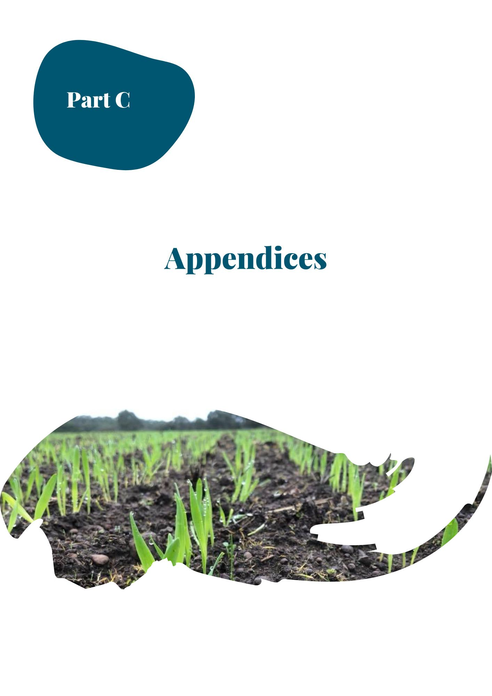
Appendix 1: Legislative framework and regional catchment strategy context

Overall framework
There are two main legislative and administrative pathways associated with TULs:
- The Victorian Water Act 1989
- The Regional Catchment Strategy (RCS) developed under the CaLP Act 1994.
Outlined in this section are the relevant policies related to irrigation development. However, agency staff and developers also need to be aware that conditions may also be set under:
- Planning and Environment Act 1987
- Aboriginal Heritage Act 2006
- Flora and Fauna Guarantee Act 1988 and FFG Amendment Act 2019
- Environmental Protection and Biodiversity Conservation Act 1999
- Wildlife Act 1975
- Any other requirements contained in Acts of Parliament and implemented by other authorities or by other states.
It is important that irrigation developers are made aware that there may be additional requirements under these acts when applying for a WUL/TUL. The applicant will need to engage with the relevant authorities outside of the irrigation development process in order to ensure all legislative obligations are met. Whilst the issuing of a licence cannot be withheld based on the requirements of other Acts of Parliament, a licence to divert water, if issued, does not override, or negate the need for the applicant to meet the requirements under other acts of Parliament. Therefore, it is important for applicants to be aware that the proposed development is unlikely to proceed without first obtaining all necessary approvals.
It is important to note that a decision maker cannot grant a statutory authorisation for an activity which requires a CHMP, until the CHMP is approved (S.52 of the AH Act).

Links to key legislation
Table 6-1 provides links to the current version of the main pieces of legislation.
Table 6-1: Links to legislation
Act | URL
The Victorian Water Act 1989 | http://classic.austlii.edu.au/au/legis/vic/consol_act/wa198983/.
CaLP Act 1994 | http://classic.austlii.edu.au/au/legis/vic/consol_act/calpa1994267/.
Planning and Environment Act 1987 | http://classic.austlii.edu.au/au/legis/vic/consol_act/paea1987254/.
Aboriginal Heritage Act 2006 | http://classic.austlii.edu.au/au/legis/vic/consol_act/aha2006164/.
Flora and Fauna Guarantee Act 1988 | http://classic.austlii.edu.au/au/legis/vic/consol_act/fafga1988205/.
FFG Amendment Act 2019 | http://classic.austlii.edu.au/au/legis/vic/num_act/fafgaa201928o2019331/.
Environmental Protection and Biodiversity Conservation Act 1999 | https://www.legislation.gov.au/Details/C2019C00275.
Wildlife Act 1975 | http://classic.austlii.edu.au/au/legis/vic/consol_act/wa197593/.

Information on water entitlements is also available at the Victorian Water Register at https://waterregister.vic.gov.au/.

Victorian Water Act 1989
The Victorian Water Act 1989 is the legislation governing the way water entitlements are issued and allocated in Victoria. It defines water entitlements and establishes the mechanisms for managing Victoria’s water resources. Table 1 outlines sections of the Victorian Water Act 1989 relevant to irrigation development (DSE, 2010).

Ministerial Determinations
The groundwater and surface water sources in the Southwest are undeclared. This means that the water share, extraction share and water use licence (WUL), which are unbundled into separate entitlements in declared systems (such as the Murray in Northern Victoria) are bundled together in a TUL.
The setting of Water Use Objectives, WUL/TUL conditions and works licence conditions all occur under the Victorian Water Act 1989. The Water Corporation acts as the Minister for Water delegate, and on behalf of the Minister, authorises the use of water through issuing WULs/TULs and works licences. In granting a WUL/TUL or works licence, Water Corporations must assess whether the proposed use of water is consistent with the Ministerial Water Use Objectives and standard water use conditions, and they must follow the policy for managing works licences.
Table 6-2: Sections from the Victorian Water Act 1989 relevant to irrigation development
 | Section | Description
Take and Use Licence (Applicable in Southwest) | Section 51 | A person requires a licence under Section 51 of the Act to ‘take and use’ water from a groundwater system, or surface water which is not a declared system (i.e., water system that has not been unbundled).
 | Sections 53 and 56 | In considering an application for such a licence, and the conditions to be imposed, the Water Corporation is required to consider matters outlined under Section 53 and 56 of the Act, including:  - Any adverse effect the exercise of rights under the licence is likely to have on in-stream uses of water, on the aquifer or on the flow of water within the waterway (e.g., water availability, permissible consumptive volume, water quality)  - The effects on the implementation of the conservation policy of the government, and the need to protect the environment, including the riverine and riparian environment  - The purpose for which the water is to be used  - Any other matter that the Minister thinks fit.
Works Licence (Applicable in Southwest) | Section 67 | A works licence is required to construct and operate works on a waterway, groundwater bore and certain private dams. A works licence is generally required to pump water from a waterway or aquifer. A works licence can authorise a person to enter onto and install works on Crown Land; but it does not authorise the applicant to lay pipes on freehold land or to remove vegetation.
 | Section 68 | Section 68 lists the matters to be taken into account in considering an application for a works licence.
Water Use Licence  (Not applicable in Southwest, provided for context) | Section 64L | A person requires a WUL under Section 64L to use water on land for irrigation purposes if the water is taken from a declared water system (i.e., an unbundled system such as a declared water system).
 | Section 64M | In dealing with an application, the relevant Water Corporation is required to consider:  - Impacts the proposed use may have on other persons or the environment (in particular water logging, salinity and nutrient impacts)  - Whether or not the proposed use can meet Standard Water Use Conditions that would apply to the licence, if granted  - Any comments received from the CMA, if the application was referred to the CMA and comments received within 30 days of the referral.  Any other matters the Minister considers relevant to that Corporation.

Water Use Objectives
The Ministerial Determinations set out five Water Use Objectives that the conditions on TULs must strive to meet if they are to be valid at law. These same objectives inform the Minister’s policies for managing TULs. The objectives are:
- Managing groundwater infiltration
- Managing disposal of drainage
- Minimising salinity
- Protecting biodiversity
- Minimising cumulative effects of water use.
The standard water use conditions specified for new or varied TULs are reproduced over the page Figure 6-1.
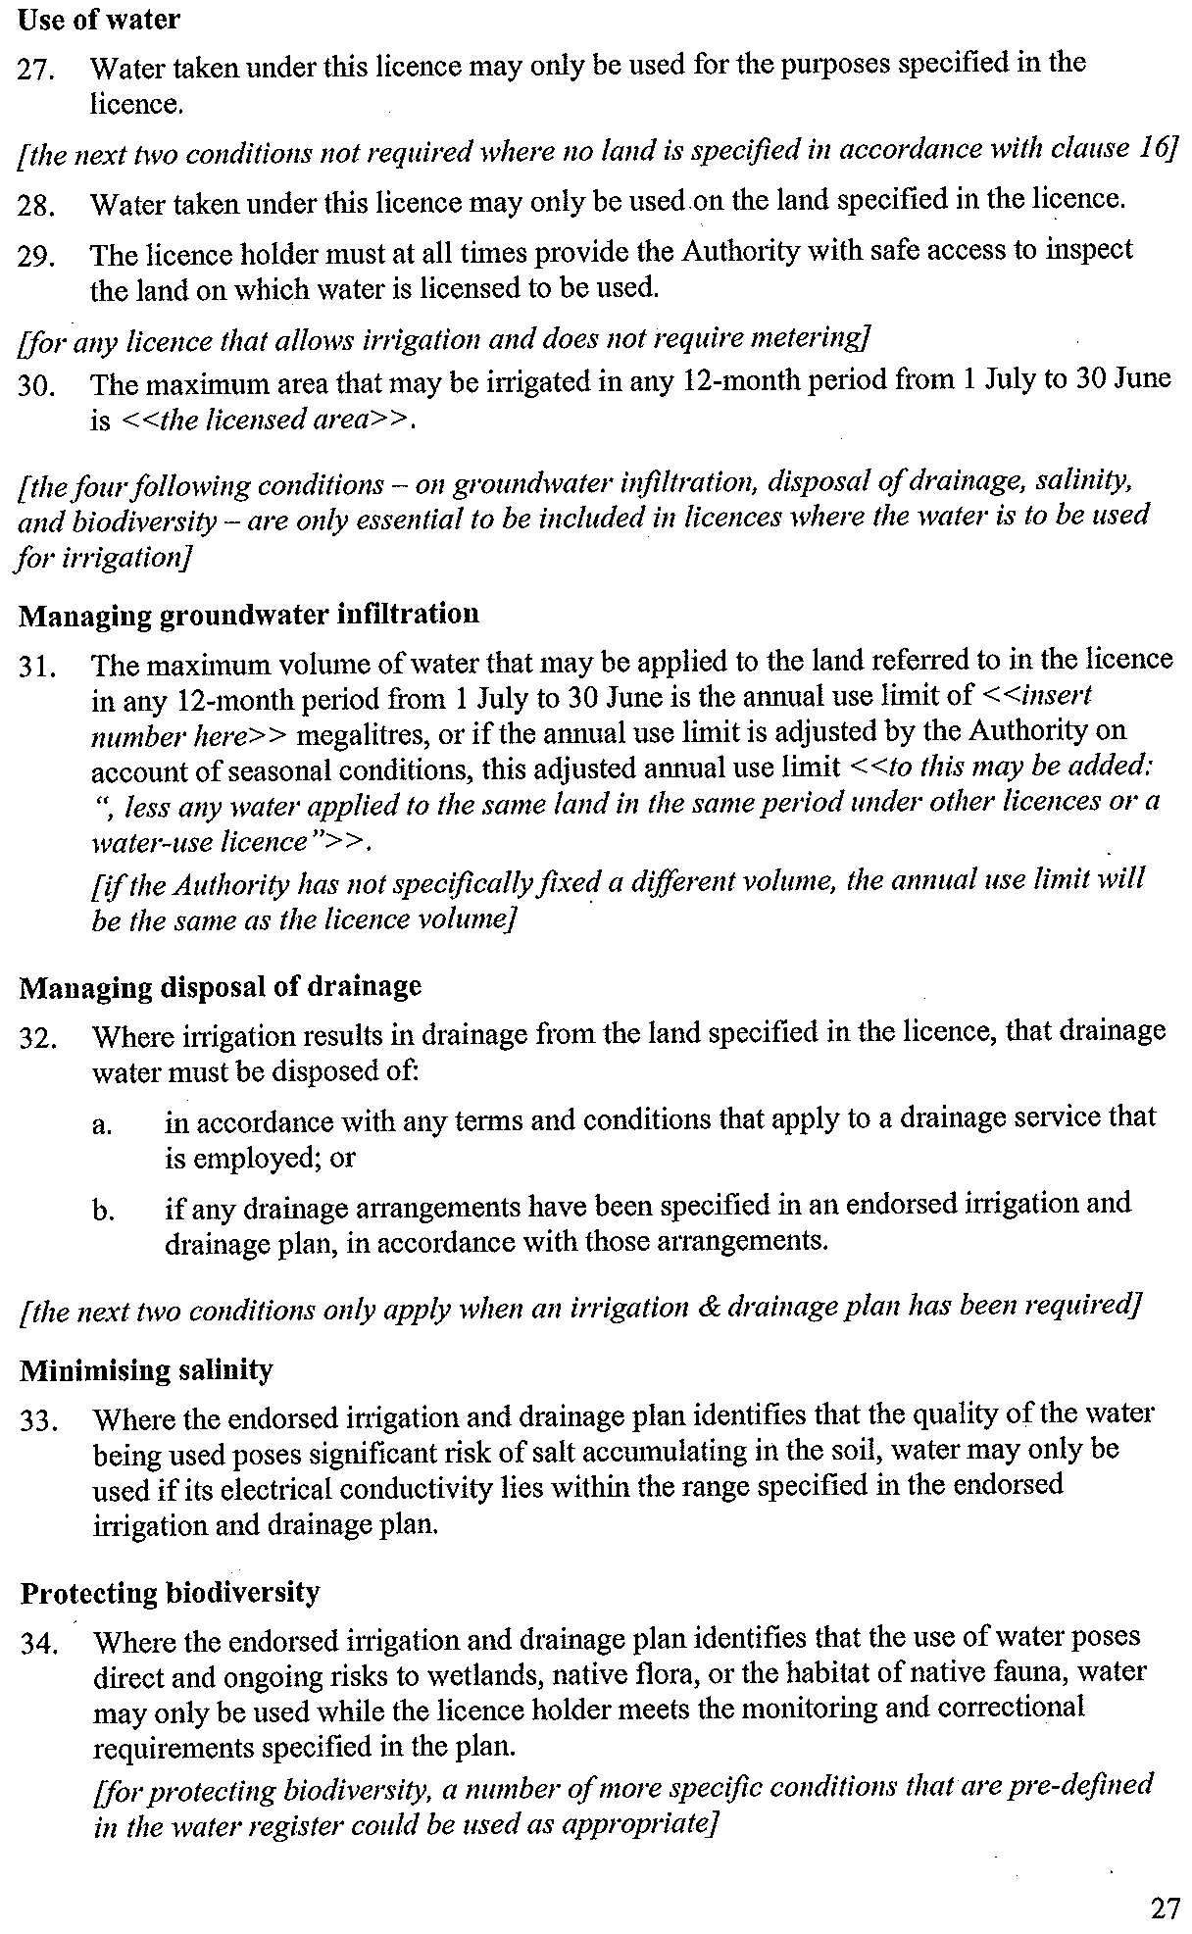
Figure 6-1: Extract from Minister’s policies for managing TULs
The definitive source on policies for managing TULs is available at:
https://waterregister.vic.gov.au/water-entitlements/about-entitlements/take-and-use-licences.
The definitive source on policies for managing WULs (Not applicable in Southwest, but provided for context) is available at:
https://waterregister.vic.gov.au/water-entitlements/about-entitlements/water-use-licences.
Under the Ministerial Determination irrigation developments or irrigation expansion activities requiring new or varied TULs are required to meet higher performance levels that are closer to best practice. More stringent standard water-use conditions are therefore applied, including the development of an irrigation drainage plan (IDP) as set out in Schedule 1 of the Ministerial Determination.
A list of conditions is provided in Appendices 5, 6, and 7.
The key purpose of an IDP is to illustrate how the irrigation system design and proposed drainage water disposal takes into consideration the characteristics of the landscape and soil type, and how it minimises harmful side-effects. By encouraging applicants to match crop types to soil suitability, and then designing irrigation systems based around that information, the irrigation development can meet a number of the water use objectives, including minimising recharge to the groundwater.

Particular Water Use Conditions
Where a development might require particular conditions to be placed on the TUL, which are not catered for within the standard conditions, the relevant Water Corporation may place “particular conditions” on the licence provided that these conditions meet the Minister’s Water Use Objectives.
Approval agencies may request particular conditions to meet individual requirements specific to a location or circumstance peculiar to a development proposal. This would normally occur in response to a specified environmental risk or risks, having been identified in association with the development, which may require a higher level of management or mitigation activity than allowed for within the standard conditions.

Policies for Managing Works Licences
The procedures and processes to be applied to an application for renewal, amendment or transfer of a works licence are set out in the Policies for Managing Works Licences. These Policies apply to all licences under Section 67 of the Water Act 1989 that are associated with the authorised take, use, conveyance, or storage of water in Victoria. These policies were amended in October 2010 with all related previous policies being revoked.
Key requirements set out in Part two of the policies are:
- The scope of works
- Requirements for issuing of a works licence
- Guidance for assessing applications that include construction and installation of dams and bores.

Catchment and Land Protection Act (CaLP) 1994
The CaLP Act 1994 has an objective of establishing a framework for the integrated and coordinated management of catchments which will maintain and enhance long-term land productivity while also conserving the environment. The Act aims to ensure that the quality of the State’s land and water resources and their associated plant and animal life are maintained and enhanced.
The CaLP Act 1994 provides for the development of RCSs by Catchment Management Authorities which, among other things, must assess the nature, causes, extent and severity of land degradation of the catchments in the region and identify areas for priority action.
Local Planning schemes must have due regard for the RCSs. With regard to WULs, the RCSs relate to the conditions placed on the use of water.

Regional Catchment Strategies
The RCS is the overarching integrated planning framework for land, water, and biodiversity in the Glenelg Hopkins Region. The RCS sits as an overall framework for the region’s sub-strategies and action plans. It was developed in partnership with key regional stakeholders and provides a six-year plan for strategic action to support and focus the ongoing coordinated effort between land, water, and biodiversity management agencies within the region.
The RCS sets an aspirational vision for the management of natural, cultural, and productive landscapes; long-term (twenty year) objectives for the condition of assets within these landscapes; short-term (six year) strategic actions required to achieve these objectives; and identifies the regional partners responsible for the delivery.
The RCS does not set specific management activities or on-ground targets; these are found within supporting plans that sit under and align to the RCS.

Overarching legislation

Aboriginal Heritage Act 2006 and the Aboriginal Heritage Regulations 2018
Aboriginal Heritage Act 2006 and the Aboriginal Heritage Regulations 2018 provides for the protection and management of Victoria’s Aboriginal heritage (e.g., Aboriginal places, objects and human remains etc.) from irrigation development activities on private land as well as public land. It is essential to start investigations on what the requirements of the Aboriginal Heritage Act 2006 (the Act) might be at the start of the planning phase. Usually, a cultural heritage management plan will be required (CHMP).
A decision maker cannot grant a statutory authorisation for an activity which requires a CHMP, until the CHMP is approved (S.52 of the AH Act). More detailed information on the above is covered in 5.1 and the Registered Aboriginal Party boundary areas are available at https://aboriginalheritagecouncil.vic.gov.au/victorias-current-registered-aboriginal-parties.

The National Parks Act 1975, the Crown Land Reserves Act 1978
This requires the public land manager’s consent for the development where privately-owned river pumps and associated infrastructure are located within the Public Conservation and Resource Zone and Public Park and Recreation Zone. In order to construct, alter, operate, remove or decommission any works from Victorian water systems, consent from the public land manager is required first and before an application is made for a planning permit or a works licence. Again, this should be an early part of the assessment.

The Flora and Fauna Guarantee Act (FFG) 1988 & FFG Amendment Act 2019, ENVIRONMENTAL Protection and Biodiversity Conservation Act 1999; Wildlife Act 1975
This is the key piece of Victorian legislation for the conservation of threatened species and communities and for the management of potentially threatening processes. Native vegetation, biodiversity offset requirements, buffer distance requirements all need to be assessed. All native vegetation likely to be impacted should be checked against the Protected Flora List (DEPI, 2014) to determine whether FFG approvals are required. Protected Flora Permits can be obtained from the Department of Environment, Land, Water and Planning’s regional office. More detailed information on the above is covered in Chapter 5.

Planning and Environmental Act 1987
Land use and development are controlled by “responsible authorities”, usually local government, under planning schemes. Local Councils usually refer the application on to another agency, such as DEECA the CMA, the Water Corporation or VicRoads. More detailed information on the above is covered in Chapter 5.

Environment Effects Act 1978
If the proposed project could have a significant effect on the environment, it must be referred to the Victorian Minister for Planning for a decision on whether an Environmental Effects Statement is required. The criteria for referral include clearing 10 hectares or more of native vegetation, potential impacts on threatened species, important wetlands, and/or Aboriginal cultural heritage. Pre-referral consultation with the DEECA Referrals Coordinator is encouraged or for more information visit: https://www.planning.vic.gov.au/environmental-assessment/environment-effects-referrals .
This report has been prepared by:

RM Consulting Group Pty Ltd trading as RMCG
135 Mollison Street, Bendigo Victoria 3550
(03) 5441 4821 — rmcg.com.au — ABN 73 613 135 247

Offices in Victoria, Tasmania, ACT and NSW
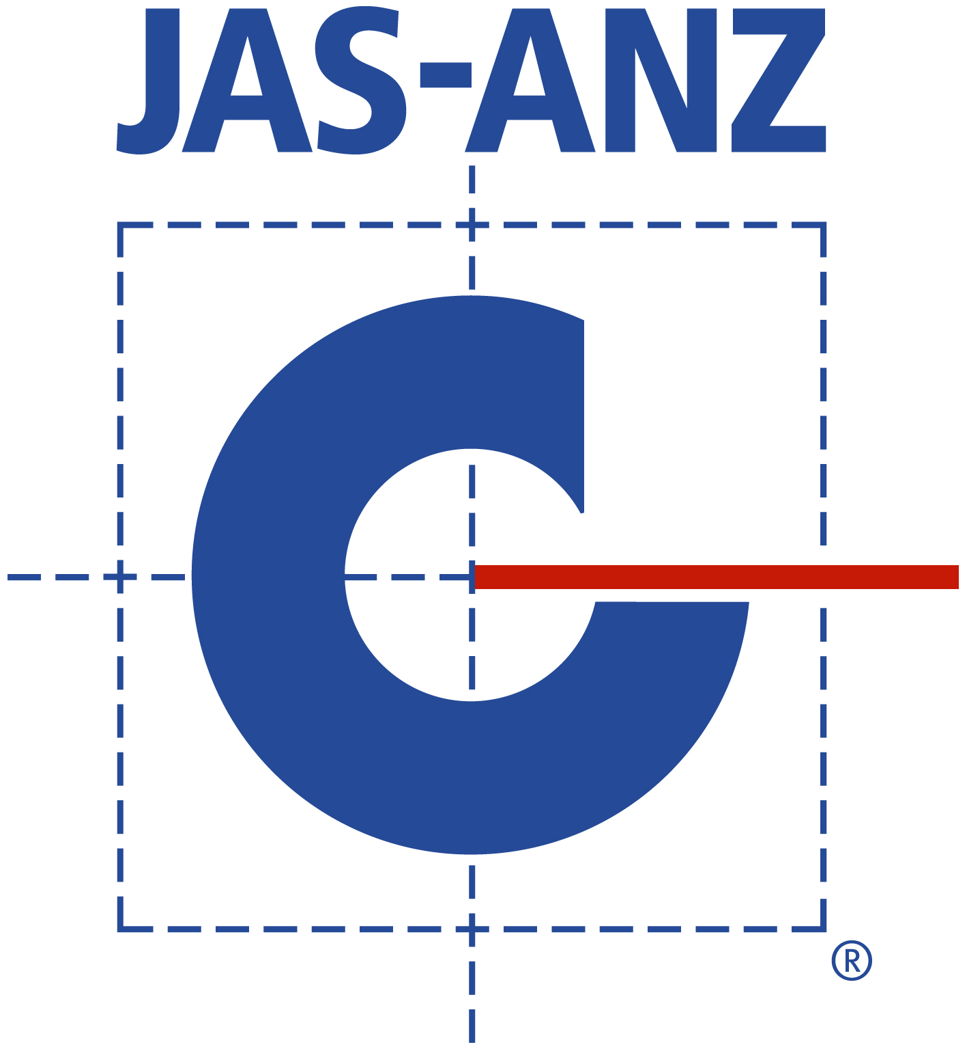

Key RMCG contact
Charles Thompson
0428 179 701 — charles@rmcg.com.au

Document review and authorisation
Project Number: #1144
Doc Version | Final/Draft | Date | Author | Project Director review | BST QA review | Release approved by | Issued to
1.0 | Draft | 13/04/2021 | C. Thompson  T. Cummins | C. Thompson | M. Sandford | C. Thompson | Bryce Morden GH CMA
2.0 | Draft | 7/05/2021 | C. Thompson  T. Cummins | C. Thompson | - | C. Thompson | Bryce Morden GH CMA
3.0 | Final Draft | 3/06/2021 | C. Thompson  T. Cummins | C. Thompson | - | C. Thompson | Bryce Morden GH CMA
4.0 | Final Draft | 29/06/2021 | C. Thompson  T. Cummins | C. Thompson | J. Belz | C. Thompson | Bryce Morden GH CMA
5.0 | Final inc. agency comments | 3/6/2022 | C. Thompson | C. Thompson |  | C. Thompson | GH CMA

A Water Use Licence (WUL) is applicable if supplied from a declared regulated water source. However, as there are no declared regulated water systems in the Southwest this is not applicable and the process for WULs is not covered in this document.
i.e. a varied licence.
In southern Victoria the Minister for Water delegates licensing powers relevant to irrigation development to SRW/ GWMWater.
Requirements for an IDP may be waived by the Minister after consultation with and written agreement from the relevant Catchment Management Authority as per the Standard Water Use Conditions Clause 6 -Schedule 1 clause 1. This will usually occur after the IDC has undertaken a documented risk assessment to confirm risks are low.
Under the Instrument of Delegation (2019), SRW/ GWMWater as the Delegate responsible for issuing the licence may modify or waive the requirement.
Accessed 12/9/19.
https://waterregister.vic.gov.au/images/documents/Policies%20for%20Managing%20Take%20and%20Use%20Licences%20-%20Approved%20by%20Water%20Min%2002.02.2014.pdf (Accessed 16/12/19).
It is suggested that rainfall be adjusted to effective rainfall. This can be calculated by removing daily events <5mm (due to being too small to penetrate soil) and treating daily events greater than 25 mm as a maximum of 25 mm per day (the amount above 25 mm being not available due to runoff from heavy events). Effective Rainfall calculation may be varied to match local conditions, eg. sometimes <2 mm and >30 mm has been used in Gippsland with lower areas of ET. The period for determining average rainfall should be based on current climate impacts i.e. post 1996.
https://www.aboriginalvictoria.vic.gov.au/preliminary-aboriginal-heritage-test.
This information as accessed from https://www.environment.vic.gov.au/__data/assets/pdf_file/0023/329450/Info-sheet-A-quick-comparison-of-first-party-and-third-party-offset-sites.pdf on 21 May 2019.

