5 February 2024
WOODY WEED REMOVAL FOR TINY BAT HABITAT

Do you own land in South-West Victoria? It may be essential feeding habitat for critically endangered Southern Bent-wing Bats.
The Southern Bent-wing Bat is a tiny native bat which lives in caves near Portland.
Glenelg Hopkins CMA Senior Biodiversity Officer, Robert Gibson, said this micro-bat is just five centimetres long, weighs 15 grams and relies predominantly on moths for food.
Unfortunately, native bushland areas where moths live are being threatened by invasive woody weeds such as Italian Buckthorn and Sweet Pittosporum. These weeds compete with native bushland and threaten to reduce the availability of moths for the bats.
Sweet Pittosporum is often used in gardens and is a native plant, however, not in this region.
“It might be a native plant, but it becomes invasive when growing in areas outside of its natural range,” Mr Gibson said.
Italian Buckthorn is a dense non-native bush that has become invasive around Portland and like Sweet Pittosporum, reduces the capacity for indigenous plants to support moths.
“The Glenelg Hopkins CMA is offering support to landholders who would like to reduce woody weeds that threaten bushland on their property and improve food availability for Southern Bent-wing Bats,” he said.
Mr Gibson said the Glenelg Hopkins CMA received a grant from the Victoria Government’s Nature Fund to reverse the decline of the local Southern Bent-wing Bat population.
“Removing woody weeds and protecting native vegetation for moth habitat is a focus of the project,” he said
Landowners within the Portland region who would like support with controlling woody weeds within areas of bushland on their property are encouraged to contact Robert Gibson at the Glenelg Hopkins CMA on 0434 936 168 or r.gibson@ghcma.vic.gov.au
Expressions of interest will close 29 February 2024.

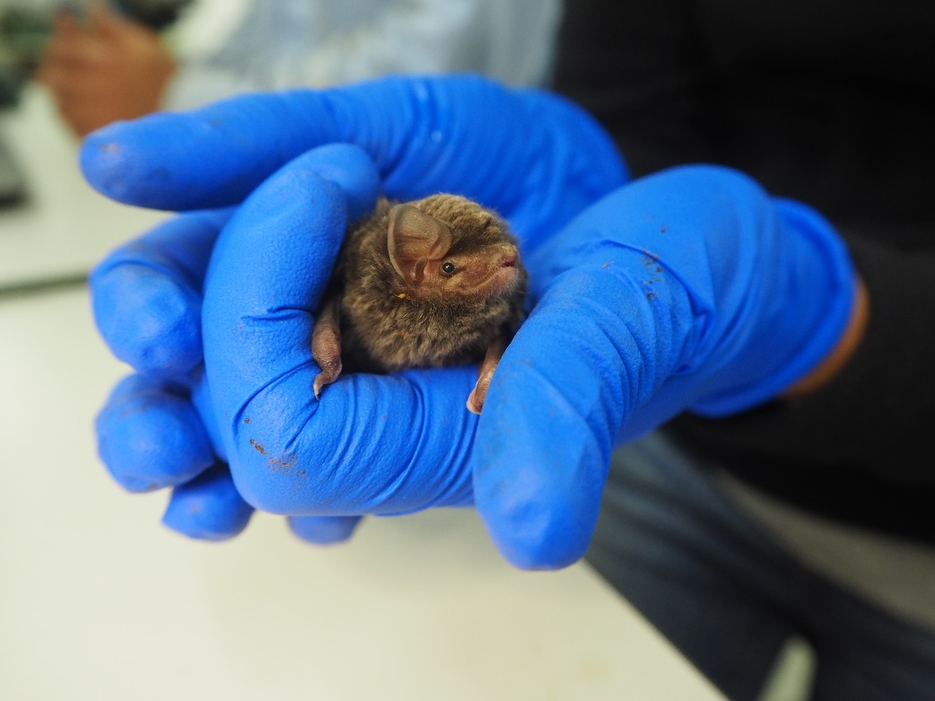
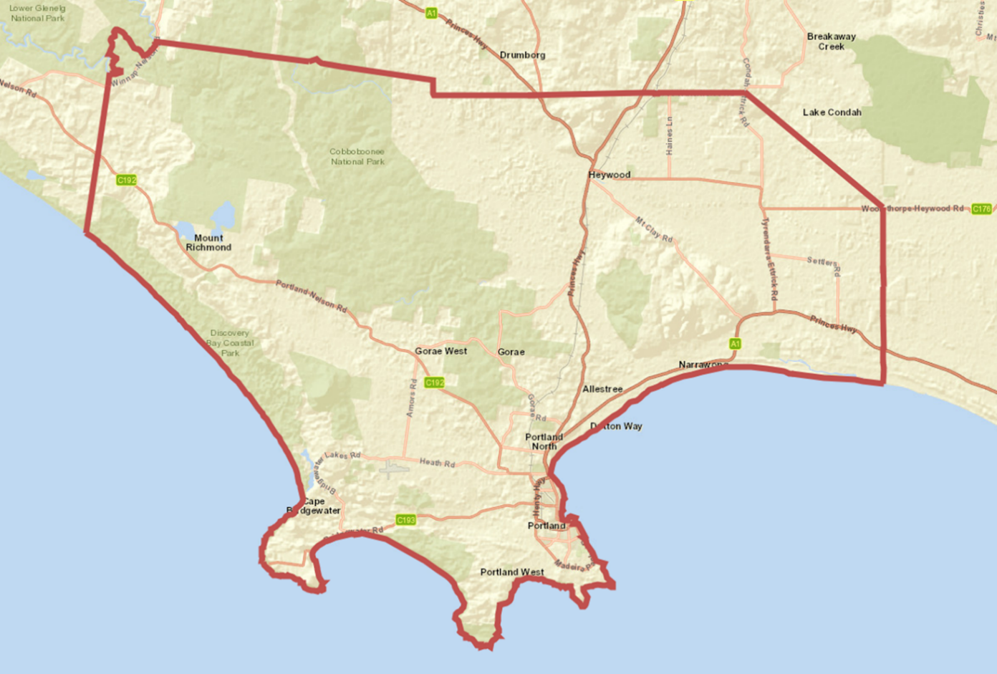
ENDS
CAPTION: Critically endangered Southern Bent-wing Bat. IMAGE: EMMI VAN HARTEN
CAPTION: Focus area for woody weed control.

