15 April 2024
CMAs WIN PRESTIGIOUS BANKSIA AWARD
Vic Catchments, the peak body for Victoria’s ten Catchment Management Authorities (CMA) which includes the Glenelg Hopkins CMA, has won the Nature Positive category of the 35th National Banksia Sustainability Awards.
The Awards celebrate trailblazers in environmental and social sustainability, with winners across 14 categories spanning travel, agriculture, conservation and more announced at the gala event – all recognised as true champions of sustainability and social impact.

The award nomination for Vic Catchments was in the Nature Positive Award category and was in recognition of the 25 years of partnerships and projects which the CMAs have undertaken in their regions which have significantly benefitted the land, water and biodiversity of Victoria which was celebrated last year (2023).

“Vic Catchments is thrilled and humbled to be winners of this highly competitive category and congratulate all the other finalists,” Cath Jenkins, Chair of Vic Catchments, said when accepting the award at the gala event held in Melbourne

“For over 25 years CMAs have been at the forefront of working with communities and partners to deliver incredible results for catchments across Victoria. It's a delight that it's been recognised by such a prestigious organisation.”

“We are a relatively small, yet passionate team and deliver projects on behalf of the Australian and Victorian governments. Partnerships are one of our biggest strengths and we share this success with everyone – Traditional Owners, partner organisations, community and government.”

“We have achieved great outcomes for our natural environments, catchments, agricultural landscapes and communities in our 26 years, and we are only just getting started.”
CMAs are responsible for the integrated planning and coordination of land, water and biodiversity management in each catchment and land protection region. Each CMA is structured to maximise community involvement in decision making.
In 2023 alone, across Victoria, the 10 CMAs delivered:
- Enhanced over 3,000 hectares of vegetation to create habitat for native species.
- Improved practices over 9,000 hectares of agricultural land.
- Issued 13,000 approvals and advice for works on waterways.
- Installed 368 kilometres of fencing to protect rivers and wetlands.
- Undertook 47,032 hectares of weed control.

Read about more achievements in the 2023 Vic Catchments Achievements Brochure here
You can read about the achievements of the CMAs across Victoria in the 2023 Vic Catchment Achievements brochure HERE or by visiting www.viccatchments.com.au
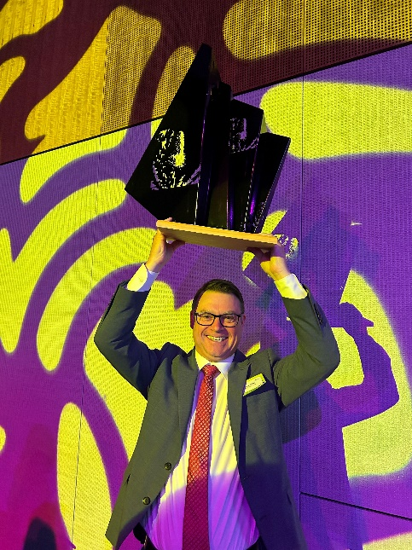
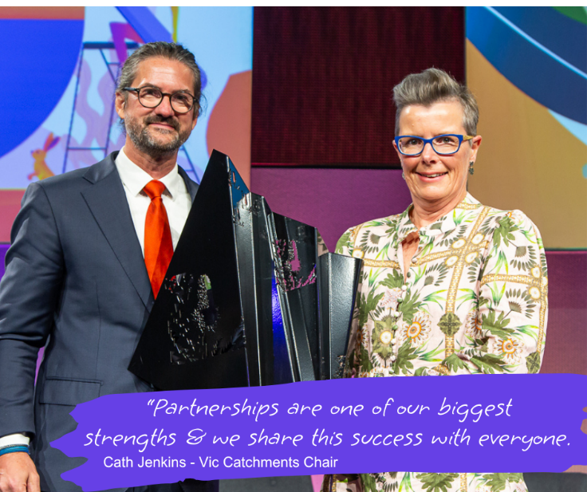
ENDS
ABOVE LEFT CAPTION: Cath Jenkins, Vic Catchments Chair, accepting the Nature Positive Award
ABOVE RIGHT CAPTION: Tony Baker, Executive officer of Vic Catchments, with the Nature Positive Award.

