23 April 2024
Fish and water passage restored as Bromfield weir removed

Warrnambool’s Bromfield Street weir, a longstanding barrier to fish migration in the Merri River, has been successfully removed.

The removal of the weir, which was a collaborative effort between local authorities, environmental organisations, and community stakeholders was funded by Victorian Government’s $248 million investment over four years (2020-2024) to improve catchment and waterway health across regional Victoria.

The Bromfield Street weir was constructed in 1907 as part of the Merri scheme to supply town water to Warrnambool, and despite this scheme being decommissioned in 1939, the weir remained in the waterway.
The aging structure of the weir, which has become unsafe over time, has been identified as key a barrier to the natural flow of the Merri River and an impediment to fish passage in the waterway.

The removal process was carried out with careful consideration for environmental impact and community engagement, Glenelg Hopkins CMA Senior Waterways Officer, Stephen Ryan, said.

Mr Ryan said environmental experts and engineering teams from Glenelg Hopkins CMA and Murrihy’s demolition employed best practices to dismantle the weir while minimising disturbance to the surrounding ecosystem.

Additionally, community input and support were integral in ensuring the success of the removal project.

“The removal of the Bromfield Street Weir is expected to have far-reaching benefits for the Merri River ecosystem and the wider Warrnambool community who enjoy recreational activities on waterway,” Mr Ryan said.

“Improved fish migration will enhance genetic exchange among populations, increase biodiversity, and contribute to the overall ecological balance of the river system.”

“Additionally, the waterway is now much more accessible for people to enjoy the recreational benefits of the river like kayaking and fishing … removing the weir means access to the upper reaches of the river without needing to pull a kayak or canoe around the weir.”

However, Mr Ryan noted the public should be aware the removal of the weir may cause a noticeable drop in water levels and potential bank slumping until the banks reestablish with vegetation.

“The Glenelg Hopkins CMA is committed to ongoing monitoring and management efforts to ensure the long-term success of the restoration project.

“In addition, it's important to note that rehabilitation works will continue in the upcoming weeks following the removal of the structure so people can expect to see our team there revegetating those bank areas.

“These works aim to further enhance the ecological health and resilience of the Merri River ecosystem,” Mr Ryan said.

The ongoing efforts reflect the dedication of local authorities, environmental organisations, and community stakeholders to safeguard the river's biodiversity and natural heritage for the benefit of present and future.
To find out more about the project, visit http://www.ghcma.vic.gov.au
ENDS
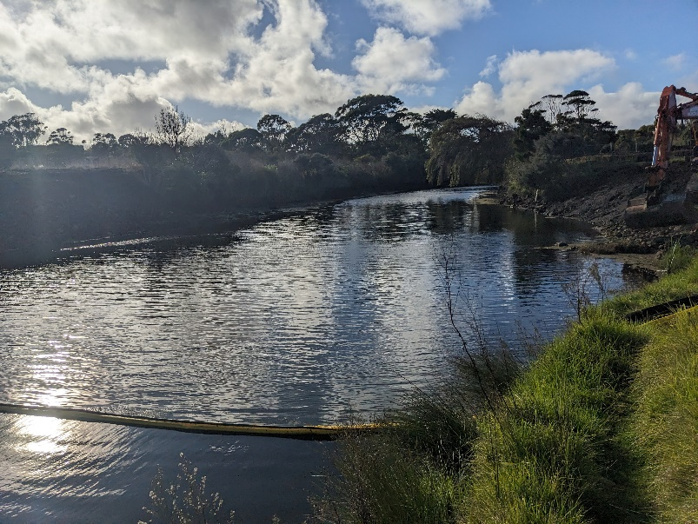
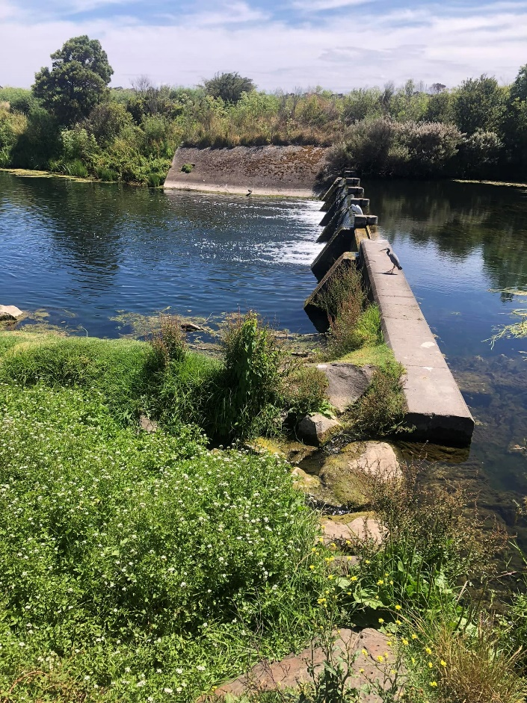
IMAGES: Before and after images of the Bromfield Street weir site on the Merri River in Warrnambool.

