Glenelg Hopkins CMA Victorian Landcare Gants 2026.

Mapping Guide
For all on ground works individual maps are required for each site. At a minimum the map should include:
- an aerial photo with the project area drawn on it. Please make every effort to accurately draw the proportions of the project area. For successful projects the CMA will request an electronic map of project areas.

There are many mapping programs that can be used for mapping. One free program is Google Earth. This program gives you the capacity to produce an electronic and a jpeg map of your project areas. You can submit the jpeg map in your application.
Please contact Tony Lithgow at Glenelg Hopkins CMA if you need assistance. Ph.55 71 2526. Please follow the guide below.

How to produce a map in Google Earth

- On the internet go to https://earth.google.com and download Google Earth or enter Google Earth in a search engine.
- Open Google Earth
- Navigate to your site using tools on top right of screen.

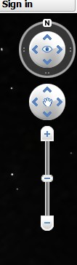
+ Press to zoom in
- Press to zoom out
click and drag on map to move

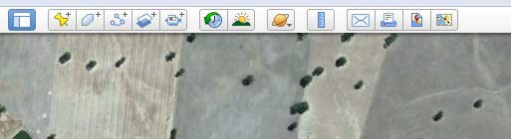
- Click on polygon tool
- Fill name i.e. Field 1 - allocate a unique number for each site (see screen shot next page)
- Change line colour to red and change line width to 3
- Change area to outline

Do not press OK

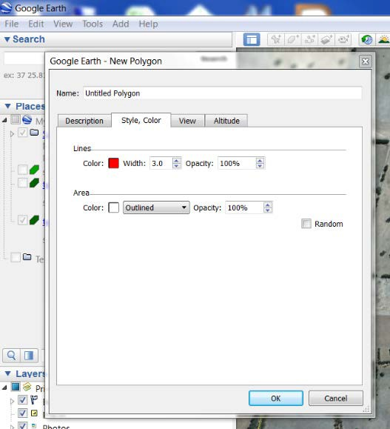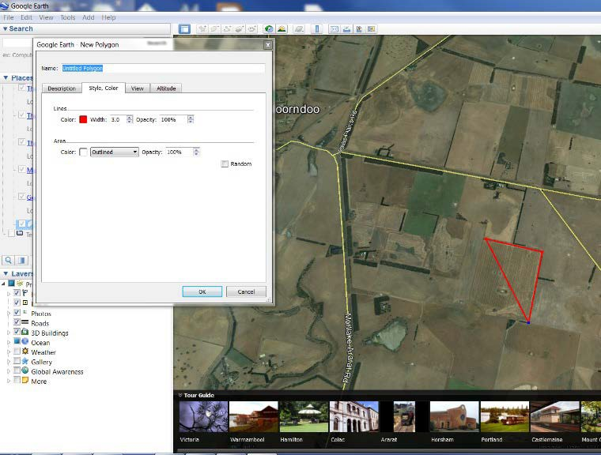

- Move curser to map click on each corner of proposed project site.
- Now press OK
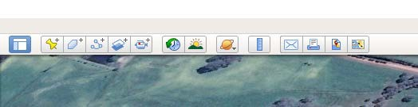
- Click on Add path icon
- Fill name i.e. Fence 1 – consistent with field number for this site
- Change line color to yellow (see screen shot)

Do not press OK
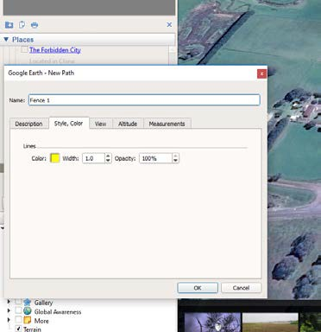
- Move curser to map click on each corner of proposed funded fence line

- Now press OK
- Click on Save Image icon
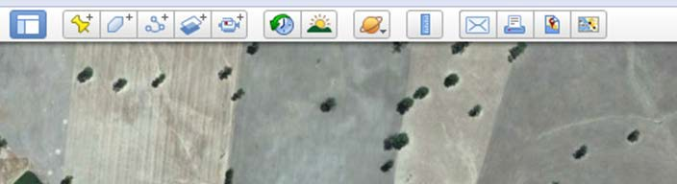
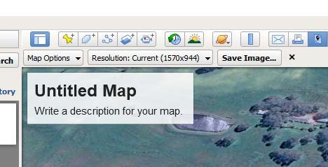

- Click on Untitled Map. You can add a title(landholder/property name) and write any description.
- Ensure ‘Resolution: current’ is 1570 x 944
- Click Save Image
- Select where you want to store the file
- Name the file
- Click Save

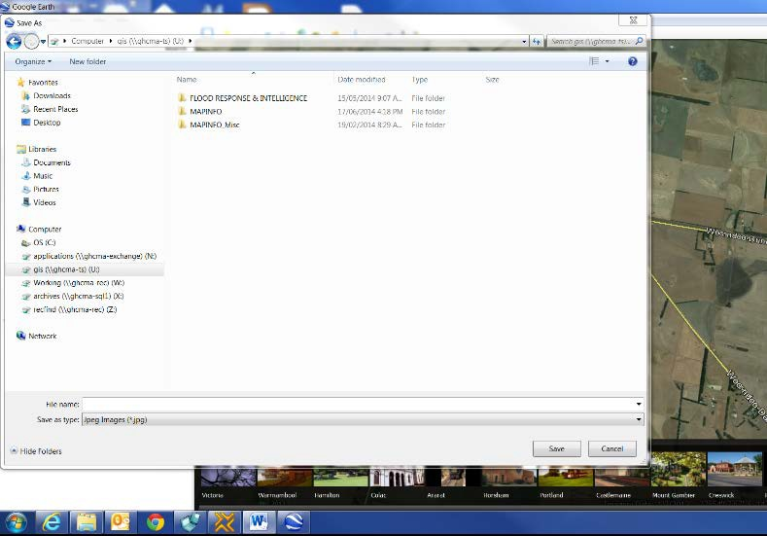

- This file can be uploaded to the application

How to save an electronic file (Kmz)
- Highlight the file you want to save.
- Select File – Save – Save Place as …
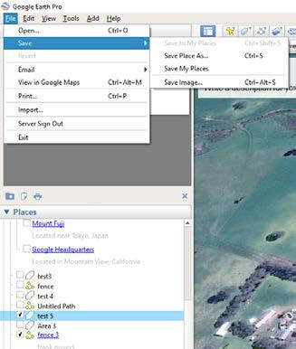
- Select where you want to save the file
- Give the file a name. Make sure you can identify the site and type of file i.e. ‘test 3 area’.
- Save type as Kmz
- Click on Save
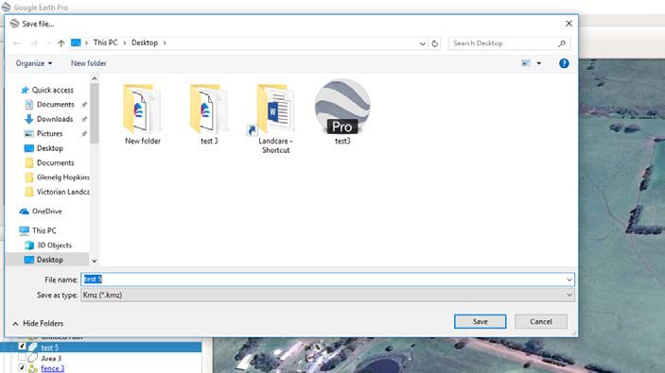

Please note you can only save one item at a time. If you have an area mapped and a fence mapped you must repeat the process for each one.
You do not have to submit these files with your application.

